**model BRE4：**

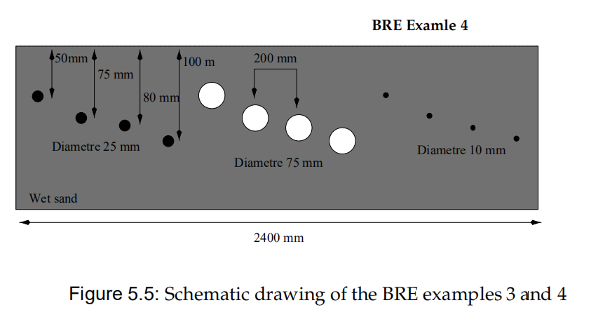

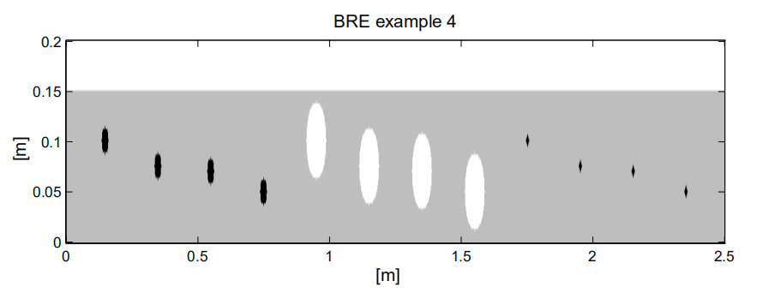

Figure 5.7: Image produced using the information in the geometry file of the BRE examples 3 and 4 (Notevertical scale is exaggerated

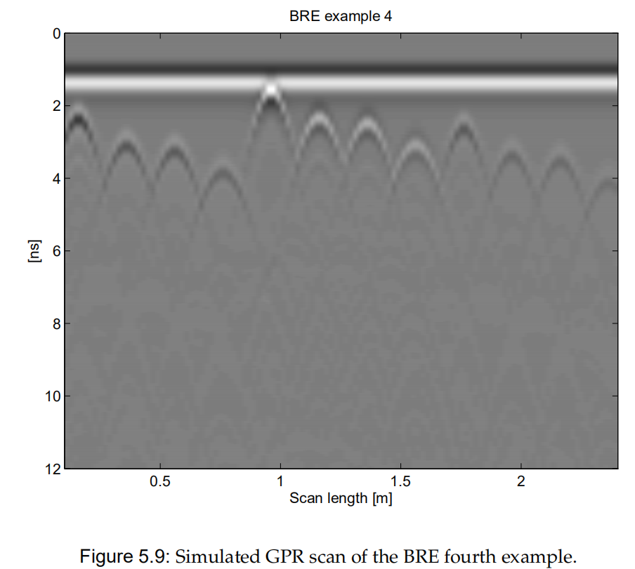

Chapter 5 GprMax2D/3D modelling examples

In the examples directory of GprMax2D installation disks there four input files which include

the modelling instructions for four examples suggested by the Building Research Establishment

(**BRE**), UK. All of the examples involve rebars and hollow tubes located in concrete or sand.

Further, most of them include voids located underneath the concrete slab. Schematic rawings of these examples can be found in Figures 5.4 and 5.5. Further, the GprMax2D models of these examples are presented in Figures 5.6 and 5.7 as images created in MATLAB using the information stored in the geometry files of the models1.

5.2 Other 2D examp

5.2.2 BRE example #4

The construction of a GprMax2D model for the fourth example of the BRE set is more straightforward than the previously described one.

A single background medium of wet sand is used and cylinders of different size and type are employed to simulate the rebars and hollow tubes as seen in the schematic drawing of Figure 5.5. It should be noted however, that the size of the 10 millimetres rebars is quite small for a discretization step ∆x and ∆y of 2.5 millimetres. Better results will be obtained using lower values. However, the size of the model will increase substantially. Decreasing ∆x and ∆y will not result in a different pattern for the response.

The result of the GprMax2D simulation for this example is presented in Figure 5.9 using a gray scale image format for the simulated GPR traces

V2-v3 参数变化：

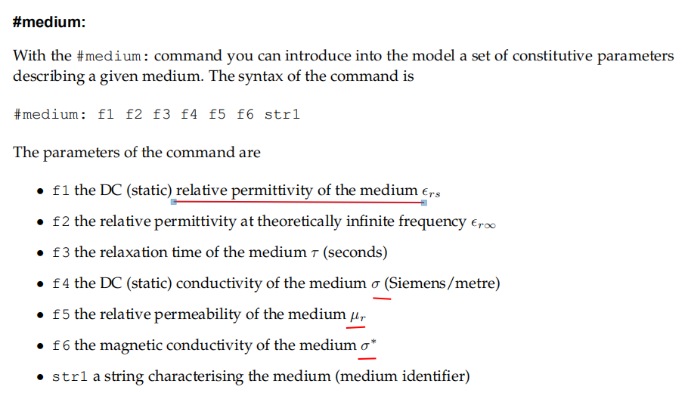

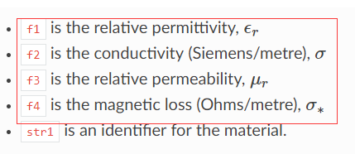



→ #material: 20 0.1 1.0 0.0 wet_sand

解决了：

%%% v2 bre4 → v3 % 官方函数%

python -m tools.inputfile_old2new xb_models/bre4_v2.in

%成功了： Written new input file: 'xb_models/bre4_v2_v3syntax.in'

python -m gprMax xb_models/bre4_v2_v3syntax.in -n 110

python -m tools.outputfiles_merge xb_models/bre4_v2_v3syntax --remove-files

python -m tools.plot_Bscan xb_models/bre4_v2_v3syntax_merged.out Ez

出图：

