

**FACULTY OF COMPUTING AND INFORMATICS**

**CSE6224 – SOFTWARE REQUIREMENTS ENG**

**GROUP: G07**

**SESSION: TT4L**

**PROJECT TITLE: University Communication and**

**Services Portal with Campus Management System and SMS Gateway Integration**

|  |  |
| --- | --- |
| **Student Name** | **Student ID** |
| Yang Jia En | 242UC2451Q |
| Teoh Xuan Xuan | 242UC2451P |
| Tey Jun Cheng | 242UC2452Z |

Submitted to: Dr. Zarina binti Che Embi

Date: 25 May 2025

**Table of Contents**

1.0 Introduction 4

1.1 Purpose 4

1.2 Scope 4

1.3 Product Overview 4

1.3.1 Product Perspective 4

1.3.2 Product Function 4

1.3.3 User Characteristics 4

1.3.4 Limitation 4

1.3.5 Apportioning of Requirements 4

1.4 Definition 4

2.0 Reference 5

3.0 Requirement 6

3.1 External Interface 6

3.1.1 6

3.1.2 6

3.2 Functions 6

3.2.1 Sequence Diagram 6

3.2.2 State Diagram 6

3.3 Functional Requirements 6

3.4 Performance Requirements 6

3.5 Usability Requirements 6

3.6 Interface Requirements 6

3.6.1 System Interface 6

3.6.2 User Interface 6

3.6.3 Hardware Interface 6

3.6.4 Software Interface 6

3.6.5 Communication Interface 6

3.6.6 Memory Constraints 6

3.6.7 Operation 6

3.6.8 Site Adaptation Requirements 6

3.6.9 Interface with Services 6

3.7 Logical Database Requirements 6

3.8 Design Constraints 6

3.9 Standard Compliance 7

3.10 Software System Attributes 7

3.10.1 Accuracy 7

3.10.2 Availability 7

3.10.3 Reliability 7

3.10.4 Security 7

3.10.5 Maintainability 7

3.10.6 Portability 7

3.10.7 Usability 7

3.11 Supporting Information 7

3.11.1 Prototyping 7

3.11.2 Questionnaire 7

3.11.3 Perspective-Based Reading 7

4.0 Verification 8

4.1 Verification Approach 8

4.2 Verification Criteria 8

4.3 Requirement Verification 8

4.3.1 Functional Requirements Verification 8

4.3.2 Performance Requirements Verification 8

4.3.3 Security Requirements Verification 8

4.3.4 Usability Requirements Verification 8

4.3.5 Maintainability Requirements Verification 8

4.3.6 Portability Requirements Verification 8

5.0 Appendices 8

5.1 Assumptions and Dependencies 8

5.2 Acronyms and Abbreviations 8

5.3 Glossary (Optional) 8

Change Log Table 9

# 1.0 Introduction

## 1.1 Purpose

The purpose of myMMU, the University Communication and Services Portal, is to serve as a centralized digital platform that streamlines communication and provides seamless access to academic and administrative services for the MMU community. By integrating with the Campus Management System and SMS Gateway, myMMU ensures that essential updates and academic information are delivered efficiently and effectively to students, lecturers, administrators, and parents.

At its core, myMMU is designed to enhance transparency, promote user engagement, and modernize institutional processes. Through this portal, students can view their academic performance, attendance records, financial statements, and important announcements. Parents are also kept informed with real-time SMS notifications about their child’s academic progress, fee reminders, and attendance alerts, enabling stronger parental involvement and support.

Additionally, lecturers and administrators benefit from streamlined workflows and direct communication channels, allowing them to focus more on delivering quality education and managing operations effectively. With its user-friendly interface and mobile accessibility, myMMU provides a consistent and inclusive digital experience for all stakeholders.

Ultimately, myMMU aims to bridge communication gaps, reduce administrative burden, and foster a more connected and responsive university environment. By embracing technological integration and real-time data sharing, this initiative marks a significant step forward in MMU’s digital transformation journey.

## 1.2 Scope

The myMMU University Communication and Services Portal will be a dynamic and centralized platform that connects students, lecturers, administrators, and parents within the MMU ecosystem. This platform is designed to provide secure access to academic records, attendance, billing information, announcements, and timely updates, while integrating with the university’s existing Campus Management System (CMS) and SMS Gateway.

At its core, myMMU will offer essential features to ensure that users can easily access and interact with academic and administrative services. Students will be able to view their academic performance, fee payment status, attendance records, and announcements in one place. Parents will receive SMS alerts on their children’s academic performance, absenteeism, and outstanding fees, promoting transparency and enabling better parental involvement.

Lecturers will be able to send announcements, monitor student attendance, and review academic progress, all through a simplified interface. Administrators will manage system configurations, broadcast campus-wide announcements, and ensure that the integration with the CMS and SMS Gateway runs smoothly.

To maintain an efficient and responsive service, myMMU will feature a modular design that supports future scalability, including multi-language support, theme personalization, and additional integrations (e.g., parking sticker services or timetable check-ins). The platform will also emphasize accessibility and responsiveness across desktop and mobile devices, ensuring a seamless experience for all users.

Furthermore, the system includes critical functions such as user authentication, role-based access control, SMS configuration, and secure data retrieval. These features ensure that myMMU not only meets core functional requirements but also satisfies institutional needs for data integrity, privacy, and real-time service delivery.

|  |  |
| --- | --- |
| User | Function |
| Student | 1. Check attendance Records 2. View billing info and payment status 3. Receive announcements and SMS alerts 4. Access timetable and course info |
| Parent | 1. Receive SMS alerts (low attendance, fee reminders, academic results) 2. View child's grades, attendance, billing info |
| Lecturer | 1. Post announcements and assignments 2. Upload materials 3. Update student's attendance and grades |
| Admin | 1. Post university-wide notifications 2. Approve classroom bookings |

Table 1.2.1: Scope of Functions by User Role in myMMU Portal

In conclusion, myMMU aims to redefine communication and service access within MMU by combining automation, transparency, and user-centric design. Its scope spans across academic, financial, and administrative domains, supporting the university’s digital transformation strategy and enhancing engagement among all stakeholders.

## 1.3 Product Overview

The myMMU University Communication and Services Portal is integrated with the university's Campus Management System and SMS Gateway, allowing students to access academic results, attendance records, billing information, and timetables. It also enables lecturers to submit grades and announcements, administrators to manage classroom bookings and inquiries, and parents to receive SMS alerts related to their child’s academic performance and financial obligations.

# **1.3.1 Product Perspective**

The myMMU University Communication and Services Portal is a centralized digital platform developed to enhance the academic and administrative experience for students, parents, lecturers, and university administrators. The system will be deployed on secure university-hosted infrastructure and will integrate directly with the Campus Management System (CMS) and an SMS Gateway, providing real-time access to essential information and direct mobile communication.

The myMMU system functions as an extension of the university's digital ecosystem, consolidating various services—such as academic performance tracking, attendance management, billing, and announcements—into one user-friendly interface. Each user role is provided with tailored access to relevant features, ensuring a secure, role-based experience.

The platform will be accessible through modern web browsers on desktop and mobile devices, promoting ease of access and usability. Students can retrieve personalized academic data and book classrooms, while parents receive timely SMS updates on their child’s academic status and financial obligations. Lecturers can push announcements, submit grades, and manage assessments. Administrators will oversee platform configuration, handle booking approvals, and broadcast campus-wide notifications.

To ensure performance and scalability, the system architecture includes:

1. A Web Server for handling user requests and interfaces.
2. A Database Server for storing academic, billing, and attendance data.
3. Secure integration with the Campus Management System for data synchronization.
4. A connection to the SMS Gateway for outbound alerts and reminders.

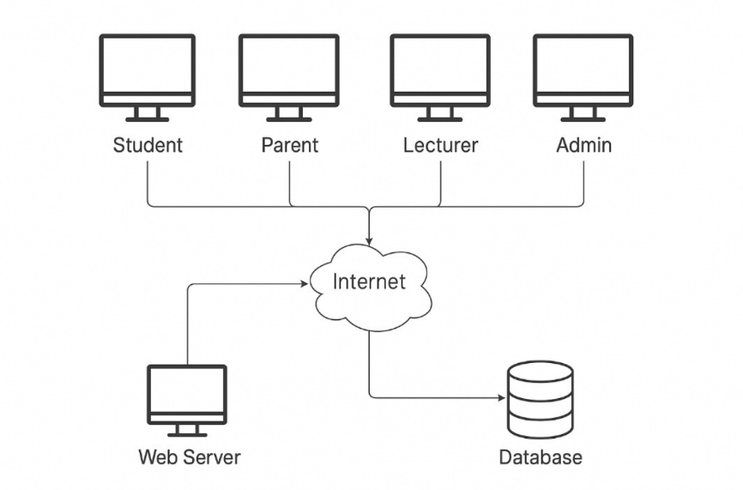

Figure 1.3.1 System Overview Diagram

The integration with the CMS ensures that academic records and billing data are always up to date, while the SMS Gateway guarantees that critical messages reach recipients in real time. This design supports the university’s goals of digital transformation, transparent communication, and academic excellence by offering a holistic and modern service platform.

context diagram

#### 1.3.1.1 System Interface

myMMU connects directly to:

* Campus Management System (CMS) for retrieving academic results, billing information, attendance, and timetable data.
* SMS Gateway to deliver notifications such as low attendance alerts, fee reminders, and performance summaries to users.
* Internal MMU authentication systems for credential validation and session handling.

#### 1.3.1.2 User Interface

The portal provides:

* A responsive web interface for desktops, tablets, and smartphones.
* Role-based dashboards (Student, Parent, Lecturer, Admin).
* A simple, accessible layout with icons, labels, and tables for data display and interaction.
* Language support: English (default), with potential for multi-language extension.

#### 1.3.1.3 Hardware Interface

* Client Devices: Any modern device with internet access (PCs, laptops, tablets, smartphones).
* Server Infrastructure: University-hosted or cloud-based servers that store and manage data, API connections, and file storage.
* Compatible with USB card readers or biometric login in the future (optional).

#### 1.3.1.4 Software Interface

* Built using Laravel/PHP or Django/Python for the backend.
* Relies on RESTful APIs to communicate with CMS and SMS services.
* Uses MySQL/PostgreSQL for database storage.
* Browser Compatibility: Latest versions of Chrome, Firefox, Edge, and Safari.

#### 1.3.1.5 Communication Interface

* All communication between the client and server occurs over HTTPS.
* Internal API communication uses JSON over REST.
* SMS alerts are triggered via a secure gateway with OTP/token-based authentication.

#### 1.3.1.6 Memory Constraints

* Minimal client-side memory usage as the application runs in-browser.
* Server specifications:
* Minimum 4GB RAM (test/development)
* Recommended 8GB+ RAM with scalable cloud storage for production

#### 1.3.1.7 Operation

* The system is operational 24/7, except during planned maintenance.
* Role-based access ensures that users only interact with relevant modules.
* Real-time data updates are ensured through scheduled syncing with CMS.

#### 1.3.1.8 Site Adaptation

* The system can be rebranded for different university branches (logo, colors, tagline).
* Configurable time zone, academic calendar, and localization.
* Scalable for future modules (e.g., club management, wellness tracking).

#### 1.3.1.9 Interface with Services

myMMU interfaces with:

* Campus Management System: Academic records, fees, timetable, and attendance.
* SMS Gateway: For outbound communication.
* Authentication Service: For secure login and session management.
* Optional: Email server or notification system for email alerts.

# **1.3.2 Product Function**

This is the overall use case diagram that show all use case for all actors.

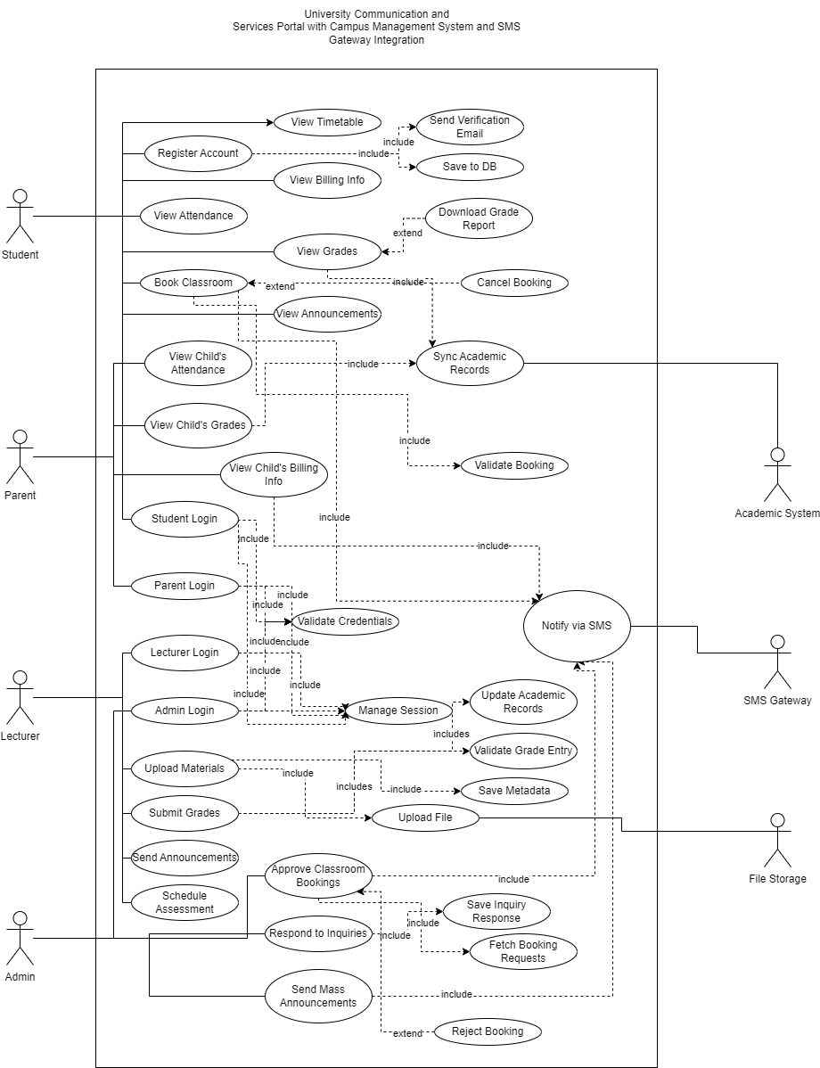

Figure 1.3.2: Use Case Diagram of myMMU University Communication and Services Portal

#### 1.3.2.1 Student

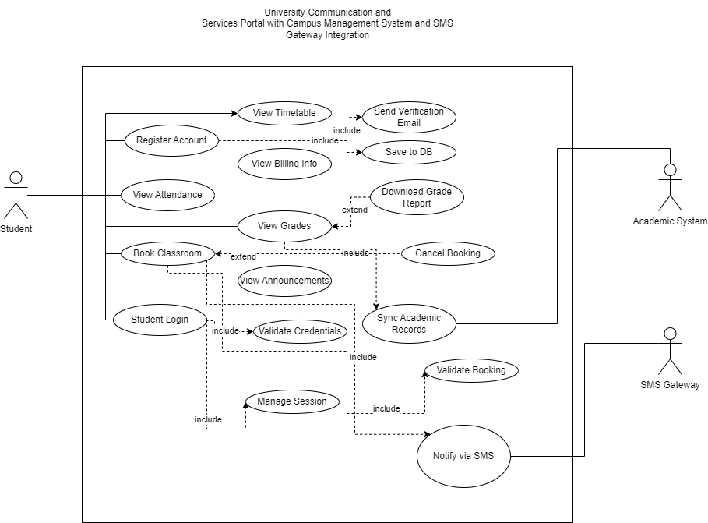

Figure 1.3.2.1: Use Case Diagram of Actor (Student)

|  |  |  |  |
| --- | --- | --- | --- |
| **Use Case ID** | **Use Case Name** | **Description** | **Author** |
| REQ_STD001 | Student Login | Allows a student to log into the system using valid credentials. | Your Name |
| REQ_STD002 | Register Account | Enables new users to register and create a student account. | Your Name |
| REQ_STD003 | View Grades | Allows students to view their academic results and download reports. | Your Name |
| REQ_STD004 | View Attendance | Enables students to check their attendance records. | Your Name |
| REQ_STD005 | View Timetable | Allows students to access their academic schedule. | Your Name |
| REQ_STD006 | View Billing Info | Enables students to check outstanding fees and payment history. | Your Name |
| REQ_STD007 | Book Classroom | Allows students to reserve a classroom based on availability. | Your Name |
| REQ_STD008 | View Announcements | Enables students to view announcements posted by lecturers or admins. | Your Name |
| REQ_STD009 | Download Grade Report | Allows students to download a detailed grade report. *(<> from View Grades)* | Your Name |
| REQ_STD010 | Cancel Booking | Permits students to cancel a previously booked classroom. *(<> from Book Classroom)* | Your Name |
| REQ_STD011 | Notify via SMS | Sends SMS notifications regarding fees, attendance, or grades. *(integrated with SMS Gateway)* | Your Name |

#### 1.3.2.2 Lecturer

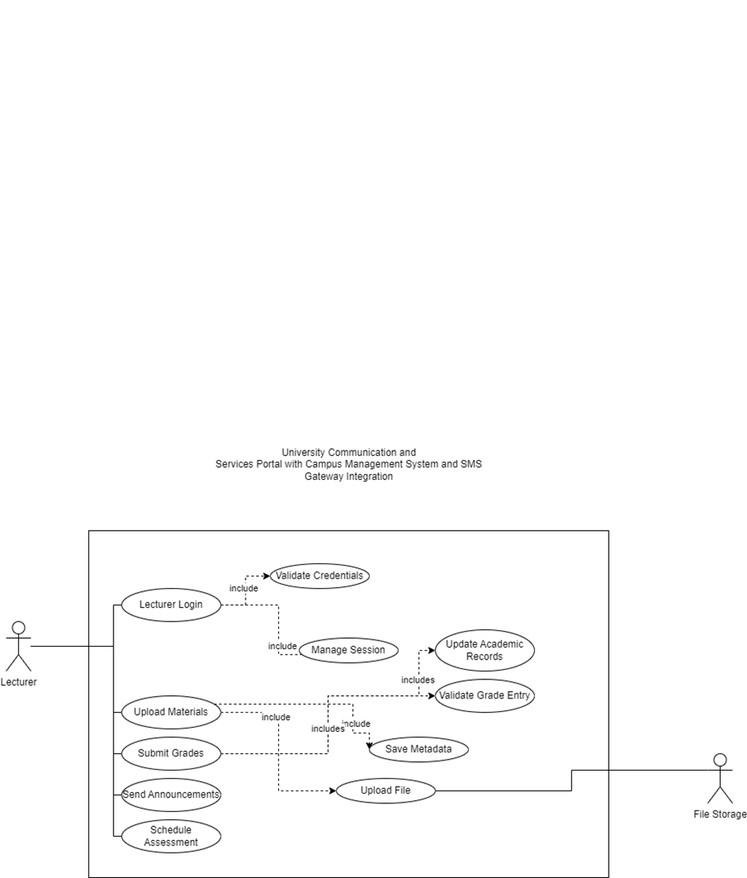

Figure 1.3.2.1: Use Case Diagram of Actor (Lecturer)

|  |  |  |  |
| --- | --- | --- | --- |
| **Use Case ID** | **Use Case Name** | **Description** | **Author** |
| REQ_LEC001 | Lecturer Login | Allows lecturers to log into the system securely using their credentials. | Your Name |
| REQ_LEC002 | Upload Materials | Enables lecturers to upload lecture notes, slides, and supporting documents for students. | Your Name |
| REQ_LEC003 | Submit Grades | Allows lecturers to input and submit students’ academic results. | Your Name |
| REQ_LEC004 | Send Announcements | Enables lecturers to broadcast announcements to their respective classes. | Your Name |
| REQ_LEC005 | Schedule Assessment | Allows lecturers to set and manage assessment dates for assignments, quizzes, or exams. | Your Name |

#### 1.3.2.3 Admin

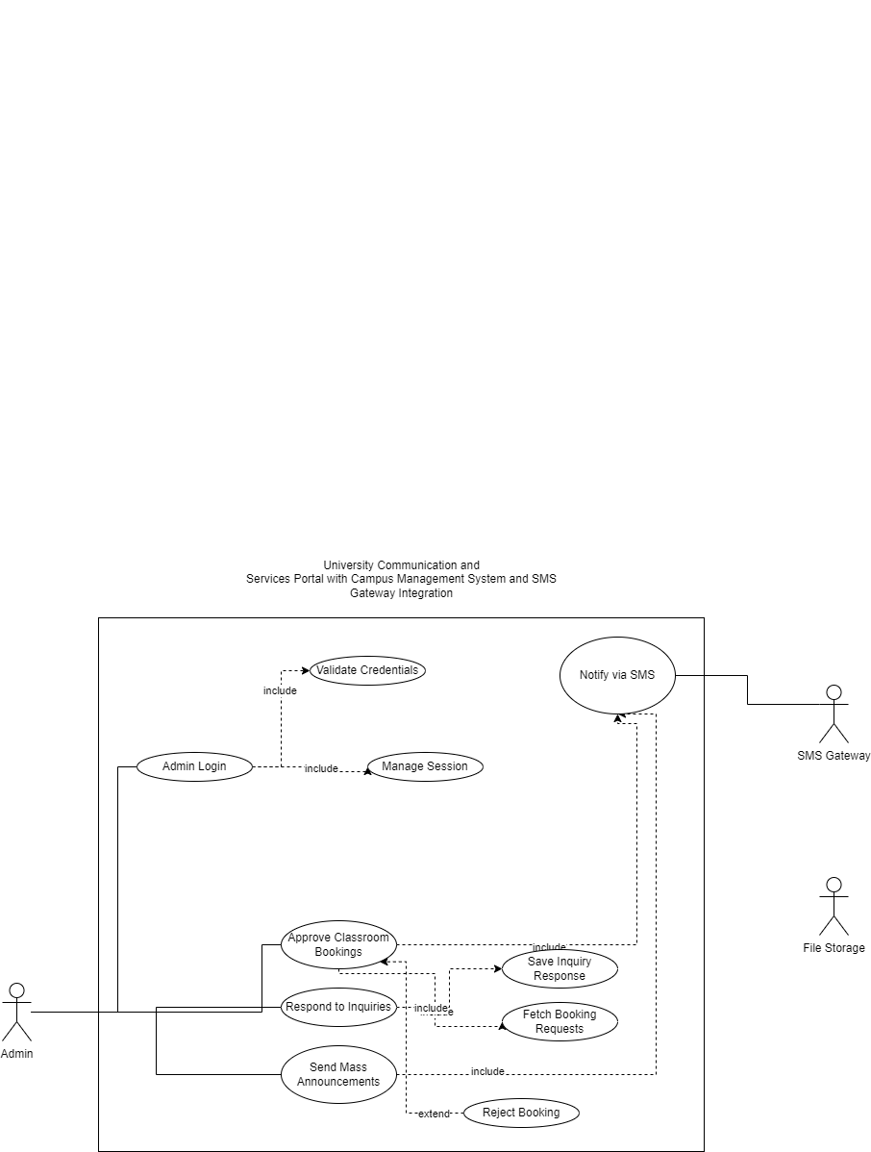

Figure 1.3.2.1: Use Case Diagram of Actor (Admin)

|  |  |  |  |
| --- | --- | --- | --- |
| **Use Case ID** | **Use Case Name** | **Description** | **Author** |
| REQ_LEC001 | Lecturer Login | Allows lecturers to log into the system securely using their credentials. | Your Name |
| REQ_LEC002 | Upload Materials | Enables lecturers to upload lecture notes, slides, and supporting documents for students. | Your Name |
| REQ_LEC003 | Submit Grades | Allows lecturers to input and submit students’ academic results. | Your Name |
| REQ_LEC004 | Send Announcements | Enables lecturers to broadcast announcements to their respective classes. | Your Name |
| REQ_LEC005 | Schedule Assessment | Allows lecturers to set and manage assessment dates for assignments, quizzes, or exams. | Your Name |

#### 1.3.2.4 Parent

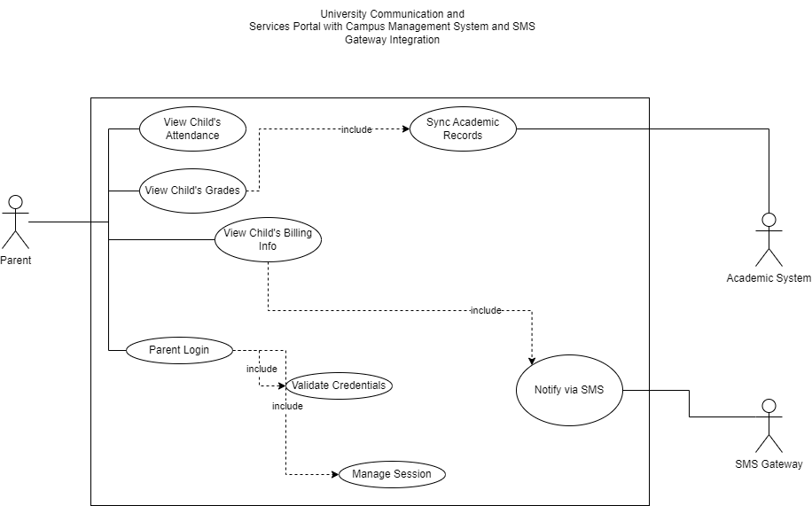

Figure 1.3.2.1: Use Case Diagram of Actor (Parent)

|  |  |  |  |
| --- | --- | --- | --- |
| **Use Case ID** | **Use Case Name** | **Description** | **Author** |
| REQ_PAR001 | Parent Login | Allows parents to securely log into the portal using their credentials. | Your Name |
| REQ_PAR002 | View Child’s Grades | Enables parents to access and review their child’s academic performance. | Your Name |
| REQ_PAR003 | View Child’s Attendance | Allows parents to monitor their child’s attendance records. | Your Name |
| REQ_PAR004 | View Child’s Billing Info | Permits parents to view their child’s outstanding fees and payment status. | Your Name |

# **1.3.3 User Characteristics**

This section outlines the characteristics of each intended user group in the myMMU portal. It includes the users’ roles, expected familiarity with technology, and the level of system interaction. Understanding these traits helps guide interface design, user onboarding, and support strategy.

|  |  |  |  |
| --- | --- | --- | --- |
| Role | Description | Status | Technical Expertise / Expected Knowledge |
| **Student** | Current students enrolled in the university using the portal for academic and service access. | User Privilege | Basic to moderate understanding of online portals, ability to check academic data, and perform transactions. |
| **Parent** | Guardians or parents who monitor their child’s academic and financial status. | User Privilege | Basic mobile usage, familiar with SMS and simple dashboard interfaces. |
| **Lecturer** | Teaching staff who submit results, upload materials, and communicate with students. | User Privilege | Moderate understanding of system tools like grade entry, document upload, and class-wide messaging. |
| **Admin** | University staff responsible for managing bookings, inquiries, and announcements. | Developer Privilege | Advanced system knowledge, administrative dashboard handling, and SMS broadcast or approval workflows. |

Table 1.3.3: User Characteristics of myMMU System

### 1.3.4 Limitation

The development and deployment of the myMMU University Communication and Services Portal come with several limitations that could affect its functionality, user experience, and maintainability. These limitations arise from technical constraints, integration dependencies, user behavior, and resource availability.

1. Hardware Limitations

The system’s performance may vary depending on the university’s existing server infrastructure and client devices used by end-users. Outdated hardware on either side may result in slower processing times, delayed data synchronization with the Campus Management System (CMS), or degraded user experience.

2. Integration Dependencies

myMMU depends heavily on its integration with external systems such as the CMS and the SMS Gateway. Any changes, downtime, or API limitations from these external systems could directly affect the portal’s functionality, requiring frequent updates or workaround implementations.

3. Security and Privacy Constraints

Ensuring the protection of academic and financial data is critical. The system must comply with university policies and data protection regulations. Failure to implement robust authentication, encryption, and access control measures could lead to data breaches, loss of trust, and system vulnerabilities.

4. User Adoption and Technological Familiarity

The portal’s effectiveness depends on its active usage by students, parents, lecturers, and administrators. Low user awareness, resistance to adopting new platforms, or unfamiliarity with system navigation could hinder engagement and reduce the system’s impact.

5. Customization and Scalability

While the portal is designed to be modular, certain university-specific features may not be easily customizable due to platform architecture constraints. Adapting the system to evolving university needs or expanding it to other campuses may require significant redevelopment.

6. Budget and Resource Constraints

The development, deployment, and maintenance of myMMU must operate within the university’s budget. Limited financial or human resources may restrict the implementation of advanced features, multilingual support, or real-time analytics, impacting the system’s growth and sustainability.

### 1.3.5 Apportioning of Requirements

The apportioning of requirements for the myMMU University Communication and Services Portal categorizes the system into key functional modules. Each module targets a specific aspect of the portal’s core features, ensuring that stakeholder needs are met efficiently through structured development. The following table outlines the requirement allocation across major system modules:

|  |  |  |
| --- | --- | --- |
| **Module ID** | **Module Name** | **Description** |
| REQ_MMU001 | User Management | Handles account registration, login, authentication, session handling, and role-based access control. |
| REQ_MMU002 | Academic Records Module | Manages retrieval and display of grades, attendance, timetable, and billing information via CMS. |
| REQ_MMU003 | Classroom Booking | Allows students to submit booking requests; enables admins to approve, reject, or cancel bookings. |
| REQ_MMU004 | Announcement Module | Supports lecturers and admins in creating and broadcasting announcements to students. |
| REQ_MMU005 | SMS Notification System | Sends real-time SMS alerts to parents and students on performance, attendance, or fee updates. |
| REQ_MMU006 | Data Sync and Integration | Handles integration with the Campus Management System and SMS Gateway for syncing academic data. |

Table 1.3.5: Apportioning of Requirements

## 1.4 Definition

Below are important terms used in the myMMU Software Requirements Specification (SRS), along with their respective definitions.

|  |  |
| --- | --- |
| **Term** | **Definition** |
| **myMMU** | A centralized portal for university communication and academic/administrative services. |
| **User** | Any individual who uses the system, including students, parents, lecturers, and administrators. |
| **Student** | A current MMU student who can access personal academic and financial data via the portal. |
| **Parent** | A guardian or parent who receives updates on the student’s academic progress and fee status. |
| **Lecturer** | University staff responsible for managing classes, assessments, grades, and announcements. |
| **Administrator** | A user with system-level privileges to manage bookings, respond to inquiries, and send alerts. |
| **Campus Management System (CMS)** | The university’s existing back-end system storing academic, billing, and attendance data. |
| **SMS Gateway** | An external service used to send real-time SMS alerts to parents and students. |
| **Dashboard** | A personalized user interface displaying relevant modules based on the user’s role. |
| **Authentication** | The login process where users provide credentials to access the system securely. |

Table 1.4: Terms and Definitions

# Reference

Mikulić, J. and Prebežac, D. (2011), "A critical review of techniques for classifying quality attributes in the Kano model", Managing Service Quality: An International Journal, Vol. 21 No. 1, pp. 46-66. <https://doi.org/10.1108/09604521111100243>

# 3.0 Requirement

## **3.1 Functions**

# **3.1.1 Sequence Diagram**

#### 3.2.1.1 User Login

#### 3.2.1.2 User Register

#### 3.2.1.3

#### 3.2.1.4

# **3.2.2 State Diagram**

## 3.3 Functional Requirements

## 3.4 Performance Requirements

## 3.5 Usability Requirements

## 3.6 Interface Requirements

### 3.6.1 System Interface

### 3.6.2 User Interface

### 3.6.3 Hardware Interface

### 3.6.4 Software Interface

### 3.6.5 Communication Interface

### 3.6.6 Memory Constraints

### 3.6.7 Operation

### 3.6.8 Site Adaptation Requirements

### **3.6.9 Interface with Services**

# **3.7 Logical Database Requirements**

## 3.8 Design Constraints

## 3.9 Standard Compliance

## 3.10 Software System Attributes

### 3.10.1 Accuracy

### 3.10.2 Availability

### 3.10.3 Reliability

### 3.10.4 Security

### 3.10.5 Maintainability

### 3.10.6 Portability

### 3.10.7 Usability

# **3.11 Supporting Information**

## 3.11.1 Prototyping

## 3.11.2 Questionnaire

## 3.11.3 Perspective-Based Reading

# 4.0 Verification

## 4.1 Verification Approach

## 4.2 Verification Criteria

## 4.3 Requirement Verification

### 4.3.1 Functional Requirements Verification

### 4.3.2 Performance Requirements Verification

### 4.3.3 Security Requirements Verification

### 4.3.4 Usability Requirements Verification

### 4.3.5 Maintainability Requirements Verification

### 4.3.6 Portability Requirements Verification

# 5.0 Appendices

## 5.1 Assumptions and Dependencies

## 5.2 Acronyms and Abbreviations

## 5.3 Glossary (Optional)

# Change Log Table

|  |  |  |  |
| --- | --- | --- | --- |
| Version | Date | Author | Changes Made |
| v1.0 | 23 May 2025 | Teoh Xuan Xuan | Added project cover page; created version history log table |
| v1.1 | 24 May 2025 | Teoh Xuan Xuan | Update Project Title and Table of Content |
| v1.2 | 24 May 2025 | Teoh Xuan Xuan | Update 1.0-2.0 content |