

**FACULTY OF COMPUTING AND INFORMATICS**

**CSE6224 – SOFTWARE REQUIREMENTS ENG**

**GROUP: G07**

**SESSION: TT4L**

**PROJECT TITLE: University Communication and**

**Services Portal with Campus Management System and SMS Gateway Integration**

|  |  |
| --- | --- |
| **Student Name** | **Student ID** |
| Yang Jia En | 242UC2451Q |
| Teoh Xuan Xuan | 242UC2451P |
| Tey Jun Cheng | 242UC2452Z |

Submitted to: Dr. Zarina binti Che Embi

Date: 25 May 2025

# Table of Contents

Table of Contents 2

1.0 Group Information 4

1.1 Group Members and Roles 4

1.2 Communication Platform Setup 4

2.0 Project Overview 6

2.1 Project Vision 6

2.2 Project Scope 6

2.3 Project Goals 7

3.0 Initial Brainstorming Notes 8

3.1 Early Feature Ideas 8

3.2 Concerns and Questions 10

4.0 Assumptions and Constraints 11

4.1 Assumptions 11

4.2 Constraints 12

5.0 Documentation and Collaboration Setup 13

5.1 GitHub Repository and Shared Files 13

6.0 Summary and Next Steps 14

Summary 14

Next Steps 14

Change Log Table 16

# 1.0 Group Information

## 1.1 Group Members and Roles

Table 1.1.1: Group Members and Roles Table

|  |  |  |  |
| --- | --- | --- | --- |
| **Name** | **Student ID** | **Role** | **Responsibilities** |
| Yang Jia En | 242UC2451Q | Team Leader | Oversees progress, coordinates meetings, ensures deadlines are met |
| Teoh Xuan Xuan | 242UC2451P | Member | Leads system analysis, helps with diagrams, and technical documentation |
| Tey Jun Cheng | 242UC2452Z | Member | Manages write-ups, formatting, and uploading to GitHub |

## 1.2 Communication Platform Setup

To ensure smooth collaboration and updates, we set up a Microsoft Teams and WhatsApp group chat as our main communication platform.

**Primary Platform:** WhatsApp

**Backup Communication:** Microsoft Teams

**Collaboration Style:**

We do not have a fixed meeting schedule. Discussions happen dynamically as needed, based on task urgency and availability.

**File Management:**

**GitHub:** Used for documentation version control and SRS collaboration

**WhatsApp:** For quick sharing of screenshots and draft files

**OneDrive:** Used to manage and edit diagrams collaboratively (e.g., context diagrams, sequence diagrams etc)

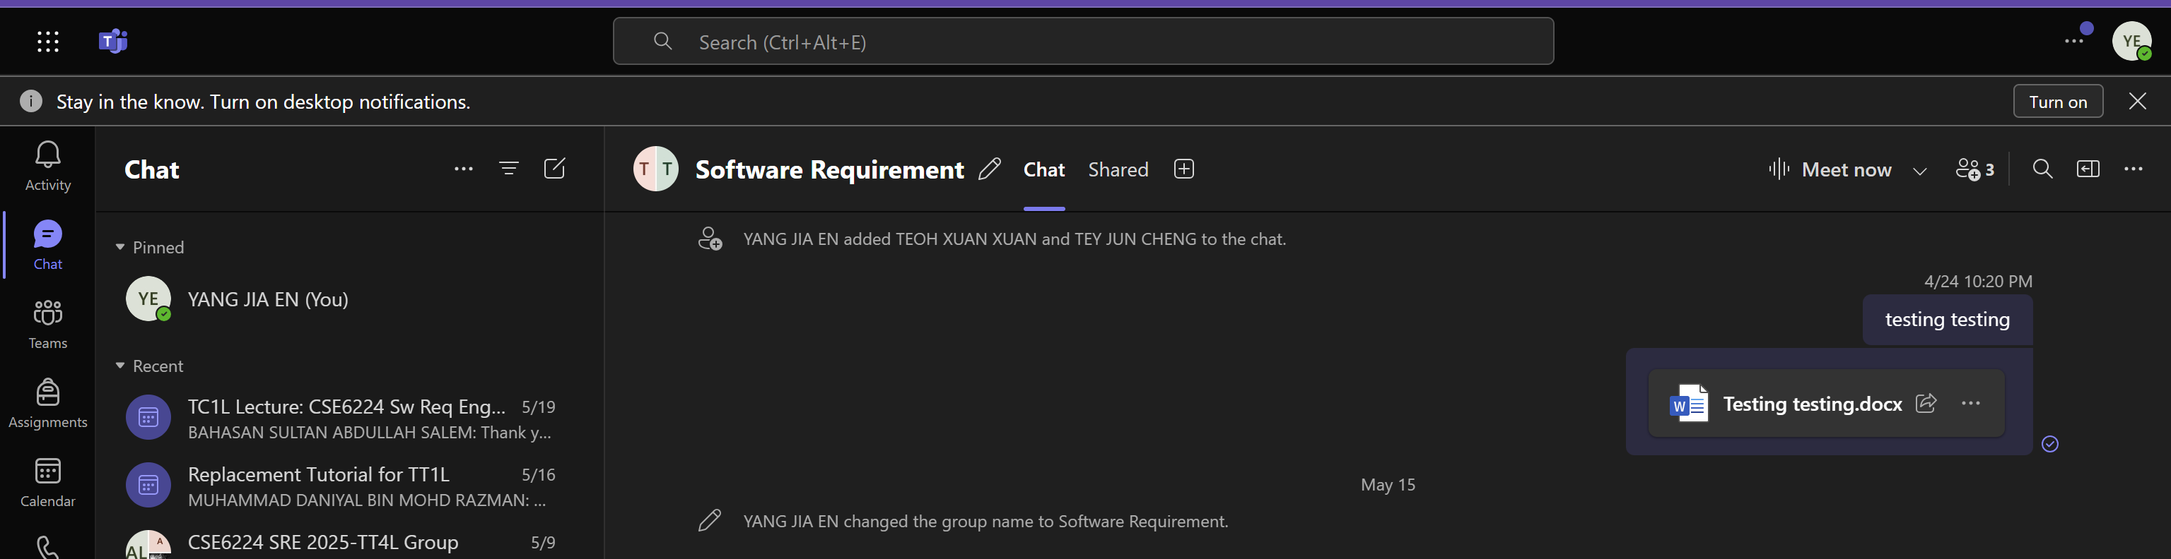

Figure 1.2.1: Proof of Communication Through Microsoft Teams

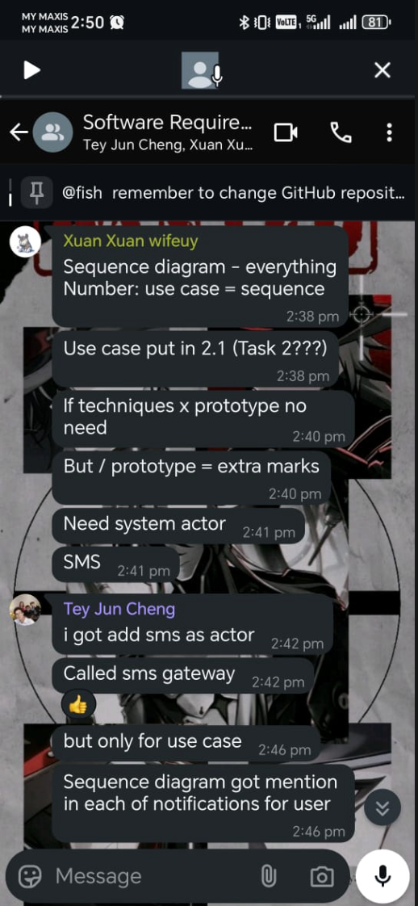

Figure 1.2.2: Proof of Communication Through WhatsApp

# 2.0 Project Overview

## 2.1 Project Vision

The vision of this project is to develop a centralized, user-friendly university communication and services portal that bridges the gap between academic, administrative, and personal communication needs. By integrating with the university’s Campus Management System (CMS) and SMS Gateway, the system aims to provide students, lecturers, administrators, and parents with transparent and timely access to vital information such as academic performance, attendance, billing, and announcements.

This portal will empower all users—especially students and parents—to stay updated through both digital dashboard access and direct mobile alerts, ultimately enhancing the overall academic experience and administrative efficiency at Multimedia University.

## 2.2 Project Scope

Included in Scope:

* Student functionalities: View grades, timetable, attendance, billing info, announcements, and book classrooms
* Lecturer functionalities: Submit grades, upload materials, schedule assessments, and send announcements
* Parent functionalities: View their child’s grades, attendance, and billing info
* Admin functionalities: Approve classroom bookings, respond to inquiries, send mass announcements

Integration with:

* Campus Management System (CMS) to fetch academic and billing records
* SMS Gateway to notify users about attendance alerts, fee reminders, and academic updates

Out of Scope:

* No in-app messaging/chat between users
* No public access; only authenticated university users can log in

## 2.3 Project Goals

* Accessibility: Allow students and parents to easily access key academic and financial information via web and SMS
* Automation: Automate alerts for critical updates like low attendance, new grade releases, and pending fees
* Efficiency: Reduce workload for admin and lecturers by centralizing announcements, booking approvals, and grade submissions
* Integration: Seamlessly connect with the university's CMS and SMS Gateway for real-time data retrieval and communication
* User-Centered Design: Ensure the portal is intuitive and accessible across devices, especially mobile

# 3.0 Initial Brainstorming Notes

## 3.1 Early Feature Ideas

In our initial discussions, we explored a range of features to enhance student experience and streamline communication across campus. These ideas include both essential system functions and potential enhancements:

Student-focused ideas:

* Personalized academic dashboard displaying GPA trends, overdue tasks, and weekly schedules
* Notification center for SMS and in-portal alerts (e.g., new grades, low attendance, payment due)
* Timetable integration with calendar export to Google Calendar or iCal
* Downloadable reports in PDF format for grades, billing, and attendance
* Virtual classroom booking with room details, photos, and capacity info
* AI-powered chatbot to answer frequently asked questions (e.g., "What is my next class?")
* Peer review or feedback feature for lecturers (internal view only)

Parent-focused ideas:

* Portal access for parents with role-based visibility of student data
* Monthly SMS summary highlighting attendance, grades, and billing
* Privacy controls allowing students to limit what data their parents can view

Lecturer and Admin tools:

* Excel-based bulk upload for student grades
* Automatic generation of grade distribution charts
* Predefined announcement templates for common notices
* Scheduling feature for future announcements
* Direct upload of learning materials and lecture videos
* Administrative dashboard showing system metrics (e.g., peak support hours, SMS delivery status)

User Experience ideas:

* Dark mode option for night viewing
* Multilingual interface (English, Bahasa Malaysia, Mandarin)
* Offline access to cached data for users with unstable internet
* Customizable dashboard layout allowing users to choose which modules are shown

## 

## 3.2 Concerns and Questions

We also identified potential concerns and open questions that may affect the design and implementation of the system:

Technical feasibility:

* Will the Campus Management System (CMS) support real-time data syncing, or will data be updated in batches?
* How can we ensure synchronization accuracy and prevent data conflicts between systems?
* Is the SMS Gateway capable of handling large-scale or scheduled message delivery reliably?

Privacy and access control:

* Should parents automatically have full visibility of a student's records, or should students control that access?
* Who has the authority to send announcements (e.g., can lecturers broadcast messages without admin approval)?
* What mechanisms will prevent unauthorized or overlapping classroom bookings?

Usability and performance:

* Will the interface be intuitive enough for non-technical users, particularly parents?
* Can the portal support accessibility features such as screen reader compatibility and adjustable font sizes?
* Will the portal be optimized to run on low-end mobile devices?

Operational logistics:

* What contingency is in place if SMS messages fail to deliver?
* Can the system track user interaction with announcements (e.g., read receipts)?
* How will planned maintenance and downtime be communicated to users?

# 4.0 **Assumptions and Constrai**nts

## 4.1 Assumptions

These are the initial assumptions we are making in order to proceed with the design and documentation of the system. These assumptions help scope our work but may need to be validated later with stakeholders.

Table 4.1.1: Assumptions Table

|  |  |
| --- | --- |
| **Assumptions** | **Details** |
| CMS Data Accessibility | The university’s Campus Management System provides a stable API or export function to retrieve data related to grades, attendance, billing, and student profiles. |
| SMS Gateway Integration | The SMS provider (used by the university) allows integration via API and supports automated, scheduled, and bulk SMS sending with delivery confirmations. |
| Authenticated User Base | All users accessing the portal (students, parents, lecturers, admins) will log in using credentials validated by the university’s existing authentication system (e.g., LDAP, SSO). |
| Device Availability | All users have access to a smartphone or PC with internet connectivity to access the portal, and parents have a mobile number that supports SMS. |
| Stakeholder Engagement | Stakeholders (e.g., lecturers, students, admin staff) are willing to participate in interviews, surveys, or usability testing to support requirement gathering and evaluation. |
| Modular System Development | The system can be developed in independent modules (e.g., grade viewing, attendance tracking) to allow parallel work by different development subteams. |
| User Roles Are Predefined | The university has clearly defined user roles and permissions (e.g., student vs. lecturer vs. admin) and this mapping will be reused in our system. |

## 4.2 Constraints

These are limitations or restrictions that may affect how the system is designed, developed, or deployed. Some of these are technical, others are organizational or regulatory.

Table 4.2.1: Constraints Table

|  |  |
| --- | --- |
| Constraints | Details |
| Data Privacy Compliance | All user data (including student performance and billing records) must be handled according to relevant data protection policies, including restrictions on parental access to sensitive information. |
| No Control Over CMS Backend | The development team has no ability to modify or directly influence the backend of the Campus Management System; integration must be non-invasive and external. |
| SMS Cost Limitation | SMS communication involves cost per message. We must implement logic to avoid spamming users and optimize batch notifications (e.g., one summary per day rather than individual alerts). |
| Limited Interface Languages | Although desirable, the system may initially support only one or two languages due to time and resource constraints. |
| Browser and Device Compatibility | The system must support legacy devices and older browsers as some users (especially parents) may use outdated hardware. |
| Limited Real-Time Functionality | Due to possible CMS sync delays or SMS queueing, some features (like attendance updates or booking confirmations) may not reflect instantly. |
| Limited Team Resources | As a university student group, we have limited time, no access to real user accounts, and must rely on sample data or mockups for testing and prototyping. |

# 5.0 Documentation and Collaboration Setup

 5.1 GitHub Repository and Shared Files

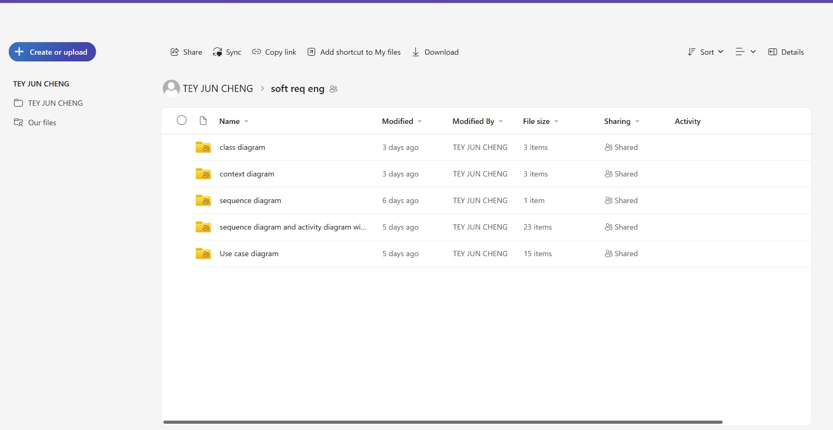

Figure 5.1.1: One Drive Share Files

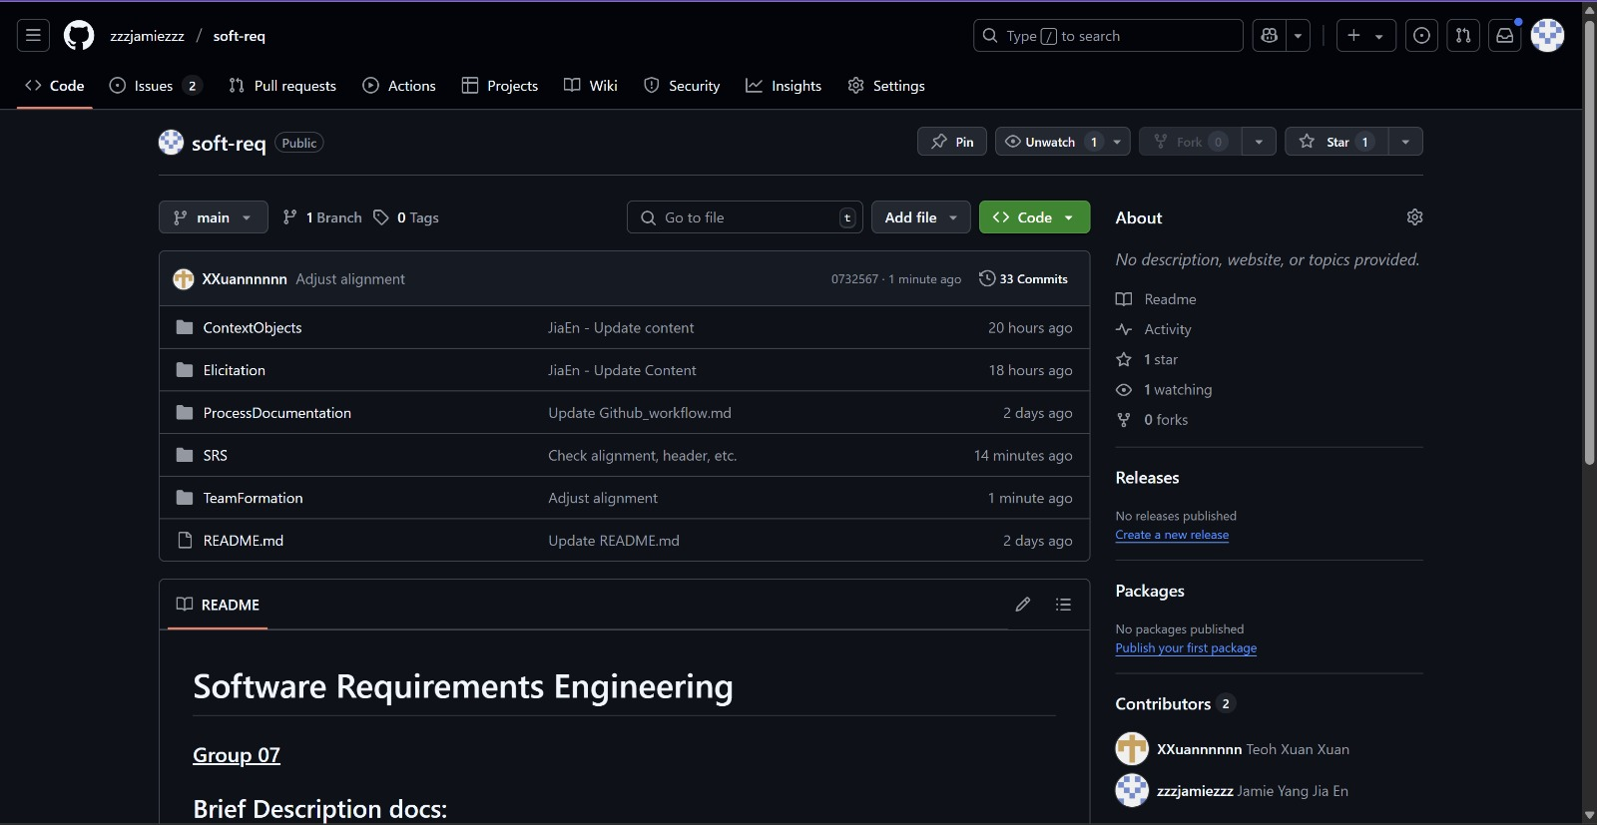

Figure 5.1.2: GitHub Repositories

# 6.0 Summary and Next Steps

## Summary

In this first phase of the project, our team successfully established the foundation for the development of the University Communication and Services Portal. We clearly defined our project vision, scope, and goals, focusing on creating a centralized system that enhances transparency, accessibility, and efficiency for all university stakeholders—including students, parents, lecturers, and administrators.

We identified key features and integration points with the existing Campus Management System and SMS Gateway, while also outlining user-specific functionalities based on initial brainstorming. Technical and organizational constraints were acknowledged to ensure realistic planning, and we adopted Microsoft Teams, WhatsApp, OneDrive, and GitHub to facilitate effective collaboration and version control.

## Next Steps

To move forward, the team will:

1. Identify Context Objects and Requirement Sources (Task 2)

Collaboratively list relevant actors, data entities, and stakeholder sources involved in the system. Clarify their roles in the requirement-gathering process.

1. Design Requirements Elicitation Plan using the Kano Model (Task 3)

Develop a plan categorizing expected system features into dissatisfiers, satisfiers, and delighters, supported by justified techniques such as interviews, questionnaires, and prototyping.

1. Conduct Elicitation Sessions (Task 4)

Execute planned techniques to gather stakeholder requirements. Record and classify these findings using the Kano model and document them with evidence (e.g., screenshots, interview notes).

1. Draft the Software Requirements Specification (Task 5)

Based on elicitation outcomes, begin documenting the system’s functional and non-functional requirements following the ISO/IEC/IEEE 29148:2018 standard, supported by diagrams and traceability tables.

1. Continue Using GitHub for Version Control

Maintain discipline in documentation updates, using GitHub to co-edit and track contributions from all group members.

By following this roadmap, we aim to produce a complete and high-quality requirements specification that meets academic expectations and lays the groundwork for a successful implementation phase.

# Change Log Table

|  |  |  |  |
| --- | --- | --- | --- |
| Version | Date | Author | Changes Made |
| v1.0 | 23 May 2025 | Teoh Xuan Xuan | Added project cover page; created version history log table |
| v1.1 | 24 May 2025 | Teoh Xuan Xuan | Update Project Title and Table of Content |
| v1.2 | 24 May 2025 | Teoh Xuan Xuan | Update format |
| v1.3 | 24 May 2025 | Yang Jia En | Added contents 1.0-6.0 |