**1. Variant**

The task is :

Square root

Description: calculate square root of the value

Input data: argument value (32-bit integer)

Output data: square root value (32-bit integer)

**2. Screenshots of obtained simulation waveforms**

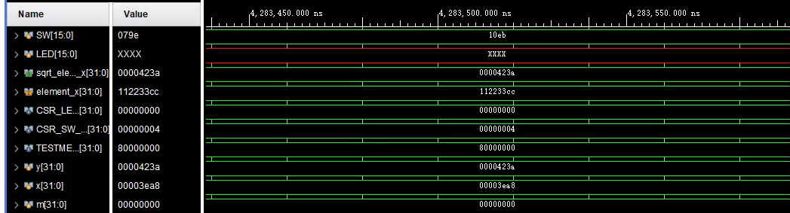

**3. Report on module characteristics:**

**i. timing:**

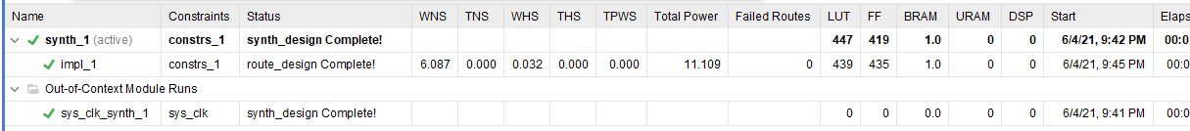

WNS:6.087ns

TNS:0.000

**ii. module’s performance:**

Clock frequency: 10 ns(100MHz) + 6ns = 16ns(62.5MHz)

Initiation Interval: 1 clock cycle; 21ns

Bandwidth: 1 op/cycle; 62.5 Mop/second

Latency: 1 clock cycle:321ns

**iii. HW resources: LUTs, FFs**



LUTs:439

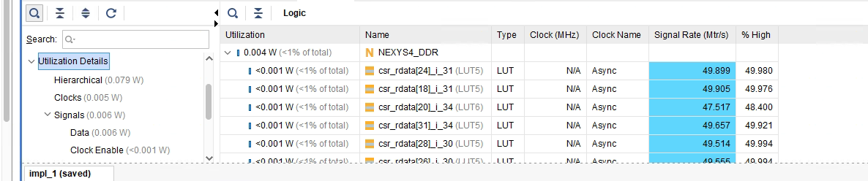

FFs: 435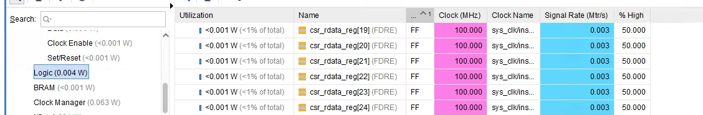

**d. Comments on achieved characteristics**

In the hardware,it’s hard to realize square root，and we need to use addition and bit operation to realize it.