**1. Variant**

The task is :

Square root

Description: calculate square root of the value

Input data: argument value (32-bit integer)

Output data: square root value (32-bit integer)

**2. Screenshots of muilticycle waveforms**

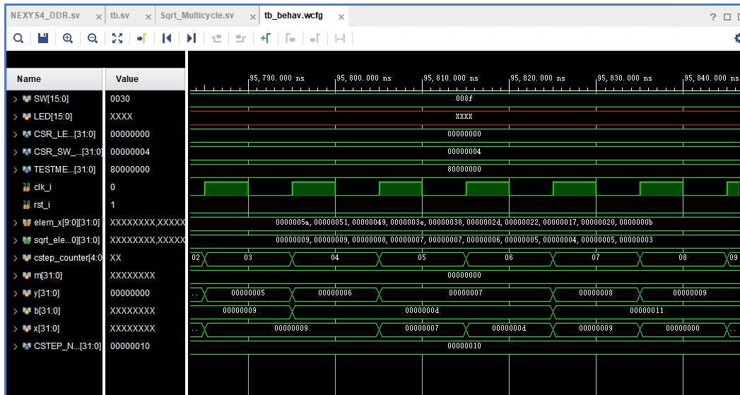

**i. timing:**

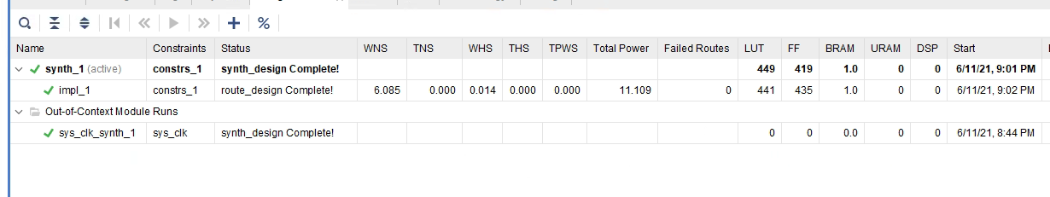

WNS:6.085 (fine compare with 6.087ns in lab1)

TNS:0.000

**ii. module’s performance:**

Clock frequency: 10 ns(100MHz) + 6.085ns = 16.085ns(62.1MHz)

Initiation Interval: 1 clock cycle; 16.085ns

Bandwidth: 1 op/cycle; 62.1 Mop/second

Latency: 1 clock cycle:16.085ns

**iii. HW resources: LUTs, FFs**

LUTs:441

FFs:435

**3. Screenshots of pipelined waveforms**

**I used the first five and the last five square root in array as 2 stage to implement pipelining.**

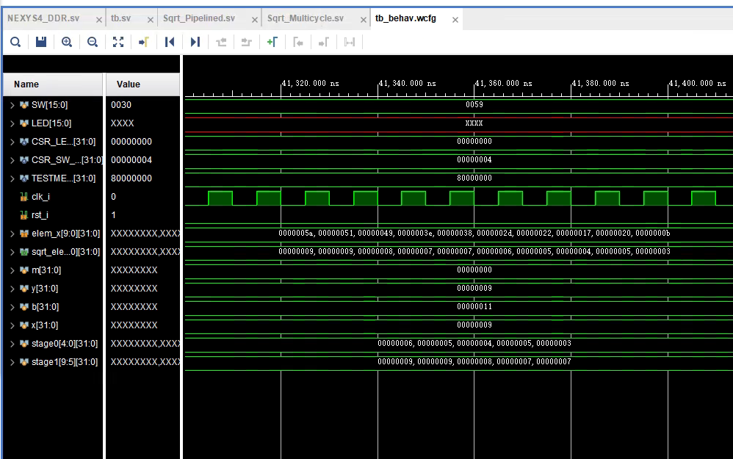

**i. timing:**

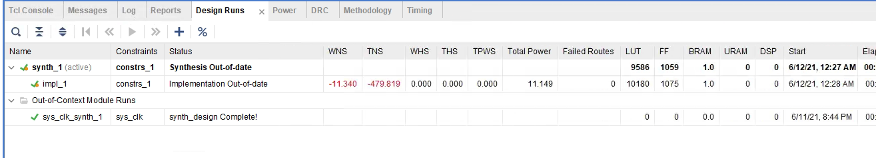

WNS:-11.340ns（fine compare with -12.187ns）

TNS:-479.819ns

and pipelined is compare with 10times sqrt root.In the file ,it is sqrt.sv

this is 10 times sqrt root WNS:-12.187ns

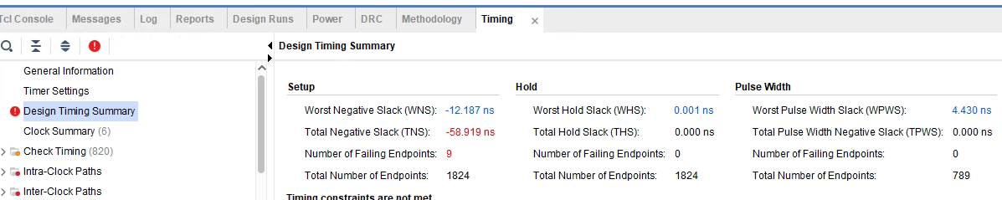

**ii. module’s performance:**

Clock frequency: 10 ns(100MHz) + 11.34ns = 21.34ns(46.86MHz)

Initiation Interval: 1 clock cycle; 21.34ns

Bandwidth: 1 op/cycle; 46.86Mop/second

Latency: 1 clock cycle:21.34ns

**iii. HW resources: LUTs, FFs**

**LUTs:10180**

**FFs:1075**