**1. Variant**

The task is :

Square root

Description: calculate square root of the value

**2.**

1-stage

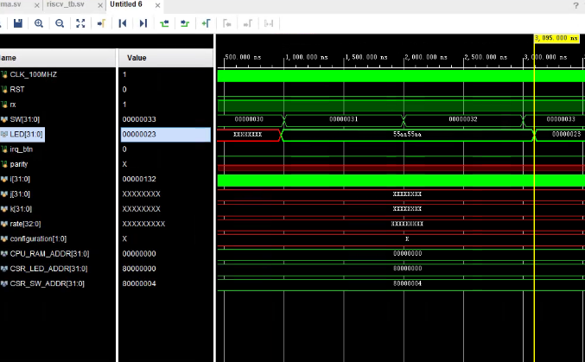

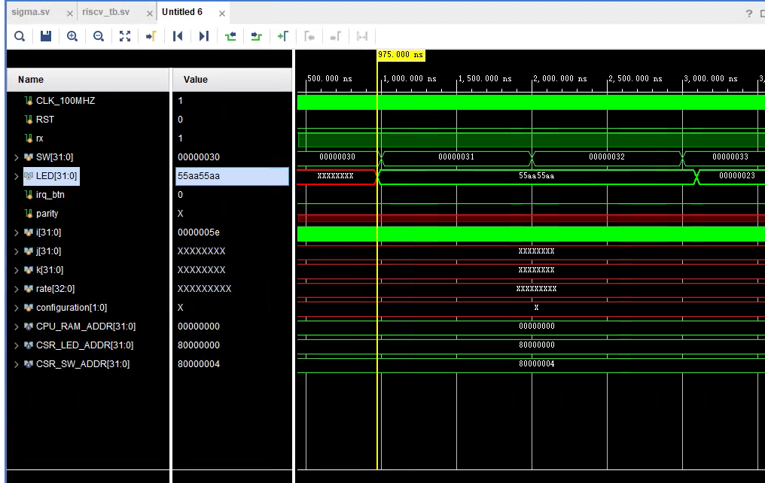

2-stage

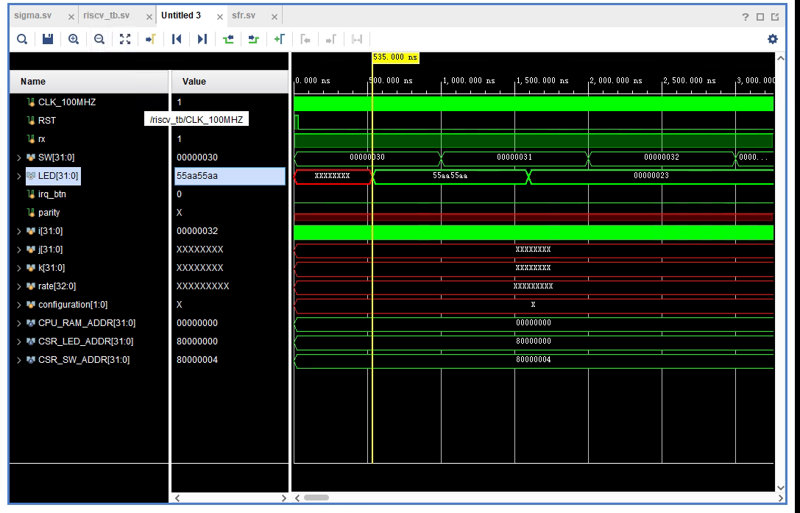

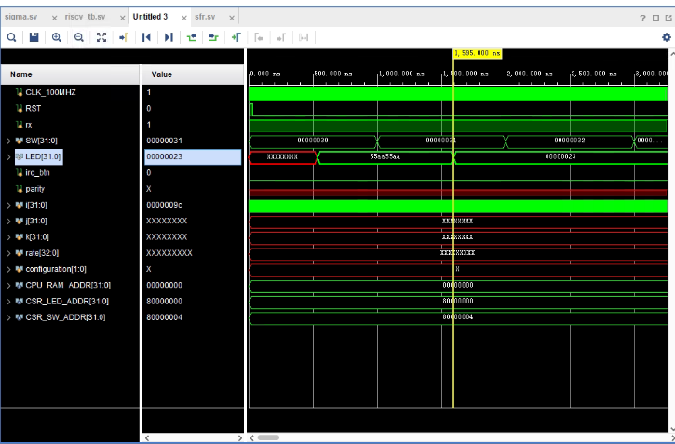

3-stage

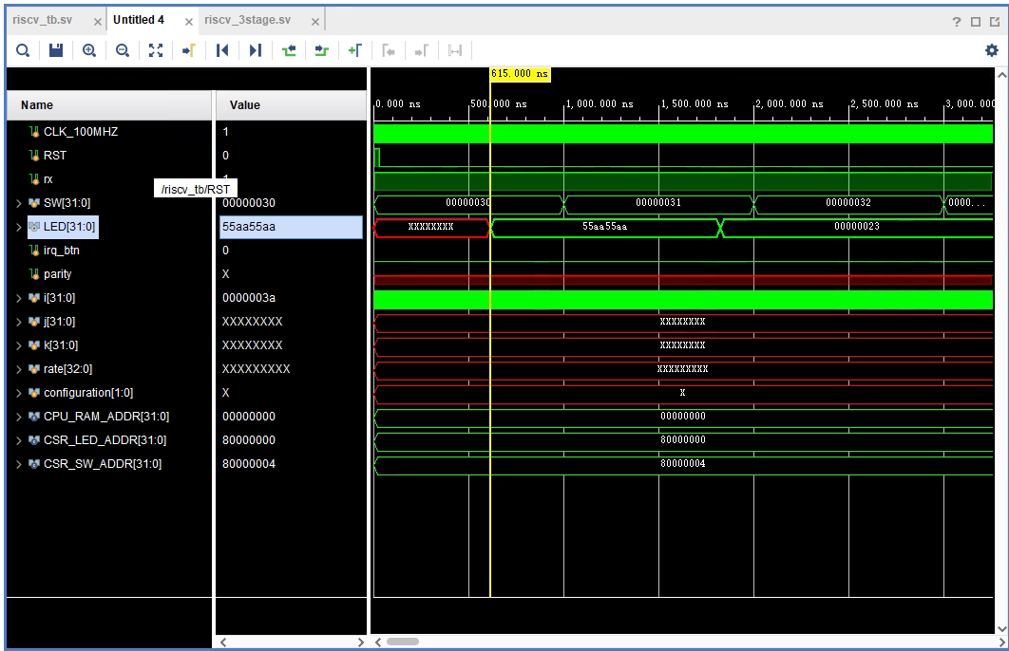

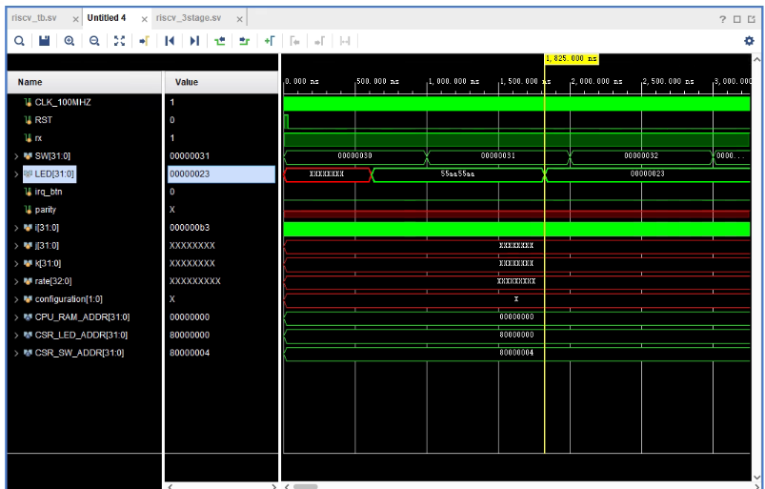

4-stage

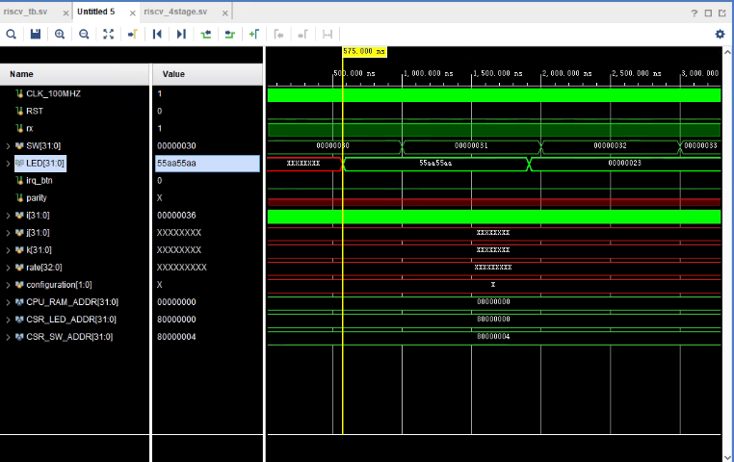

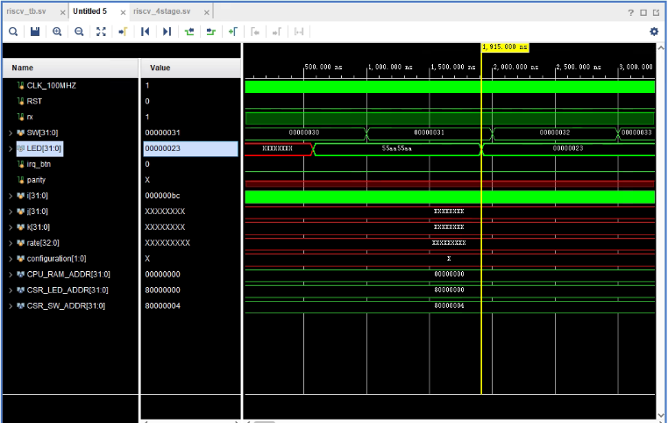

5-stage

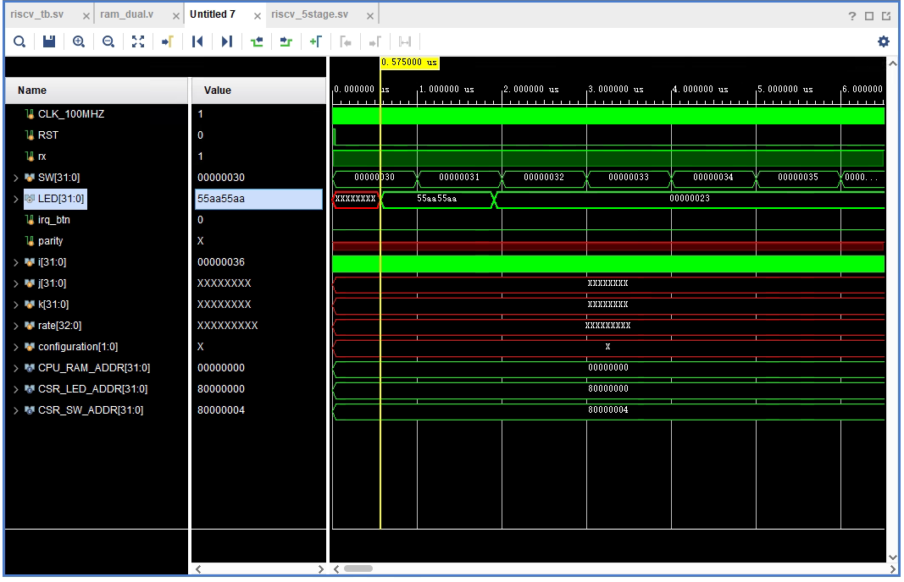

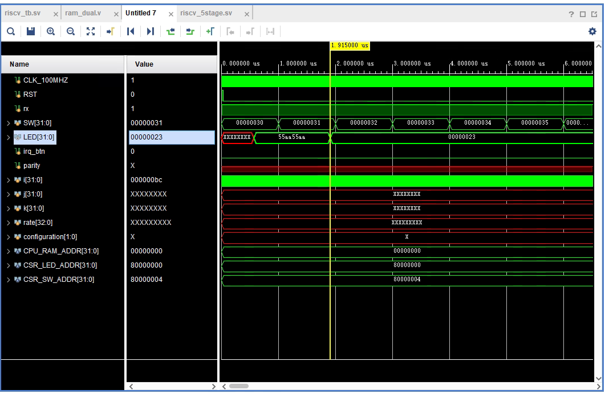

6-stage

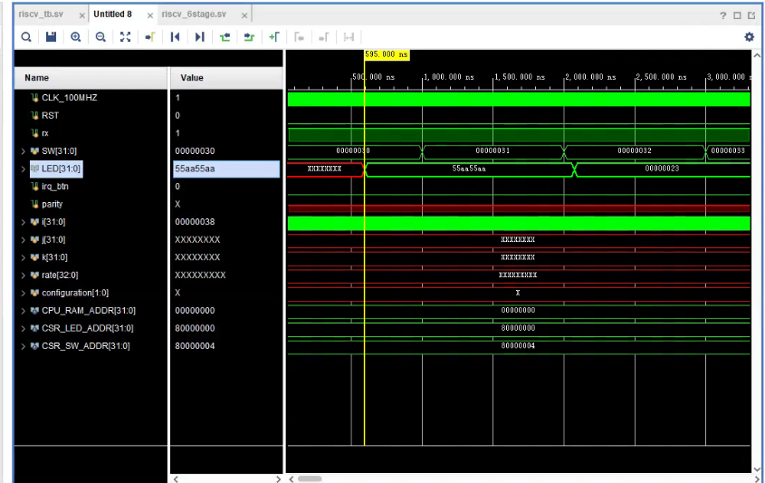

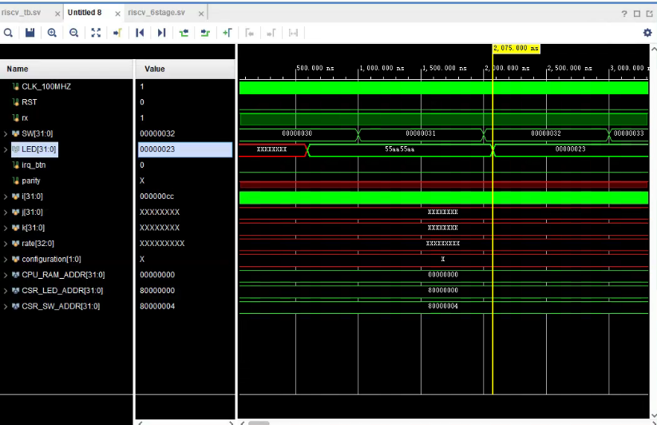

|  |  |
| --- | --- |
| eCPU configuration | Latency, clock cycles |
| 1-stage | 212 |
| 2-stage | 106 |
| 3-stage | 121 |
| 4-stage | 134 |
| 5-stage | 134 |
| 6-stage | 148 |

Table 1 Performance (in clock cycles) of target functionality implementations based on various

eCPU configurations

|  |  |  |  |
| --- | --- | --- | --- |
| eCPU configuration | Frequency, MHz | LUTs | FFs |
| 1-stage | 70 | 2910 | 1831 |
| 2-stage | 70 | 3363 | 1931 |
| 3-stage | 80 | 3211 | 2078 |
| 4-stage | 140 | 3305 | 2344 |
| 5-stage | 150 | 3501 | 2391 |
| 6-stage | 160 | 3655 | 2492 |

Table 2 Characteristics of provided sigma_tile implementations

|  |  |
| --- | --- |
| eCPU configuration | Latency, ns |
| 1-stage | 3028 |
| 2-stage | 1514 |
| 3-stage | 1512 |
| 4-stage | 957 |
| 5-stage | 893 |
| 6-stage | 925 |

Table 3 Absolute performance of target functionality implementations based on various eCPU

configurations