**1. Variant**

The task is :

Square root

Description: calculate square root of the value

**2.**

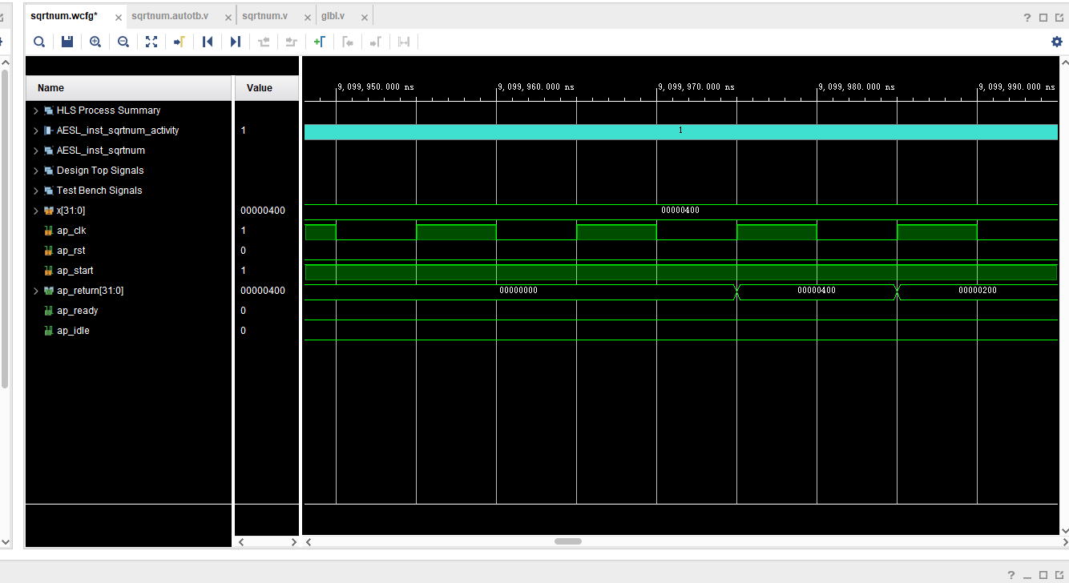

**Co-simulation waveform for synthesized HLS-based implementation**

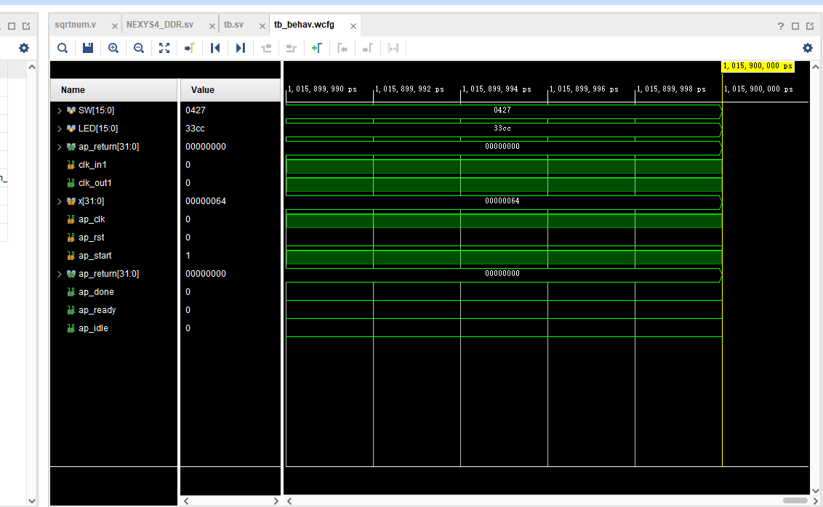

**Simulation waveform for synthesized HLS-based implementation in UDM project**



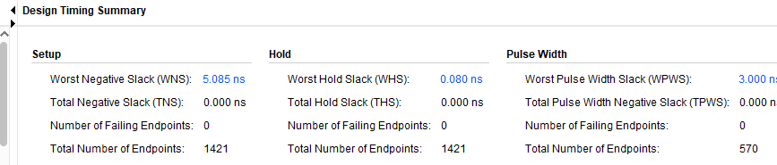

WNS:5.085ns

TNS:0.000

Clock frequency: 10 ns(100MHz) + 5ns = 15ns(66.7MHz)

Initiation Interval: 1 clock cycle; 15ns

Bandwidth: 1 op/cycle; 66.7 Mop/second

Latency: 1 clock cycle:15ns

LUTs:487

FFs:563