OpenCode Session Telemetry Sidebar
Installation and user guide

What this is
A right-hand sidebar for the OpenCode desktop app. It shows live session telemetry: context-window usage, session cost, generation speed, cache hit ratio, MCP usage, your OpenCode Go and OpenAI subscription caps (5-hour, weekly, monthly), and an estimated per-model share of each Go cap window. A Search button beside it finds text across every past session.
- Context window in percent and tokens, for the latest measured request.
- Session cost, taken from OpenCode’s own session record.
- Speed of the last completed generation, in tokens/second.
- Cache hit ratio (cached reads over all input tokens).
- MCP servers with per-server call counts in the active context.
- OpenCode Go and OpenAI caps with reset times and remaining percent.
- Estimated per-model share of each Go cap window.
- History search over user prompts and agent replies, opening hits as new tabs.

Requirements
- Windows 10 or 11.
- The OpenCode desktop app, version 2.x.
- Python 3.8 or newer, available as py on PATH (check with: py --version).

Before you start
Quit OpenCode completely: close every window and the tray icon. The installer refuses to run while OpenCode is open, and changes nothing until you confirm. Optionally, run Verify-Compatibility.cmd first: it checks whether your OpenCode build can be patched and changes nothing.

Install
- Quit OpenCode completely (all windows and the tray icon).
- Double-click Install-Sidebar.cmd and wait for the message “Installed. Original archive is backed up; launch OpenCode normally.”
- Start OpenCode and open any session.
You should see a Telemetry button at the bottom-right of the window, with a Search button beside it. The sidebar is open by default; click the button (or press Escape while it has focus) to collapse it. The first refresh can take a few seconds while the session loads.

What it looks like when it works
The panel below was captured on a real session. Compare it with what you see: the same sections, the same labels, live numbers from your own account.

Context, cost, speed, cache and MCP usage
Context shows the percentage of the model context window used by the latest measured request, with token counts underneath. Cost · session is the cost OpenCode itself reports for the whole session. Speed is the last completed generation in tokens per second (K = thousand, M = million). Cache hit ratio is cached reads over all input tokens. MCPs lists every configured server and how many calls each one served in the active context.
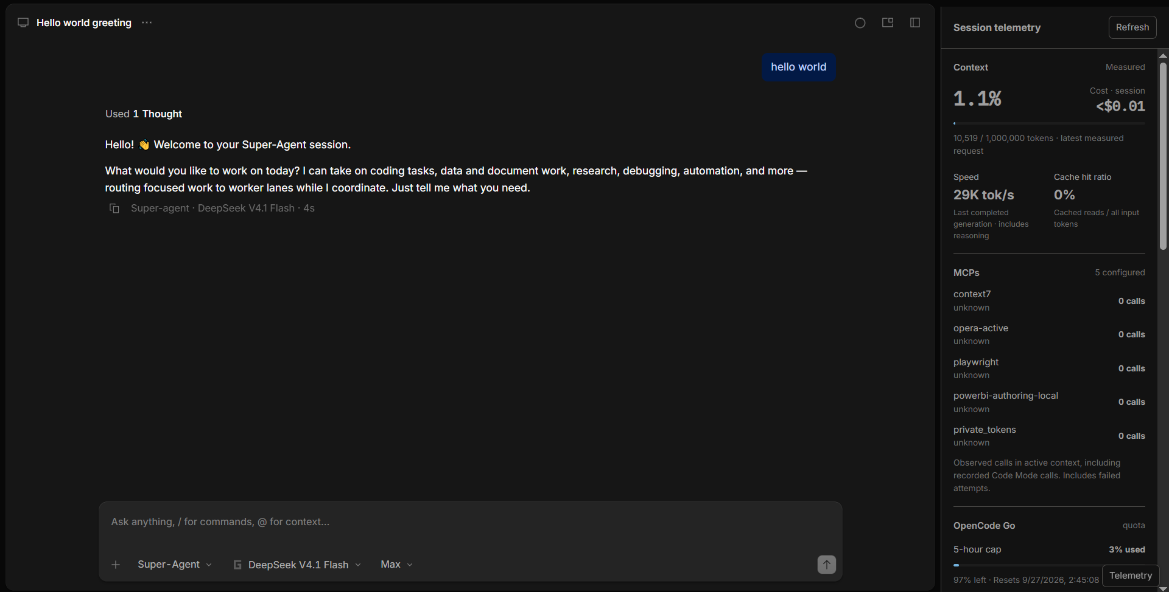
Context, cost, speed, cache and MCP usage

OpenCode Go caps with the estimated per-model split
Each cap window shows the percentage used as reported by the provider, the percentage left, and the reset time. Underneath, BY MODEL · ESTIMATED lists which models consumed the window: the provider total is distributed by each Go model’s share of locally recorded cost. Free models show 0% because they carry no billable cost. These shares are estimates, not provider data.
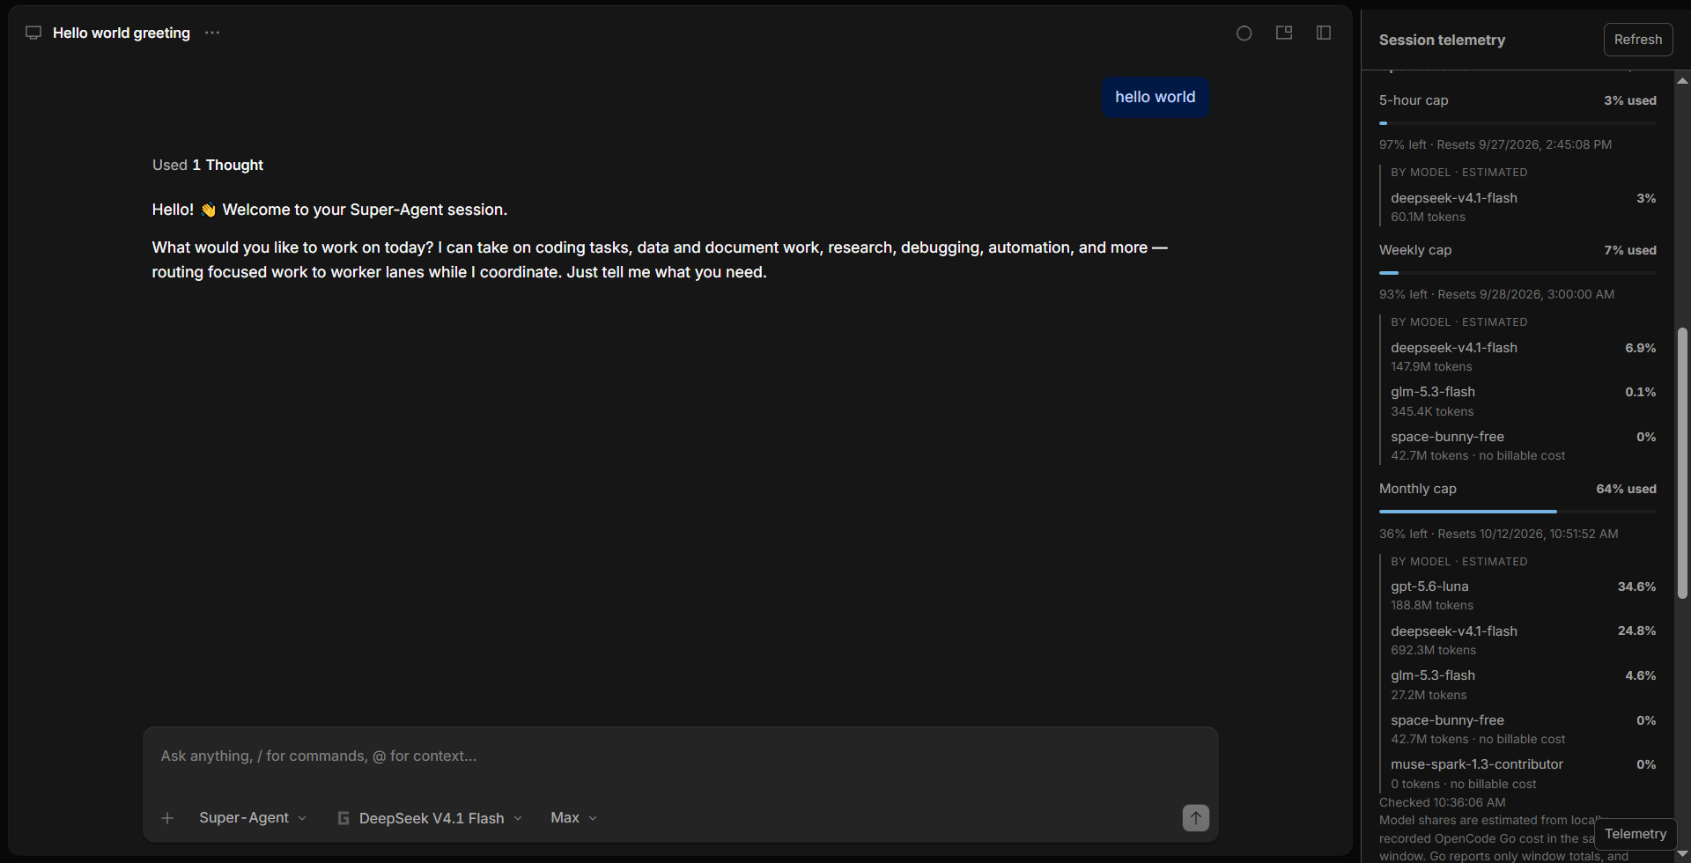
OpenCode Go caps with the estimated per-model split

OpenAI caps, model token share and diagnostics
The OpenAI section works the same way: 5-hour, weekly and monthly windows with reset times (a window the provider does not report shows Unavailable instead of a made-up number). Model token share breaks the active context down by model. The small line at the bottom reports the detected session and how many client calls the sidebar has observed - useful when asking for help.
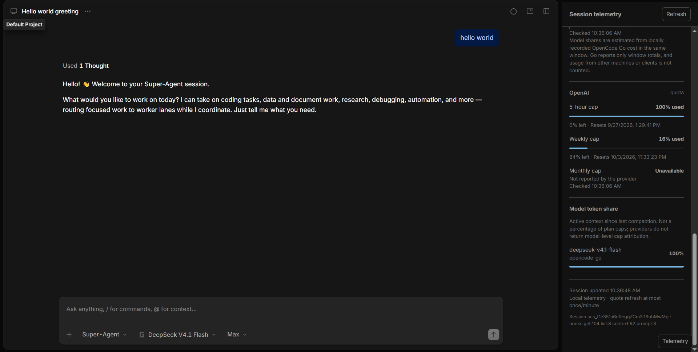
OpenAI caps, model token share and diagnostics

Search
The Search button next to Telemetry searches the text of every session stored by OpenCode — user prompts and agent replies — and opens any hit as an additional session tab, leaving your open sessions untouched.
- The User and Agent checkboxes choose which roles are searched (both on by default).
- The dropdown caps the number of results; an empty query lists the most recent messages.
- Hover a result for a wider context window; reasoning and tool calls are never searched.
- Text is escaped before rendering, the database is only ever read, and a search that finds nothing does not slow the app down: typing again cancels the previous search.

Reading the numbers honestly
- Window totals (1% used, 64% used, …) come from the provider and are exact.
- Per-model shares under the Go caps are estimates: the provider reports only a window total, so the sidebar distributes it by each model’s share of locally recorded cost. Usage from other machines is not counted.
- A cap the provider does not report shows Unavailable, never a guessed number.
- Free models show 0% because they carry no billable cost.
- A Stale label means a refresh failed and the last good reading is kept on screen.

Uninstall
- Quit OpenCode completely.
- Double-click Rollback-Sidebar.cmd.
The original app archive is restored and the telemetry plugin is moved into the backups folder rather than deleted, so nothing is lost.

If something goes wrong
- Installer says OpenCode is still running: quit it fully, including the tray icon.
- Installer says the archive changed: OpenCode was updated after staging; just run Install-Sidebar.cmd again, it re-stages automatically.
- Sidebar missing after an OpenCode update: expected; run Install-Sidebar.cmd again.
- Everything shows Unavailable: check that you are signed in, then look at the small diagnostics line at the bottom of the panel (session id and observed call counts) and include it when asking for help.

Safety notes
- The original app archive is backed up before anything is replaced.
- Your credentials never leave the OpenCode server process; the sidebar only ever receives percentages and reset times.
- Nothing is uploaded anywhere. The only network requests are to the two provider usage endpoints.

