第2章 入门

如果您想试着用一下Git的话，那么我们马上就可以开始了。本章将会带领您构建起自己的第一个项目。我们会为您演示那些用于查看版本修改、查看历史和与其他开发者交换版本的命令。

建构Git环境
首先，我们需要先安装好Git。您可以在Git的官网上找到您所需要的一切：
http://git-scm.com/download
Git是一个高可配置软件。在一开始，我们只需用config命令先将自己的用户名和e-mail地址配置好就可以了。
> git config --global user.email "hans@mustermann.de"

第一个Git项目
在这里，我们建议您最好能为接下来的Git测试单独开辟一个项目。总之应先从一个简单的小项目开始。在我们的这个小项目中，first-steps目录下面有两个文本文件。
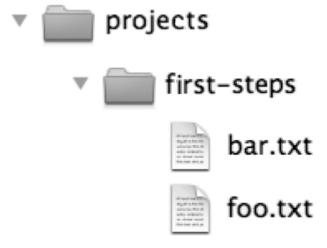
图2.1：我们的示例项目
在您开始摆弄这个玩具项目之前，最好先做一个备份！尽管在Git中，想要造成永久性地删除或碰坏也不是件容易的事情，而且每当您要做某些“危险”动作的时候，Git通常也会发出相应的警告消息。但是，有备无患总是好的。

创建一个版本库
现在，我们首先需要创建一个版本库，用于存储该项目的历史。为此，我们需要在该项目目录中使用init命令。对于一个带版本库的项目目录，我们通常称之为工作区。
> cd /projects/first-steps
> git init
Initialized empty Git repository in /projects/first-steps/.git/
init命令会在上述目录中创建一个名为.git的隐藏目录，并在其中创建了一个版本库。但请注意，该目录在Windows资源管理器或Mac Finder中可能是不可见的。
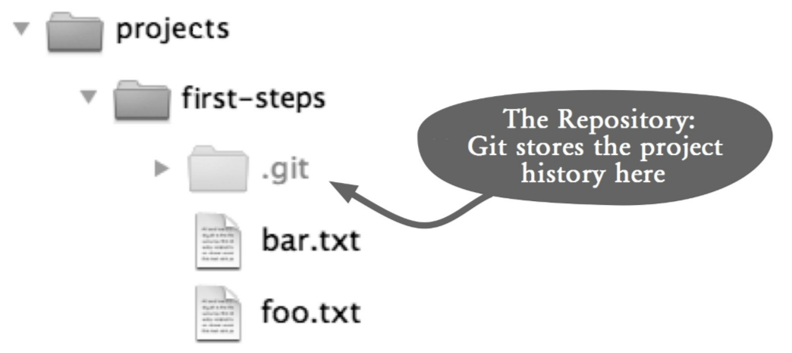
图2.2：本地版本库所在的目录
图中翻译{
The repository：git stores the project history here：版本库：Git会将项目历史存储在这里。
其余部分不用翻译
}

首次提交
接下来，我们需要将foo.txt和bar.txt这两个文件添加到版本库中去。在Git中，我们通常将一个项目版本称之为一次提交，这要分两个步骤来实现。第一步，我们要先用add命令来确定哪些文件应被包含在下次提交中。第二步，再用commit命令将修改传送到版本库中，并赋予该提交一个哈希值以便标识这次新提交。在这里，我们的哈希值为2f43cd0，但您的可能会有所不同，因为该值取决于您的文件内容。
> git add foo.txt bar.txt
> git commit --message "Sample project imported."
master (root-commit) 2f43cd0] Sample project imported.
2 files changed, 2 insertions(+), 0 deletions(-)
create mode 100644 bar.txt
create mode 100644 foo.txt

检查状态
现在，我们来修改一下foo.txt文件的内容，删除掉bar.txt文件，并添加一个名为bar.html的新文件。然后，status命令就会显示出该项目自上次提交以来所发生的所有修改。请注意，新文件bar.html在这里被标示成了未跟踪状态，这是因为我们还没有用add命令将其注册到版本库。
> git status
# On branch master
# Changed but not updated:
# (use "git add/rm <file>..." to update what will be committed)
# (use "git checkout -- <file>..." to discard changes in
# working directory)
#
# deleted: bar.txt
# modified: foo.txt
#
# Untracked files:
# (use "git add <file>..." to include in what will be committed)
#
# bar.html no changes added to commit (use "git add" and/or "git commit -a")
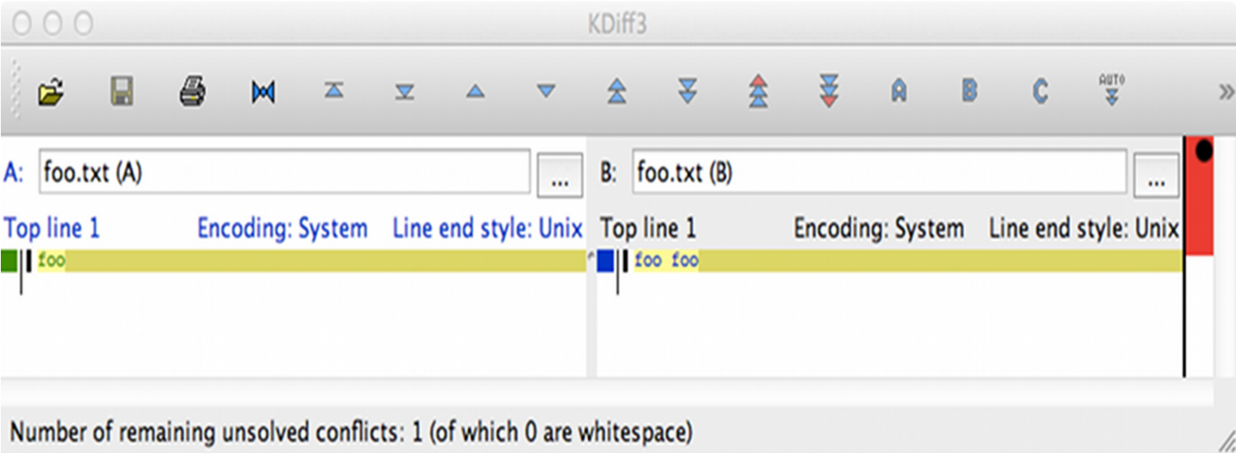
图2.3：图形工具（kdiff3）中的Diff报告
如果我们还想看到更多细节性的内容，也可以通过diff命令来显示其每个被修改的行。当然。有很多人可能会觉得diff的输出是个非常难读的东西。幸运的是，在这一领域，我们有许多工具和开发环境可用，它们可以将这一切显示得更为清晰（见图2.3）。
> git diff foo.txt
diff --git a/foo.txt b/foo.txt
index 1910281..090387f 100644
--- a/foo.txt
+++ b/foo.txt
@@ -1 +1 @@
-foo
\ No newline at end of file
+foo foo
\ No newline at end of file

提交修改
All changes must be reported to every new commit. Use the add command for modified and new files and use the rm command for deleted files.
所有更改必须报告给每一个新的提交。使用修改过的文件和新文件添加命令，并使用rm命令删除的文件。
> git add foo.txt bar.html
> git rm bar.txt
rm 'bar.txt'
Calling the status command again shows what will be included in the next commit.
调用状态命令再次显示了将被列入下一个commit.
> git status
# On branch master
# Changes to be committed:
# (use "git reset HEAD <file>..." to unstage)
#
# new file: bar.html
# deleted: bar.txt
# modified: foo.txt
#
Use the commit command to commit these changes.
使用commit命令提交这些变化。
> git commit --message "Some changes."
[master 7ac0f38] Some changes.
3 files changed, 2 insertions(+), 2 deletions(-)
create mode 100644 bar.html
delete mode 100644 bar.txt

显示历史
The log command displays the project history. All commits are shown in chronologically descending order.
日志命令显示项目的历史。所有的提交都会显示在按时间顺序降序排列。
> git log
commit 7ac0f38f575a60940ec93c98de11966d784e9e4f
Author: Rene Preissel <rp@eToSquare.de>
Date: Thu Dec 2 09:52:25 2010 +0100
Some changes.
commit 2f43cd047baadc1b52a8367b7cad2cb63bca05b7
Author: Rene Preissel <rp@eToSquare.de>
Date: Thu Dec 2 09:44:24 2010 +0100
Sample project imported.

Collaboration with Git
You now have a workspace with project files and a repository with a history of the project. In a classic centralized version system, such as CVS and Subversion, each developer has his/her own workspace, but all developers share a common repository. In Git, each developer has his/her own workspace with a separate repository, hence a full-fledged version control system that does not rely on a central server. Developers working together on a project can exchange commits in their repositories. To test this, let’s create a new workspace that simulates the activities of a second developer.
你现在有项目文件的工作区，并与该项目的历史库。在一个典型的集中式版本的系统，如CVS和Subversion，每个开发者都有他/她自己的工作空间，但所有开发人员共享一个通用存储库。在Git，每个开发者都有他/她自己的工作空间与独立的存储设备，因此，一个成熟的版本控制系统，不依赖中央服务器上。开发商在一个项目上一起工作可以在自己的仓库交换提交。为了验证这一点，让我们创建一个新的工作区，模拟第二个开发者的活动。

Cloning A Repository
The new developer needs his/her own copy (called a clone) of the repository. It contains all the information that includes the original and the entire project history. Run this clone command to make a clone.
> git clone /projects/first-steps /projects/first-steps-clone
Cloning into first-steps-clone...
done.
The project structure will look like the one in Figure 2.4.
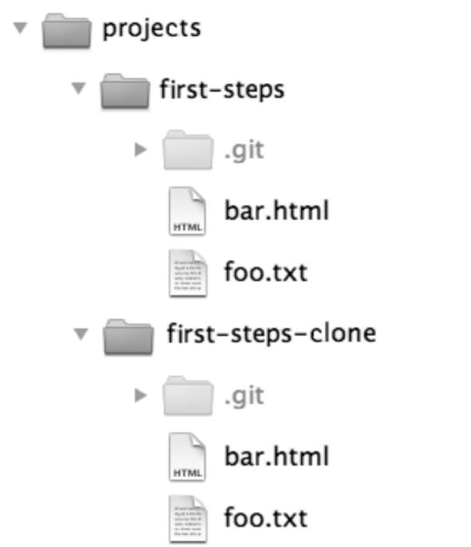
Figure 2.4: The sample project and its clone

Getting Changes from Another Repository
Modify the first-steps/foo.txt file and then do the following to create a new commit.
修改第一部曲/ foo.txt的文件，然后执行以下操作来创建一个新的提交。
> cd /projects/first-steps
> git add foo.txt
> git commit --message "A change in the original."
The new commit is now stored in the original first-steps repository, but is still missing from the clone (first-stepsclone) repository. To better understand the situation, we are showing the log for first-steps:
新提交现在存储在原来的第一部曲库，但仍从克隆（第一stepsclone）库丢失。为了更好地理解，我们显示了日志第一部曲的情况：
> git log --oneline
a662055 A change in the original.
7ac0f38 Some changes.
2f43cd0 Sample project imported.
In the next step, modify the first-steps-clone/bar.html file in the clone repository and then do the following.
在接下来的步骤，修改克隆库中的第一部曲克隆/一个bar.html文件，然后进行以下操作。
> cd /projects/first-steps-clone
> git add bar.html
> git commit --message "A change in the clone."
> git log --oneline
1fcc06a A change in the clone.
7ac0f38 Some changes.
2f43cd0 Sample project imported.
You now have a new commit in each of the two repositories. Next, we will transfer the new commit in the original repository to the clone using the pull command. When we created the clone repository, the path to the original repository was also stored in the clone, so a pull command would know where to pick up new commits.
您现在有一个新的提交分别在两个仓库中。接下来，我们将转移在原来的存储库中的新承诺使用拉命令克隆。当我们创建了克隆库，路径与版本库也存储在克隆，因此拉命令就知道在哪里可以拿起新的提交。
> cd /projects/first-steps-clone
> git pull
remote: Counting objects: 5, done.
remote: Compressing objects: 100% (2/2), done.
remote: Total 3 (delta 0), reused 0 (delta 0)
Unpacking objects: 100% (3/3), done.
From /projects/first-steps
7ac0f38..a662055 master -> origin/master
Merge made by recursive.
foo.txt | 2 +-
1 files changed, 1 insertions(+), 1 deletions(-)
The pull command has picked up the new changes from the original repository, compared them with local changes in the clone and merged both changes in the workspace and created a new commit it. This is called a merge.
拉命令回升，从原来的存储库中的新变化，比较他们在克隆的本地更改和合并两个变化，工作区和创建了一个新的提交。这就是所谓的合并。
Attention! In some cases there will be conflicts when merging. In such an event, Git cannot automatically merge the versions. In this case, you need to manually clean up the files first and then confirm the changes with a commit.
注意！在某些情况下会出现冲突，合并时。在这种情况下，GIT中不能自动合并版本。在这种情况下，你需要手动清理文件，然后再确认提交更改。
A new log command displays the result of the merge after the pull. This time we use a graphical version of the log.
注意！在某些情况下会出现冲突，合并时。在这种情况下，GIT中不能自动合并版本。在这种情况下，你需要手动清理文件，然后再确认提交更改。
> git log --graph
9e7d7b9 Merge branch ’master’ of /projects/first-steps
*
|\
| * a662055 A change in the original.
* | 1fcc06a A change in the clone.
|/
* 7ac0f38 Some changes.
* 2f43cd0 Sample project imported.
The history is no longer linear. In the graph you can see very clearly the parallel development (the two commits in the middle) and then the merge commit with which the branches were merged again (at the top).
历史不再是线性的。在上图可以很清楚地看到了并行开发（中间的两次提交），然后合并提交与该分支再次合并（在顶部）。

Picking up Changes from Any Repository
Used without a parameter, the pull command will only work in a clone repository, since a clone has a link to the original repository. When you do a pull, you can specify the path to any repository so that you can fetch changes in a development branch.
如果不使用参数，拉命令将只能在一个克隆库，因为克隆有一个链接到原始的资料库。当你做一拉，就可以指定路径的任何存储库，以便您可以获取转变发展分支。
Let’s now pull changes in the clone to the original repository.
现在，让我们拉变化克隆原来的存储库。
> cd /projects/first-steps
> git pull /projects/first-steps-clone master
remote: Counting objects: 8, done.
remote: Compressing objects: 100% (4/4), done.
remote: Total 5 (delta 0), reused 0 (delta 0)
Unpacking objects: 100% (5/5), done.
From /projects/first-steps-clone
* branch master → FETCH_HEAD
Updating a662055..9e7d7b9
Fast-forward
bar.html | 2 +-
1 files changed, 1 insertions(+), 1 deletions(-)

Creating A Repository for Sharing
In addition to the pull command that takes commits from another repository, there is also a push command that transfers commits to another repository. However, the push command should be applied only to a repository where no developer is working. The best way is to create a repository with no workspace in it. Such a repository is called a bare repository. You use the --bare option of the clone command to create a bare repository. A bare repository can be used as a focal point to which developers transfer their commits (using the push command) so that others can pull changes. Figure 2.5 shows a bare repository.
除了拉命令需提交从另一个存储库中，也有一个push命令的传输承诺另一个仓库。然而，推压命令应该只应用到存储库，其中没有显影剂正在工作。最好的方法是创建一个存储库中没有任何工作空间。这样的存储库被称为纯仓库。您可以使用克隆命令的--bare选项创建一个纯仓库。纯仓库可以用作着力点，其中开发人员转让其提交（使用push命令），以便其他人可以拉的变化。图2.5显示了一个纯仓库。
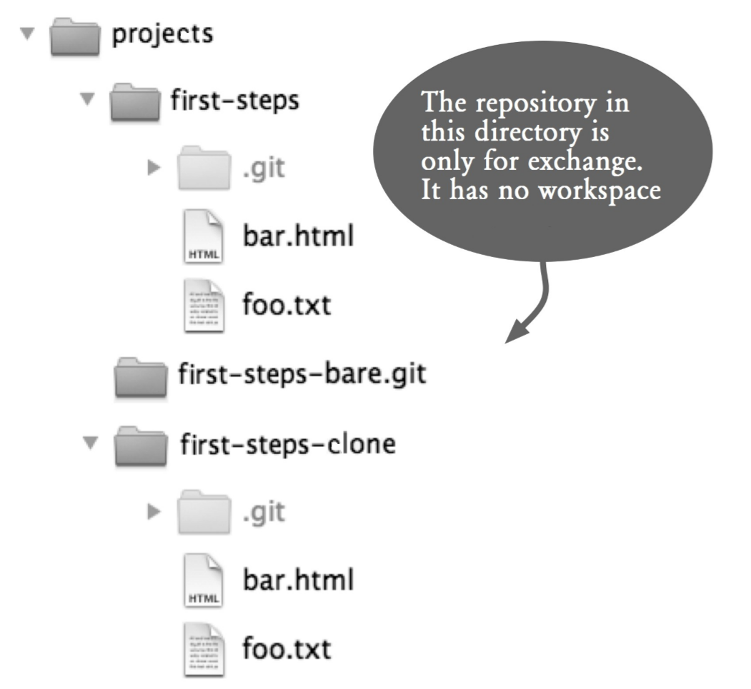
Figure 2.5: A bare repository, a repository with no workspace
> git clone --bare /projects/first-steps
/projects/first-steps-bare.git
Cloning into bare repository first-steps-bare.git... done.

Uploading Changes with push
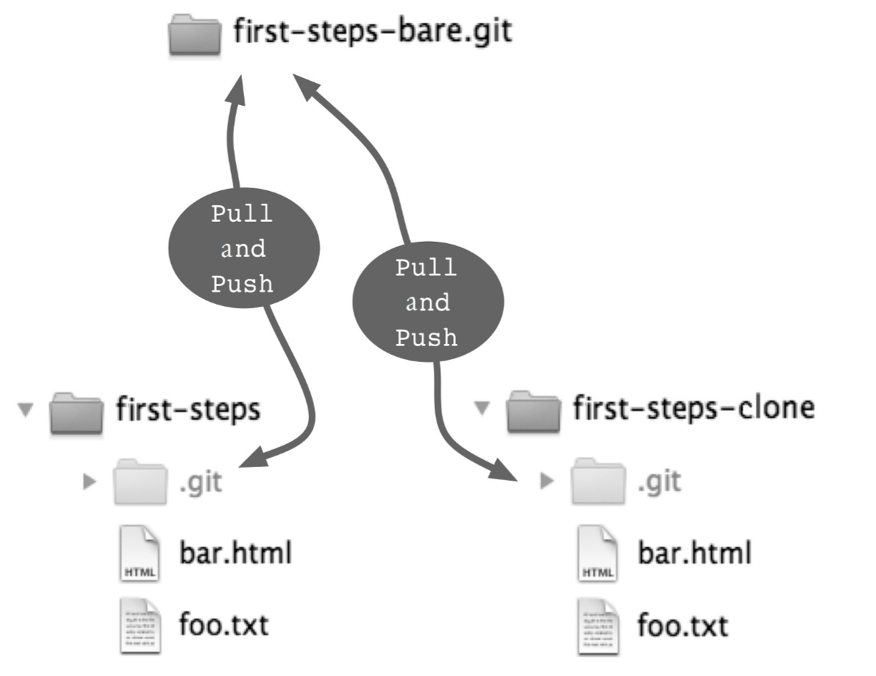
Figure 2.6: Sharing through a shared repository
To demonstrate the push command, change the firststeps/foo.txt file again and do the following to create a new commit.
为了证明推命令，再次更改的firststeps/ foo.txt的文件，然后执行以下操作来创建一个新的提交。
> cd /projects/first-steps
> git add foo.txt
> git commit --message "More changes in the original."
Then transfer this commit using the push command to the shared repository (See Figure 2.6). This command expects the same parameters as the pull command, the path to the repository and the branch to use.
然后传送使用push命令，以共享资源库这个承诺（见图2.6）。该指令要求将相同的参数拉命令，使用仓库路径和分支。
> git push /projects/first-steps-bare.git master
Counting objects: 5, done.
Delta compression using up to 2 threads.
Compressing objects: 100% (2/2), done.
Writing objects: 100% (3/3), 293 bytes, done.
Total 3 (delta 0), reused 0 (delta 0)
Unpacking objects: 100% (3/3), done.
To /projects/first-steps-bare.git/
9e7d7b9..7e7e589 master -> master

Pull: Picking up Changes
To bring the changes to the clone repository, you use the pull command with the path to the shared repository.
为了使更改克隆库，你用拉命令和路径共享资源库。
> cd /projects/first-steps-clone
> git pull /projects/first-steps-bare.git master
remote: Counting objects: 5, done.
remote: Compressing objects: 100% (2/2), done.
remote: Total 3 (delta 0), reused 0 (delta 0)
Unpacking objects: 100% (3/3), done.
From ../first-steps-bare
* branch master -> FETCH_HEAD
Updating 9e7d7b9..7e7e589
Fast-forward
foo.txt | 2 +-
1 files changed, 1 insertions(+), 1 deletions(-)
Attention! If another developer has done a push before us, the push command will reject the transfer. Then, the new updates by the other developer must first be picked up with a pull and merged locally
注意！如果另一个开发者已经摆在我们面前做一推，推命令将拒绝移交。然后，将新的更新的其他开发人员必须首先被拾起带有上拉，并在本地合并。

Summary
- Workspace and repository: A workspace is a directory that contains a repository in a .git subdirectory. You use the init command to create a repository in the current directory.
工作空间和资源库：工作区是包含在一个git的子目录中的存储库的目录。您可以使用init命令创建在当前目录的仓库。
- Commit: A commit defines one version for all the files in the repository and describes when, where and by whom the version was created. Use the add command to determine which files to be included in the next commit and then use the commit command to create a new commit.
提交：一个提交定义了一个版本，在库中的所有文件，并描述了何时，何地由何人版本中创建。使用add命令来确定哪些文件被纳入下一次提交，然后使用commit命令来创建一个新的提交。
- Getting information: The status command shows which files have been modified locally and what changes will be incorporated into the next commit. The log command shows the commit history. The diff command can be used to show the differences between two versions of a file.
获取信息：status命令显示哪些文件已被本地修改和什么样的变化将被纳入下一个承诺。日志命令显示提交历史。 diff命令可以用来显示两个版本的文件之间的差异。
- Clone: The clone command creates a copy of a repository called a clone. In general, every developer has a full clone of the project repository with the entire project history in his/her workspace. With this clone, he/she can work independently without connecting to a server.
- Push and pull: push and pull are commands for sharing commits between local and remote repositories.
- 克隆：克隆命令创建一个存储库的副本称为克隆。在一般情况下，每个开发者都在他/她的工作区，整个项目历史的项目库的完整克隆。与此克隆，他/她可以独立工作，而无需连接到一个服务器。
- 推拉：推拉的命令在本地和远程存储库之间共享提交。

译者注：示例中似乎少了用户名的部分：git config --global user.name ”Hans”

