第8章 重置一份整洁的历史

Many branches in a commit history are unclear. Git makes it possible to straighten out the history. The most important tool for this is the rebase command, which can move the impact of a commit to another place in the commit graph.
在提交历史许多分支都不清楚。 Git的能够理顺历史。这样做的最重要的工具是底垫的命令，其可以在提交图的提交冲击移动到另一个地方。
You can do this,
你可以这样做，
- if you accidentally performed a commit on the wrong branch. It could be a bug fix that you have diverted to the line of development (master).
- when multiple developers work hard on the same software and integrate their changes frequently. Without rebasing they would create a history of many small branches and junctions (called a diamond necklace). With the rebase command you can instead create a smooth linear history.
- 如果你不小心进行了提交了错误的分支。这可能是因为你已经转移到发展（主）线一个bug修复。
- 当多个开发人员在同一软件努力工作，频繁地集成其变动。如果没有衍合他们会创造出许多小分支和路口的历史（称为钻石项链）。有了rebase命令可以改为创建一个平滑线性的历史。

The Principle: Copying of Commits 原则：承诺的复制
The rebasing principle is simple: Git takes a sequence of commits that you want to move, and play it again on the target branch in exactly the same order. This produces for each of the original commits a true copy of the same changeset, the same author, date and comments.
重订基期原理很简单：Git的需要，你要移动，并在完全相同的顺序再次发挥它在目标分支提交的序列。这将产生每个原犯同样的变更，同一作者，日期和评论的真实副本。
Note: At first glance it looks like Git would move commits when rebasing. In fact, the “shifted” commits are always new commits with different commit hashes. This is important if more branches have already been diverted from the original commits.
注：乍一看，它看起来像的Git时重订基会动议提交。事实上，在“转变”提交总是伴随着不同的提交哈希新的提交。如果有更多的分支已经从原始提交转，这是很重要的。
Note: As the new commits are recorded at different points in the commit graph, naturally there can be conflicts because the changes do not fit there. Such changes must then be resolved as merge conflicts manually.
注：由于新提交在提交图形的不同点记录下来，当然可以有冲突，因为变化不适合那里。那么这些变化必须解决的手动合并冲突。

Avoiding the “Diamond Chain” 避免了“钻石链”
When several developers working on the same software incorporate changes frequently, a commit history that looks like a diamond chain will be created. With rebasing, you can create a linear history with equivalent content.
当几个开发人员在同一软件的工作经常和修改，提交历史看起来像一个钻石链将被创建。随着重订基期，您可以创建具有同等含量的线性历史。
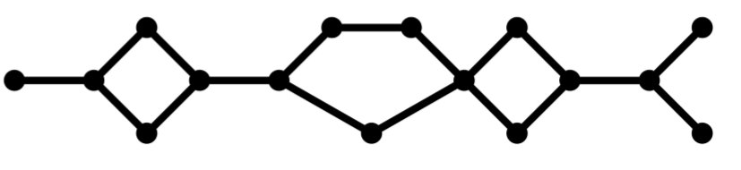
Figure 8.1: Diamond necklace
The example in Figure 8.2 shows how rebasing works. A branch called feature-a was diverted from the master branch and has two commits, C and D. At the same time, master has been further developed and has one more commit, B.
图8.2示例显示了如何重订基期的作品。一个分支叫功能一个是从主分支转移并有两次提交，C和D，同时，船长已得到进一步发展，并多了一个承诺，B。
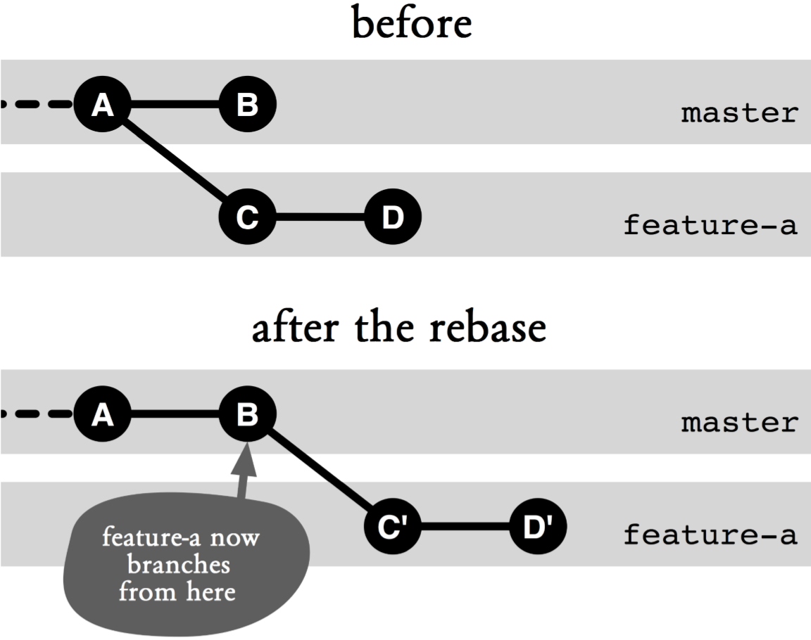
Figure 8.2: Simple rebasing
Now you can merge the changes with git merge master and smooth out the history again using the rebase command. This command takes a parameter: the branch whose latest changes will be brought into the active branch.
现在，您可以合并使用Git合并主的变化和理顺历史再次使用变基命令。这个命令需要一个参数：其最新的变化将被带入活跃的分支的分支。
> # Branch "feature-a" is active
> git rebase master
Upon receiving this command, Git will rebase the active branch (feature-a) onto master by doing the following.
在收到这个命令，Git会通过执行以下操作底垫主动分支（功能一）到主。
- Which commits? Git determines which commits in the active branch feature-a are not yet in the target branch (master). In our example, C and D.
- Where? Git determines the target commit, the commit in master on which feature-a will be rebased to. In the example, B.
- Copying the commits: Based on the target commit all changes in the commits to be rebased are replayed, creating commits C' and D'.
- Resetting the active branch to the copy: The active branch is moved to the top of the copied commit. In the example, D'.
- 哪些承诺？ Git的决定在活动的分支功能一个单位犯尚未在目标分支（主）。在我们的例子中，C和D.
- 在哪里？ Git的确定目标承诺，在掌握了哪种功能，一个将被变基到提交。在这个例子中，B。
- 复制承诺：根据目标提交在提交的所有更改将变基重播上，创建提交C'和D'。
- 重置活性分支到复制：将活性分支被移动到的复制的提交的顶部。在这个例子中，D'。
In many cases, you should not call the rebase command directly. Instead, you should use the --rebase option with the pull command to rebase the changes in the remote repository.
在很多情况下，你不应该直接调用变基命令。相反，你应该使用--rebase选项与拉命令变基在远程存储库中的变化。
Note: The old commits C and D are incidentally still in the repository, even though they are no longer directly visible because the branch feature-a is now pointing to D'. However, C and D can still be accessed using their hashes, respectively. Only after a garbage collection with the gc command will they disappear from the repository.
注：老款C和D是顺带还在存储库中，即使它们不再是直接可见的，因为该分支的特征，一个是现在指向D'。然而，C和D仍然可以使用他们的哈希值分别访问。只有垃圾收集与GC的命令后，他们会从资源库中消失。

And When It Comes to Conflicts? 当它涉及到冲突？
Just like the merge command, the rebase command may also terminate with conflicts when changes do not match. There is one important difference, however: When merging you get results in a single commit which are the combination of changes from both branches. When rebasing, however, several commits are generated step by step again. If everything goes smoothly, the contents of the last commit will be the same as that of the result of the merge command, because Git uses the same algorithms to resolve conflicts for both commands. But if the rebase command encounters a conflict, the process will be interrupted, with files decorated with conflict markers. You can clean up the files manually or with a merge tool, then add them to the staging area. From there you can use the rebase command with the --continue option to proceed.
就像合并命令，底垫命令也可以与冲突时终止变化不匹配。有一个重要的区别，但是：当合并您得到的结果在一个单一的提交而从两个分支的变化相结合。衍合然而，当多次提交再次产生一步一步来。如果一切顺利的话，最后的内容提交将相同的合并命令的结果，因为Git使用相同的算法来解决这两个命令的冲突。但是，如果在rebase命令遇到冲突时，进程将被打断，与饰有冲突标记的文件。您可以手动或使用合并工具清理文件，然后将它们添加到临时区域。从那里，你可以使用底垫命令和选项--continue继续。
> git add foo.txt
> git add bar.txt
> git rebase --continue
You can also cancel the rebase command using the --abort option. You can skip the conflicted commit using the --skip option. It will then simply be omitted, i.e. their changes will not appear on the new branch.
您也可以使用--abort选项取消重订命令。您可以跳过使用--skip选项冲突提交。然后它会简单地被省略，鼻内他们的更改将不会出现在新的分支。
Warning! Unlike in a merge, in an interrupted rebasing parts of the copied commits may have been applied.
警告！不像在合并，在复制的提交的中断的垫底部分可能已被应用。

Transplanting A Branch 移栽分公司
Sometimes you already created a branch and its first commit. With the --onto option you can transplant a branch to another location in the commit graph.
有时候，你已经创建了一个分支，它的第一承诺。随着--onto选项，您可以移植一个分支在提交图中的另一个位置。
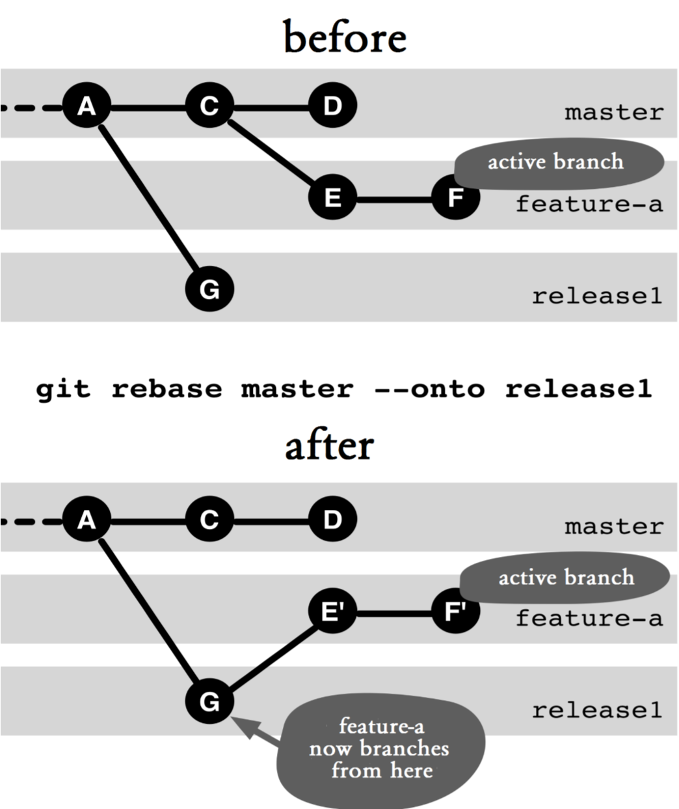
Figure 8.3: Moving a branch
In the example in Figure 8.3, the feature-a branch is transplanted to release1.
在图8.3的例子中，功能的分支移植到release1。
> # Branch "feature-a" is active
> git rebase master --onto release1
The first parameter to the rebase command specifies the original branch (in this case, master). Git then determines all commits in the active branch (feature-a) that are not in the original branch (in this example, E and F). These commits will then be copied to the location indicated by the --onto option (in this case, release1).
至底垫命令所述第一参数指定原始分支（在此情况下，主站）。 GIT中然后确定在现用支路（特征-a）的不属于原始分支所有提交（在这个例子中，E和F）。然后这些提交将被复制到由--onto选项（在这种情况下，release1）指示的位置。
Step by Step: Moving a branch 移动分支
A branch has to be moved to another location in the commit graph.
分支已被移动到提交图形的另一个位置。
1. If necessary, change to the branch to be moved如果有必要，切换到分支移动
> git checkout the-branch
2. Determine the origin确定原点
There is the origin branch, from which the branch to be moved has diverted. Git will move all commits that are not in the origin branch.
还有就是产地的分支，从中移动的分公司已挪作他用。 Git会移动不在原点分支的所有提交。
3. Check to see what are being moved请检查正在移动什么
It is advisable to check in advance which commits will be affected, because a wrong rebasing can lead to a very confusing situation in the repository.
明智的做法是提前单位犯将受到检查，因为一个错误的重订基期可能会导致在资源库中一个非常混乱的局面。
> git log origin..the-branch
4. Determine the target point确定目标点
Choose a branch target on which the shifted branch should be rebased to.
选择所移动的分支机构应重订到分支目标。
5. Perform the rebasing执行重订基期
> git rebase origin --onto target
Note: The origin for the rebase command does not have to be a branch. It can also be any commit.
注意：用于底垫命令的起源不必是一个分支。它也可以是任何提交。

What Happens to the Original Commits after Rebasing?
Commits will be copied during rebasing. The originals (in this example, C and D) can still be accessed using their hashes. Normally, when no further branches are diverted from these commits, the next garbage collection (using the gc command) will simply remove them from the repository.
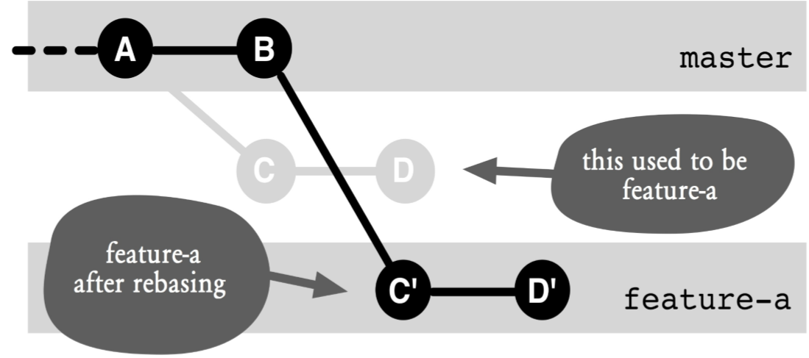
Figure 8.4: The old and new branches after rebasing

Why Is It Problematic to Have the Original and Copy Commits in the Same Repository? 为什么它有问题有原件及复印件犯同一个版本库？
Duplicates make the repository confusing. They can easily cause misunderstandings as to which branches a given code change is included in and which branches it is not included in. Normally, git log HEAD..a-branch shows which commits in a-branch are not yet in the current branch. If there are duplicates, the current branch may already contain the code change. This will complicate reviews and quality assurance.
重复使库混乱。他们可以很容易引起误解，以该分支给定的代码变化被包括在与该分支它不包括在。通常，GIT中登录HEAD..a分支显示哪些犯一个分支尚未在当前分支。如果有重复的，当前的分支可能已经包含的代码更改。这将审查和质量保证复杂化。
In addition, there may be difficulties later when the branch with the duplicate commit is merged with the branch with the original commit. In the best case, Git recognizes that the same change occurred more than once, and apply them only once. In the worst case, if the duplicate commit was modified to resolve a conflict, Git does not detect this and then tried to apply the changes several times. This results in unexpected conflicts for the user.
此外，还有可能晚时具有重复的分支提交合并与分支与原始提交的困难。在最好的情况下，Git会认识到，同样的变化发生了不止一次，并且仅一次。在最坏的情况下，如果重复的提交被修改来解决冲突，GIT中没有检测到这一点，并然后试图多次应用更改。这导致对于用户意外冲突。
Once you have transferred a commit to a remote repository, you should not move the commit with the rebase command. Otherwise, other developers could continue to work with the originals and problems will occur when it is time to merge the changes again.
一旦你已经转移提交到远程仓库，你应该不动的变基命令提交。否则，其他开发商可能会继续与原件和问题，在工作的时候，是时候再合并的变动将发生。

Cherry-Picking 捡取
There is another way to copy a commit, namely by using the cherry-pick command. You specify which commit you want to have, and Git will create a new commit with the same changeset and metadata in the current branch.
还有另一种方式来复制一个承诺，即通过使用摘樱桃命令。您指定提交你想有，和Git将创建在当前分支相同的变更和元数据的新的承诺。
> git cherry-pick 23ec70f6b0
Here are the things you should know about cherry-picking:
下面是你应该知道挑肥拣瘦的事情：
- cherry-pick does not take the history into account. merge and rebase can still classify renamed and moved files correctly. cherry-pick cannot.
- Cherry-picking is sometimes used to transfer small bug fixes to various release versions.
- Another application is to transfer useful changes from a feature branch that you want to remove.
- Warning: Cherry-picking can lead to the problems with duplicate commits above.
- 摘樱桃不走历史的考虑。合并，变基仍然可以进行正确分类重命名并移动的文件。摘樱桃不能。
- 樱桃采摘有时用于小bug修复转移到不同的发行版本。
- 另一个应用是从传输特性分支要删除有用的变化。
- 警告：樱桃采摘可能导致问题重复上述承诺。

Summary 本章小结
- Rebasing: Git can copy commits to other places in the commit graph. The changes and metadata (author, date) remain the same, but there will be a new commit hash. You can use the rebase command to rebuild the commit graph in many ways.
- Just before the push: Normally you should use the rebase command only on commits that have not been transferred to other repositories. Otherwise, it could later lead to nasty merge conflicts.
- Smoothing out the history: If you resolve conflicts during parallel development with the merge command, you will get a history with many branches and merges. If you use rebase instead of merge, you will get a linear history.
- Conflicts during rebasing: Git plays the copied commits piece by piece again. If there is a conflict because the changes do not fit the workspace, the process will be interrupted. As with merge, the developer can resolve the conflict manually and continue the rebasing.
- rebase --onto: With this option, you can move a branch to a completely different location in the commit graph.
- 衍合：Git的可复制的提交到其他地方在提交图形。这些变化和元数据（作者，日期）保持不变，但会有一个新的提交哈希值。您可以使用变基命令重建在许多方面提交图形。
- 就前推：通常情况下，你应该只对那些没有被转移到其他存储库提交使用变基命令。否则，以后可以导致讨厌的合并冲突。
- 理顺历史：如果您解决与合并命令并行开发过程中出现冲突，你会得到一个历史有许多分支和合并。如果您使用衍合，而不是合并，你会得到一个线性的历史。
- 在重订冲突：混帐再次扮演一块复制的一块提交。如果有冲突，因为变化不适合工作区，该过程将被中断。与合并，开发人员可以手动解决冲突，并继续重订基期。
- 变基--onto：使用该选项，可以在提交图的分支移动到一个完全不同的位置。

