第16章 基于特性分支的开发

如果团队中的每个人都在相同的分支上做开发，我们会得到一个非常混乱的、带有很多合并提交的父级有限历史。这样一来，我们就很难就某个特指定的性修改或错误修复进行具体定位。但尤其在代码审核和错误排查这样的工作中，确切知道某个特性在哪几行代码中是非常有用的。通过使用特性分支，我们可以利用Git提供这些开发信息。
在做特性开发的过程中，增量提交的方式有助于我们在同一时间段内维护旧有功能的版本。但是，如果我们是希望对某一发行版中所包含的新特性，显然还是粗粒度的提交更具有实际意义。在本章将要介绍的工作流中，特性分支上的增量提交与master分支上的发行版提交将会被同步创建。并且，粗粒度的master分支历史还很有可能被用来当作发行版文档的基础，测试人员会非常欢迎这种能清楚引用相关特性的粗粒度提交。本章的工作流将会详细介绍特性分支的使用，以便我们：
- 能轻松定位实现了某一特性的提交，
- 且让master分支上的第一父级历史中只保留能充当发行版文档的粗粒度提交，
- 并行特性的交付也成为了可能，
- 以及master上所发生的重大变更也能在特性开发期间比使用。

概述
在图16.1中，我们会看到本章工作流的基本结构，那就是一个团队在特性分支上开发时会创建的工作流。他们会从master分支着手，为每个特性或错误修复都创建一个新的分支（bug在下面没有被明确地列出来）。该分支会被用于执行所有的修改和改进。一旦该特性到了已经可以被集成到master分支上时，我们只需要对其执行一次合并即可。当然这里务必要小心一件事，该合并操作必须要在master分支上发起，并且不能使用快进式合并。这样我们就能在master分支上得到一个清晰的第一父级历史，因为该分支上将只包含特性分支的合并提交。
如果一些特性之间存在着依赖关系，或者某个特性采用的是增量式的开发，那么它们就应以并行式交付的方式被集成到master分支上，并接着在特性分支上做进一步开发，

使用要求
- 基于特性的开发方略：我们的项目计划或者产品计划必须要立足于特性开发。也就是说，项目中的各种功能性需求要能被转化成相应的特性工作包。当然，这些特性之间可以有非常少量的重叠。
- 特性的小型化：即一个特性必须要能在几个小时或者几天内开发完成。费时较长的特性开发会与其它部分的开发并行运作。在这种情况下，特性整合的成本越高，其带来的风险就越大。
- 在本地执行回归测试：在将新特性提交给master分支之前，我们应该先在自己的开发机器上进行本地的回归测试。检查一下该特性所带来的变更是否与其它特性兼容，以及是否有我们不希望看到的副作用。如果我们没有在本地进行这样的回归测试，这些错误就往往只能在master分支的合并提交中被发现。而对这些错误的校正操作将会使master分支的历史记录不再基于特征分支，从而抵消了使用特性分支的主要优势。

工作流简述：基于特性分支的开发
先用独立的专用分支来开发各个特性或进行错误修复，然后在特性开发或错误修复完成之后将其合并到master分支上去。
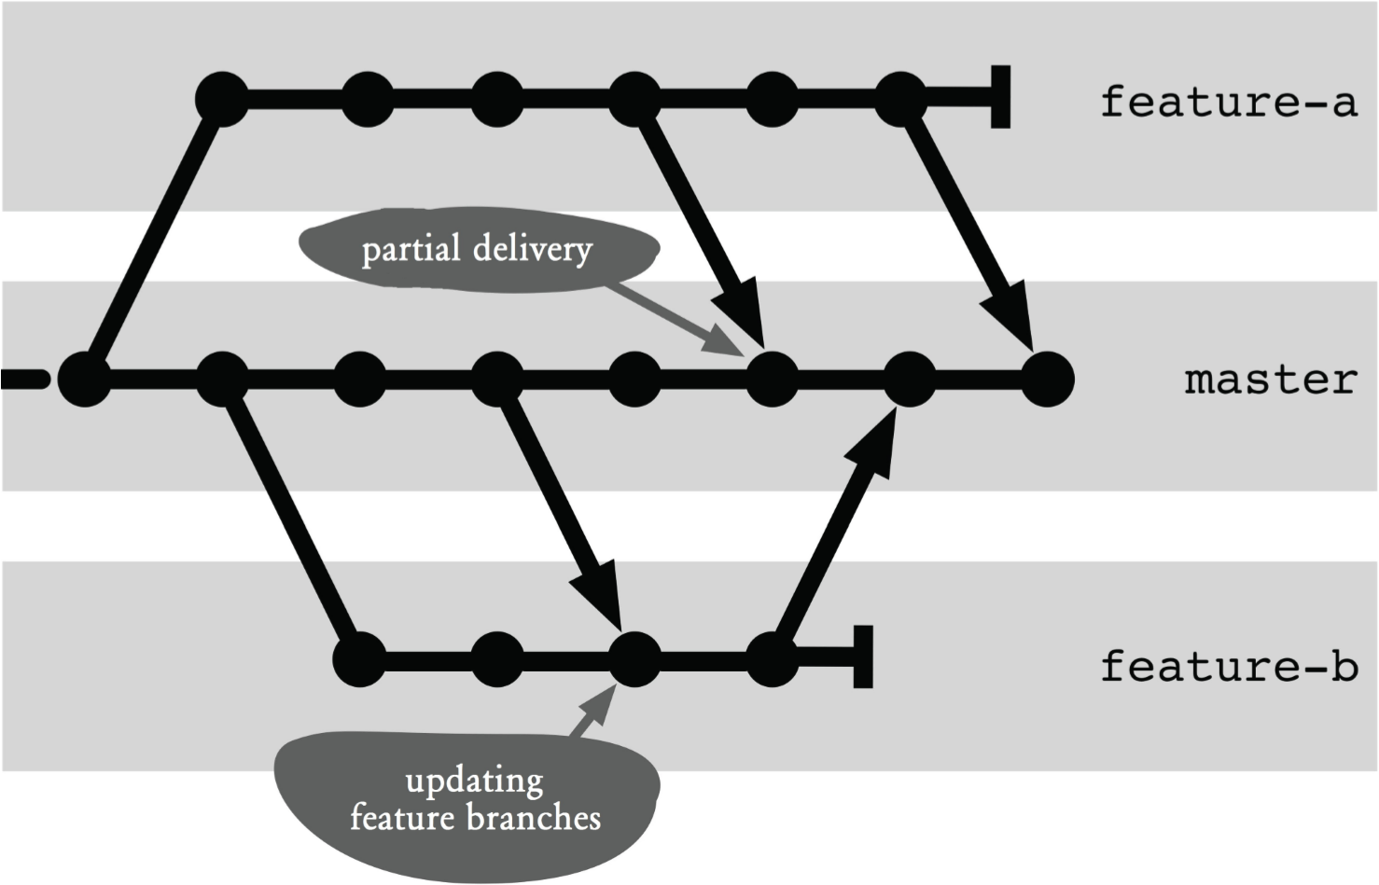
图16.1：工作流概览
图中翻译 ｛
Partial delivery：并行式交付
Updating features branch：更新特性分支
其余部分不用翻译
｝

执行过程及其实现
以下操作将会假设我们始终会有一个中央版本库。就像往常一样，开发工作会在该版本库的本地克隆体中完成，然后中央版本库则会以该克隆体的远程源版本库的角色被访问。
因而在接下来的流程中，我们将会看到push命令被频繁地用来将本地修改传送给中央版本库。
一旦在工作中使用了特性分支，本地版本库中就往往会存在多个分支。在没有参数的情况下，push命令只会将当前活动分支中的内容传送给到远程版本库。当然我们也可以通过设置push.default选项来更改这一行为。
> git config push.default upstream
该选项的默认值匹配所有与远程版本库中有相同分支的本地分支。因此，我们每次在执行push命令时都必须明确指定分支，以限定传送的内容。

创建特性分支
只要某个特性是可以被处理的，我们就可以为其创建一个新的分支。这里最重要的是要确保这些分支必须始终是基于master分支来创建的

第1步：更新master分支
如果可以访问到中央版本库，先将本地的master分支更新到最新状态是很有必要的。这样做有助于我们确保当前没有合并冲突，我们建议您在做这件事之前，不要在本地版本库的master分支上开展任何基于特性的任务。
> git checkout master
> git pull --ff-only
这里的--ff-only参数表示这里只允许进行快进式合并。换句话说，如果这时存在着一些本地修改，该合并操作就会被取消。
如果合并操作报错并被终止，那么我们就必须直接在master分支上做修复错误的工作。该分支上的这些修改就应该先被转移到某个特性分支上。

第2步：创建特性分支
新分支的创建开于我们的工作同步开始。
> git checkout -b feature-a
如果整个团队来能对特性分支或bug修复分支进行统一命名，当然是非常有益的。 另外，Git也支持对分支进行分层命名，例如feature/a。
通常情况下，人们会采用一种追踪工具（例如Bugzilla或Mantis）来对特性开发和bug修复的工作进行管理。这些工具会赋予这些相关特性和bug一个唯一的编号或令牌。而这些编号也可被用作Git的分支名称。

第3步（可选）：在中央版本库上维护特性分支
通常，特性分支都只创建在本地，当这些分支的生命周期很短时尤为如此。
但如果某个特性的实现需要较长的时间，或者有多个开发者在开发同一个特性，其中间成功就会显得相当重要。于是，我们会希望将该分支放到中央版本库上去维护。
为了做到这一点，我们可以用push命令在中央版本库中创建一个对应的分支。
> git push --set-upstream origin feature-a
这里的--set-upstream参数会将本地的特性分支与远程版本库中的新分支连接起来。这也就是说，我们将来执行的所有push和pull命令都可以免去显式指定远程分支的操作了。
而origin参数则指定了远程版本库的名称（即中央版本库的别名），以及所维护的特性分支的名称。
这样一来，我们今后所修改的本地特性就可以通过一个简单的push命令被同步维护到中央版本库中了。
> git push

在master分支上集成某一特性
根据我们我们已经定义好的需求，确保相关特性不长期以并行形式存在是很重要的。否则，出现合并冲突和不兼容的风险就会大大增加。即使该特性不会被纳入到下一发行版中，我们也会建议您尽快完成功能的整合，并禁止切换到该特性分支。
在这一节中，我们将详细介绍如何将一个特性整合到master分支。其中的重点在于，相关的合并必须始终在master分支上执行。否则master分支就无法获得一个第一父级的提交历史，这就毫无意义了。

第1步：更新master分支
在实际执行merge命令之前，本地的master分支必须保持最新状态，如果我们在本地分支上做这些事，就很有可能会出现合并冲突。
> git checkout master
> git pull --ff-only

第2步：合并特性分支
我们在特性分支中所做的修改可以通过merge命令被传送给master分支。这样一来，master分支上第一父级的历史就可以被当作一个特性发展的历史。当然，这里是不允许快进式合并的。
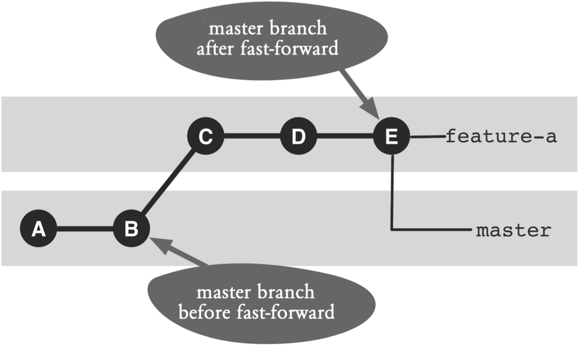
图16.2：快进式操作问题与第一父级历史
图中翻译｛
Master branch after fast-forward：快进之后的master分支
Master branch before fast-forward：快进之前的master分支
其余部分不用翻译
｝
我们可以通过图16.2来看一下快进式合并可能会带来的问题。如您所见，在合并之前，master分支所指向的位置是提交B而特性分支则指向了提交E。在经过快进式合并之后，master分支现在也位于提交E之上。这样一来，master分支上的第一父级历史中就纳入了两个中间提交D和C。
您可以用以下命令来执行合并操作，并同时防止其执行快进式合并：
> git merge feature-a --no-ff --no-commit
在这里，--no-ff参数的作用就是防止快进式合并。而--no-commit参数则用于指示Git，不要因为接下来可能失败的测试而停止任何提交。
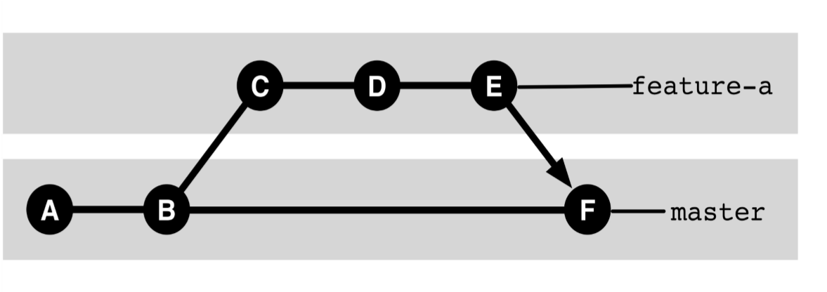
图16.3：非快进式合并 （该图文字不用翻译）
现在，我们再来看看图16.3，该图所示范的就是快进式合并被阻止之后的提交历史。我们会看到一个新的合并提交F。这样提交C到E就不会被纳入到master分支的第一父级历史中了。
如果我们在本地特性分支上做这些修改的时候，其它特性分支也修改了相同的文件，该合并就可能会引发冲突。而这些冲突则必须要用普通的方式来解决。

第3步：做一下回归测试，并为其创建一个提交
在执行完合并操作之后，我们通常就应该运行一下回归测试。在这种情况下，如果新特性会引发其它特性的错误，就会被该测试检查出来。
如果该测试确实引发了这样的错误，我们就必须要这些错误进行分析。为了排除它们，我们就必须要要先哟个reset命令丢弃当前所执行的这次合并。
> git reset --hard HEAD`
在这里，--hard参数的作用是确保暂存区和工作区中所发生的全部修改都会被丢弃。而之后的 HEAD则表示当前分支必须是最后一个已关闭的提交。
紧接着，特征分支会被再次激活。上述错误可以在这里得到纠正，之后只需要从第1步开始再走一遍至今为止的流程即可。
如果回归测试没有找到错误，那我们就可以直接提交完事。
> git commit -m "Delivering feature-a"
如果我们想以文档形式来使用master分支上的历史记录，就必须要对合并提交的注释内容进行统一设置。具体来说，就是我们必须要对特性设置一个具有关联性的唯一标识，譬如使用编号。这样一来，我们就可以用log命令加--grep参数搜索到master分支上的相关特性。

第4步：将master分支传递给中央版本库
在完成上述最后一步操作之后，本地版本库中的master分支应该已经与特性分支完成了统一。下一步，我们必须要通过push命令将master分支传递给中央版本库。
> git push
如果这个命令在执行过程中出现了错误，那么master分支上一定有其他特性分支已经被整合了进来，并且不再可能是一次快进式合并了。这时候我们通常的做法是先执行一下pull命令，将其修改合并到本地来。但这样做的话，我们的第一父级历史就不能再发挥作用了。
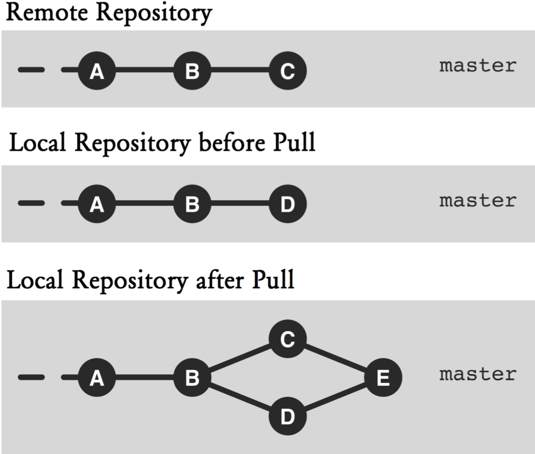
图16.4：执行了pull命令之后，第一父级历史就不可用了
图中翻译 ｛
Remote repository：远程版本库
Local repository before pull：执行pull命令之前的本地版本库
Local repository after pull：执行pull命令之后的本地版本库
其余部分不用翻译
｝
在图16.4中，顶部和中间这两部分所描述的概况如下：提交C为远程版本库的当前提交，而本地版本库当前所应用的是提交D。如果我们现在执行pull命令，就会创建出一个新的合并提交E（见图16.4的底部）。因此可以看出，提交Ç将不会再被纳入到master分支的第一个父级历史中了。
但第一父级历史中应该要纳入所有的特性，所以在push命令失败之后，本地特性分支上的合并提交必须要用reset命令移除掉。
> git reset --hard ORIG_HEAD
在这里，ORIG_HEAD所引用的就是当前分支在合并之前所指向的提交。
然后，我们只需要从第一步开始再执行一遍之前的操作序列即可。也就是用pull命令重新将master分支中的新提交检索出来。，
当然，如果push命令执行成功了，那么新的特性自然就已经被纳入到了中央版本库中。

第5步：删除或继续使用该特性分支（二选一）
变化1：删除该特性分支
如果在与master分支合并之后，该特性开发就完成了，那么我们就可以删掉这个特性分支了。
> git branch -d feature-a
这里的-d选项就是要删除指定的分支。
如果删除过程中出现了错误信息，那么很可能是我们忘记了将特性分支合并到master上。因为-d选项只有在一个分支上的所有提交都被其它分支引用了的情况下才会删除该分支。如果您是想删除一个没有被master分支全面接管其所有提交的特性分支，可以选择改用-D选项。另外，如果被删除的分支在中央版本库中有对应的维护分支，则那边的分支也会随即被删除。
> git push origin :feature-a
在这里，分支名称之前的冒号是很重要的。该命令的意图是：不粘贴特性分支上的所有东西。

变化2：继续特性开发
如果该特性开发还尚未完成（也就是说，它在首轮整合中只有部分交付给了master分支），那么该特性分支就还可以继续被使用。
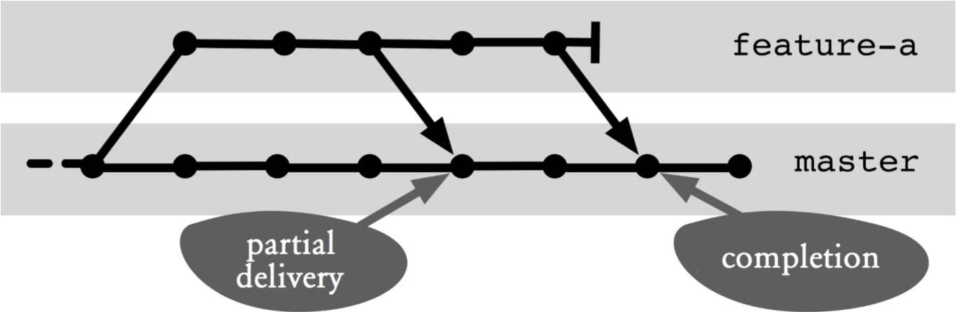
图16.5：继续某特性分支上的开发工作
图中翻译 ｛
Parial delivery：部分交付
Completion：完成
其余部分不用翻译
｝
在图16.5中，进一步的工作大致上是对部分交付之后那部分的一个概述。在这过程中，该分支将继续被当作特性分支来使用。
> git checkout feature-a
一旦下一批内容准备就绪了，我们就可以再次将其整合到master分支上，这时候Git也会显得足够智能化，它只会将新提交中的修改传递给master分支。

将master分支上所发生的修改传递给特性分支
In the best-case scenario, the development of a feature takes place independently of other features. However, sometimes there are important changes on the master branch that are necessary for the feature development, such as major refactoring or changes to basic services. In this case, the changes on the master branch need to be transferred to the feature branch.
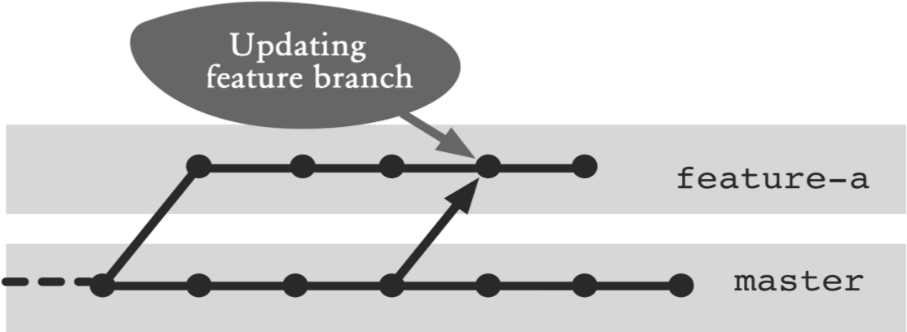
Figure 16.6: Changes on the master branch transferred to the feature branch
Figure 16.6 illustrates the situation. It is a merge from the master branch that needs to be performed on the feature branch.

Step 1: Update the master branch
First, the changes on the master branch must be imported to the local repository.
> git checkout master
> git pull --ff-only
The --ff-only option indicates that only fast-forward merges are permitted. This prevents you from accidentally performing a merge on the master branch.

Step 2: Apply changes in the feature branch
In the second step, the changes must be applied in the feature branch with a merge.
> git checkout feature-a
> git merge --no-ff master
Here, --no-ff prohibits fast-forward merges. A fast-forward merge can only happen at this point if the master branch and the feature branch have been merged right before this merge. A fast-forward merge would then destroy the firstparent history of the feature branch.
Any conflicts that arise must be resolved normally.
The feature branch can take any intermediate version from the master branch. Git can deal with multiple merges very well. However, the commit history would then be complex and difficult to read.
Git-Flow: High-Level OperationsGit Flow, which can be downloaded from https://githum.com/nvie/gitflow, is a collection of scripts that can be used to simplify the handling of branches, particularly feature branches. With this Git extension you can create and activate a new feature branch at the same time as follows:
> git flow feature start feature-a
Finally, the feature branch can be transferred to the master branch and simultaneously deleted.
> git flow feature finish feature-a

何不换一种做法？

Why not Continue to Work on the Merged Version after a Partial Delivery?
If a partial delivery of a feature occurs on the master branch, the master branch will contain a merge commit with changes of its own features and updates from other features. On the other hand, the updates from the other features are not yet available on the feature branch (See Figure 16.7).
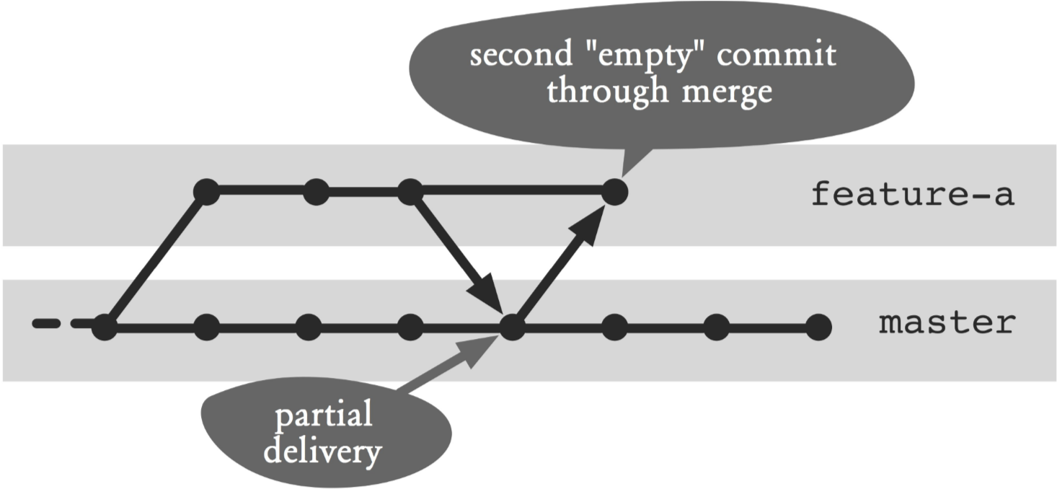
Figure 16.7: Another merge after a partial delivery
Wouldn’t it make sense to perform a merge from the master branch into the feature branch and thus work on the merged branch?
The short answer is: The history would be unnecessarily complex, and in most cases, this procedure would bring no benefit to the feature development.
A merge of the master branch on the feature branch right after a partial delivery usually always leads to a fastforward merge, i.e. both branches would point to the same commit. However, this would ruin the first-parent history of the feature branch—which changes were made in the course of the feature development would no longer be traceable. As such, you have to suppress the fast-forward merge, which in turn will lead to a new “empty” merge commit. That is, there would always be two merge commits for each partial delivery of a feature.
In most cases, it is not important for a feature development to be proceed on the most up-to-date version of the master branch.
If it is necessary to apply changes, then you can do that. However, it should not always be right after each partial delivery.

Why Feature Branches Are Not Integrated until Shortly before the Release?
When working with feature branches, release management often comes up with the idea, the decision, shortly before the delivery date, as to which features should be shipped with the new release.
Conceptually, it seems it is very easy to go with the feature branch approach too. Each feature is fully developed on a branch, but not yet integrated into the master branch. Which features will be integrated into the master branch are decided just before the D-day.
In an ideal world—where features are fully independent and no programming errors exist—this approach would work. In reality, however, this approach usually leads to major merge conflicts in integration and a long stabilization phase.
Furthermore, it is more complicated to develop features that have dependencies. Normally you would make a partial delivery of a feature on the master branch. In a solution with late integration of a feature, branches must exchange changes (see the following section). This would make independent integration of these features impossible to be carried out just before the release.
Also, proven processes for quality software, such as continuous integration with a build server, integration and refactoring are difficult to implement in late integration.

Why Not Exchange Commits between Feature Branches?
The workflow described provides no direct exchange of commits between feature branches. The integration always takes place on partial deliveries on the master branch.
Wouldn’t it be easier to perform a merge directly between feature branches?
Step by Step: ReReRe – Automatic conflict resolution
Manual conflict resolution in files can be recorded. If the same conflict occurs again and again, the resolution can be applied automatically. This is called ”Reuse recorded resolution.” In short: ReReRe.
- Enable ReReRe
The feature to record conflict resolutions must be enabled once for each repository.
> git config rerere.enabled 1
Rerere stores conflict resolutions locally, as such ReReRe must be enabled in every clone.
- Record conflict resolution
Once ReReRe is enabled, all conflict resolutions conducted will be saved automatically to files with every commit command. However, if no commit is performed (e.g., if the attempt is rejected with a reset command), the rerere command must be invoked explicitly:
> git rerere Recorded resolution for 'foo.txt'.
3. Apply conflict resolution
Once ReReRe is enabled, Git will attempt to resolve conflicts automatically at every merge attempt. Here, although the files are changed in already solved conflicts, no add command is called to confirm the conflict resolution.
> git merge featureE
Auto-merging foo.txt
CONFLICT (content): Merge conflict in foo.txt
Resolved 'foo.txt' using previous resolution.
Automatic merge failed; fix conflicts and then commit the
result.
After you take over control to resolve the conflicts, you must add the affected file to the next commit using the add command.
> git add foo.txt

Step by Step Showing open feature branches
We need to show feature branches that have not been merged with the master branch.
1. Show open feature branches
If you work consistently with feature branches, you often have more than one active feature branch in your repository. The branch command can display all branches that have not been merged.
> git branch --no-merged master
The --no-merged option shows all branches with commits that have not been included in the master branch, i.e. all the feature branches that have not yet been merged with the master branch.
The decisive advantage of feature branches is the simple and comprehensible history. Add merges directly between feature branches, and this advantage goes away.
Step by Step: Show all changes in a merged feature
All changes of a feature should be shown as a diff.
It is important to find out which changes were made.
This is especially true when doing a code review. Figure 16.8 is an example of a feature branch with a partial delivery and a final delivery. Subsequently, the commits are referenced according to this figure.
1. Locate the commits of a feature
For a diff you need all the commits of the feature in the master branch. Normally, there will only be one merge commit, except when partial deliveries were made: Then there will be several commits. In the example, commits H and G are found.
> git checkout master
> git log --first-parent --oneline --grep="featureC"
c52ce0a Delivery featureC c3a00bc PartialDelivery featureC
The --grep option searches the log for the given piece text.
2. Do a diff
The changes can be viewed by doing a diff between the commits found and with their respective first parent. In the example, the changes between commit B and commit G and between commit G and commit H are shown.
> git diff c3a00bc^1 c3a00bc
> git diff c52ce0a^1 c52ce0a

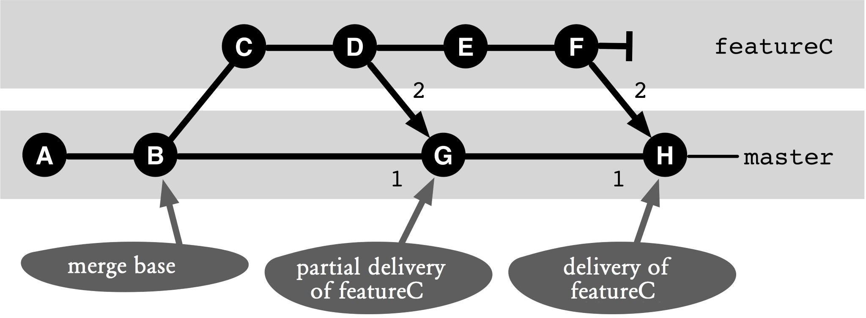
Figure 16.8: An example of a feature branch
Step by Step: Finding all commits of a feature branch
All commits that were created during feature development, will be displayed.
During a code review you want to understand more thoroughly how changes in a feature branch were built in. It may be useful to look at all the commits of the feature branch individually. Figure 16.8 is an example of a feature branch with a partial delivery and a final delivery. Subsequently, the commits are referenced according to this figure.
1. Find merge commits of the feature
First, you need all the commits on the master branch that have something to do with the feature. Normally, there will only be one merge commit, except where there are partial deliveries, in which case there will be several commits. In the example commits H and G are found.
> git checkout master
> git log --first-parent --oneline –grep="featureC"
c52ce0a Delivery featureC c3a00bc PartialDelivery featureC
The --grep option searches the log for the given piece of text.
2. Find the start of the feature branch
To display all commits, you need to find the commit on the master branch from which the feature branch branches. The starting point is the lowest commit, which was found in the previous step (commit G). This must be a merge commit with two parents. You can find the commit with the merge-base command. This commit is the common starting point of the first parent (commit B) and the second parent (commit D), the merge base (commit B).
> git merge-base c3a00bc^2 c3a00bc^1 ca52c7f9bfd010abd739ca99e4201f56be1cfb42
3. Show feature commits
Once the starting point has been found, you can display all commits of the feature branch with the log command. To do this, ask what commits are necessary for the merge base (commit B) to be the last commit of the feature branch. The last commit of the feature branch is the second parent (commit F) of the last delivery (commit H).
> git log --oneline ca52c7f..c52ce0a^2

