Chapter 4 Multiple Commits

A new commit does not have to accept any changes from the workspace. In fact, Git gives the user full control here. In the extreme case, it can be determined what changes should be incorporated in the next commit.
新的承诺并没有接受来自工作区的任何变化。事实上，Git会为用户提供了完全控制这里。在极端情况下，可以判定应在下一掺入什么样的变化提交。
A commit occurs in two steps. First, all changes are collected in a buffer using the add command. This buffer is called the staging area or index. Next, the changes from the staging area are transferred to the repository using the commit command.
一个提交分两步进行。首先，所有的改变都在收集使用add命令缓冲区。这个缓冲区被称为暂存区域或索引。其次，从临时区域的变化被转移到使用commit命令库。
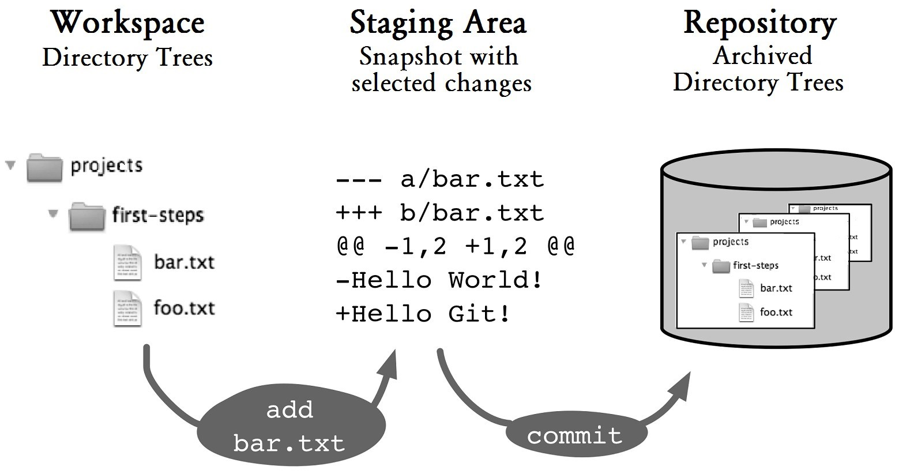
Figure 4.1: The route of changes in the repository

The status Command
The status command shows what changes are currently available in the workspace and which of them are already registered in the staging area for the next commit.
status命令显示了怎样的变化目前可在工作区中，哪些人已经在临时区域注册的下次提交。
> git status
# On branch staging # Changes to be committed:
# (use "git reset HEAD <file>..." to unstage)
#
# modified: bar.txt
# # Changed but not updated:
# (use "git add <file>..." to update what will be committed) # (use "git checkout -- <file>..." to discard changes in ...
#
# modified: foo.txt
# # Untracked files:
# (use "git add <file>..." to include in what will be committed)
#
# new.txt
no changes added to commit (use "git add" and/or "git commit -a")
The output shows various headings:
输出显示各个标题：
- Changes to be committed: Lists the files for which changes are to be included in the repository with the next commit.
- Changed but not updated: Lists the files that have changed, but have not been registered for the next commit.
- Untracked files: Lists all new files.
- 要致力于改变：列出了哪些变化是文件被列入下一个存储库提交。
- 改变，但不更新：列出已更改的文件，但尚未注册为下次提交。
- 未跟踪的文件：列出所有的新文件。
It helps that Git indicates what command can be used to change the status again. For example, you can use this command to unstage blah.txt.
它有助于Git的指示什么命令可以用来再次更改状态。例如，您可以使用此命令unstage blah.txt。
git reset HEAD blah.txt
CVS and Subversion users may find the use of the term update here confusing. In those systems, “update” means the acquisition of changes from the repository into the workspace. In Git, however, update is the incorporation of changes from the workspace into the staging area. This is exactly the opposite direction. Babylon sends its regards.
CVS和Subversion的用户可能会发现使用术语更新此迷惑的。在这些系统中，“更新”是指收购从仓库到工作区的变化。在Git，然而，更新是从工作区到临时区域变化的结合。这是完全相反的方向。巴比伦发送它的问候。
If there are many changes, you can use the --short option to make the output more compact. For instance,
如果有很多的变化，则可以使用--short选项，以使输出更紧凑。 例如，
> git status --short
M blah.txt
M foo.txt
M bar.txt
?? new-file.txt
Step by Step：Selective Commits
A new commit is created. However, it should not include all updates. Here you can select all files or some files only.
新提交的创建。但是，它不应该包括所有的更新。在这里，您只能选择所有文件或某些文件。
1. View the changes查看更改
> git status
Under the headings “Changed but not updated” and “Untracked files” the status command shows the files that are not yet registered for the next commit.
在标题“更改，但没有更新”和“未跟踪文件”status命令显示尚未注册为下提交的文件。
2. Collect the changes收集的变化
Use the add command to add the changes to the staging area. You can specify the file paths individually. Or, you can specify a directory to include new and changed files from all subdirectories. The add command can be called many times and you can also use wildcards * and ? to specify paths.
使用add命令来修改添加到暂存区域。您可以分别指定文件路径。或者，你可以指定一个目录，包括从所有子目录新的和已更改的文件。该add命令可以调用很多次，你也可以使用通配符*和？指定的路径。
> git add foo.txt bar.txt # selected files
> git add dir/ # a directory and everything underneath
> git add. # current directory and everything underneath
If you want even finer control, you can use the interactive mode by using the --interactive option. Then, you can select individual code fragments and, in extreme cases, individual lines of code to register for the commit.
如果你想更好地控制，您可以使用--interactive选项，使用交互模式。然后，您可以选择单个代码段，在极端的情况下，代码每一行登记的提交。
3. Create a commit创建提交
Finally, apply the changes with a commit.
最后，应用与提交更改。
> git commit
After this the staging area will be empty. The workspace is not affected by the commit. Changes that were not added with add, remain in the workspace.
在此之后，临时区域将是空的。工作区不受提交。那些没有与附加增加的变化，留在工作区中。
Selective commits can be very useful to separate changes from one another. Example: A new class has been created. Alongside a few mistakes in other classes have been corrected. Separating the changes into several commits makes the history clearer and makes it easier to selectively deliver single bug fixes earlier (cherry-picking).
选择性提交可以是变化彼此分离非常有用的。例如：一个新的类已创建。除了在其他类别犯了一些错误已得到纠正。分离变成多次提交，使历史更清晰，更容易选择较早提供单个的错误修复（樱桃采摘）。
However, you should keep in mind that selective commits can create in the repository software versions that have never existed locally. They have therefore never been tested and in the worst case may not even compile. We recommend that you avoid selective commits if possible. It is often sufficient to make a note that you want to fix an error, rather than fix it right away.
然而，你应该记住，有选择性的提交可以创建从未存在本地存储库的软件版本。他们因此从未测试并在最坏的情况下甚至可能不编译。我们建议您不要选择提交如果可能的话。它往往是足以让你要修复的错误，而不是修复它的时候了一张纸条。

The Staging Area Stores Snapshots
One thing you should know about the staging area: it is more than just a list of files for the next commit. It stores not only locations of changes, but also what have changed. For this purpose Git generates a snapshot of the affected files with exactly the selected changes. Figure 4.2 illustrates this. In Line 1, the workspace, the staging area and the repository are still the same. Then, the developer working on the file makes some changes in his workspace (Line 2). He then uses the add command to transfer the changes to the staging area, but not yet to the repository (Line 3)
有一件事你应该知道的暂存区域：它不仅仅是文件只是为下一次提交的清单。它存储不仅改变了位置，还能有什么发生了变化。为此，Git的生成受影响的文件与完全改变选择的快照。图4.2说明了这一点。在1号线，工作区，临时区域和仓库仍然是相同的。然后，开发工作的文件，使得他的工作空间（2号线）的一些变化。然后，他用add命令将更改传输到临时区域，但尚未到仓库（3号线）
In Line 4, the developer changes the file again. Now all the three areas have different contents. A commit command transmits the first change to the repository (Line 5). The second change is still in the workspace. The developer then uses the add command to transfer it to the staging area (Line 6).
在4号线，开发商再次更改文件。现在所有的三个区域具有不同的内容。通过commit命令发送第一变到存储库（5号线）。第二个变化是仍然在工作区中。然后，开发人员可使用add命令将其转移到临时区域（6号线）。
Step by Step What Is in the Staging Area? What Is Not?
Changes were registered using the add command for the next commit. Afterward, further changes were made in the workspace. The diff command shows what is going on.
使用add命令来为下提交登记变更。随后，进一步改变工作区发了言。 diff命令显示是怎么回事。
a. What is in the staging area? 什么是临时区域？
Changes that have already been added using the add command to the staging area with the --staged option will be shown as staged. The following command displays the differences between the staging area and the current HEAD commit in the repository.
将表明，已经使用add命令与--staged选择分段区增加的变化来作为上演。以下命令显示临时区域和当前HEAD之间的差异犯下在库中。
> git diff --staged # staging vs. repository
b. What is not registered yet? 没有登记是什么吗？
Without any options, the diff command shows the local changes in the workspace that are not registered yet, in other words the difference between the staging area and the workspace.
如果没有任何选项，diff命令显示了在还没有登记，换句话说临时区域和工作区之间的差异的工作区中的局部变化。
> git diff # staging vs. workspace

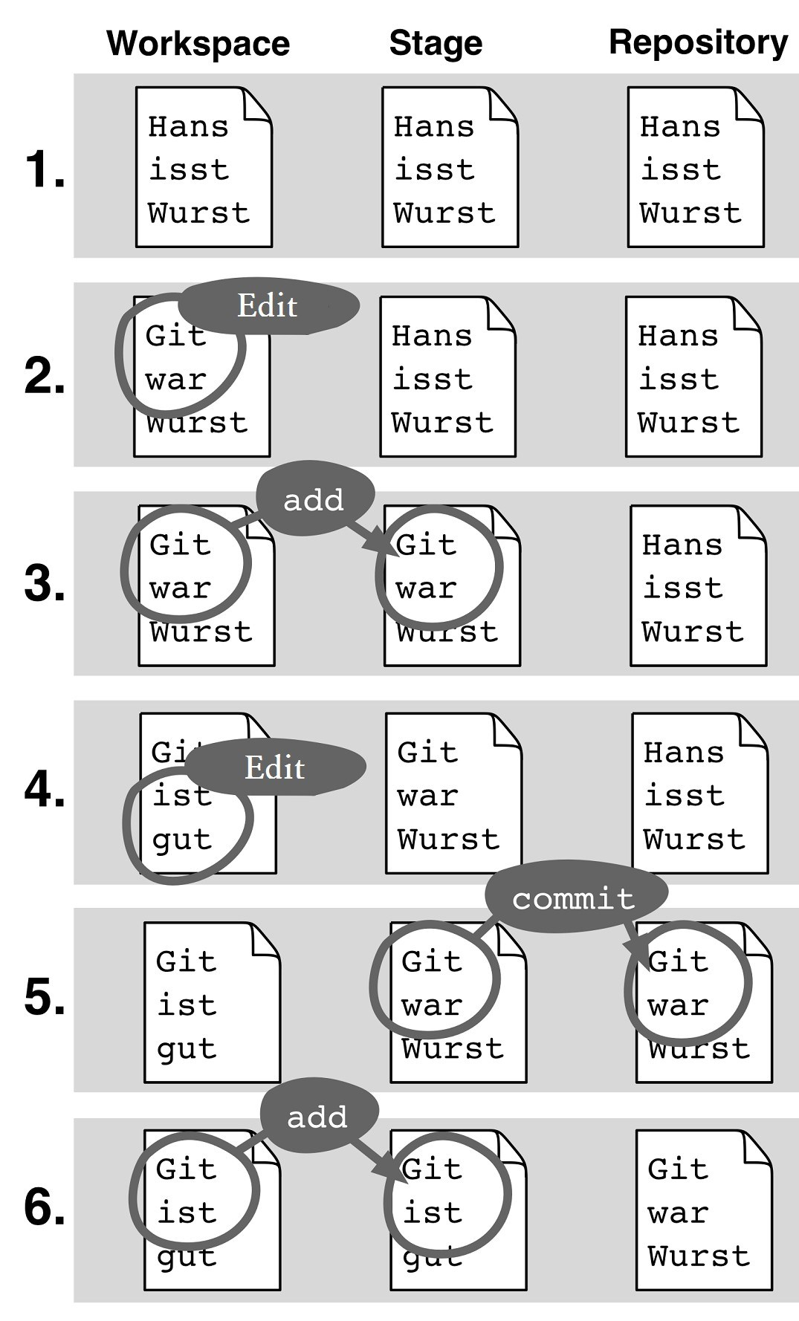
Figure 4.2: Changes from the workspace are copied to the staging area and to the repository

What To Do with Changes That Are Not To Be Committed?
As it happens, there are things that you do not want to commit, including:
碰巧的是，有些事情你不想犯，其中包括：
- experimental changes for debugging purposes
- changes that are added by accident
- changes that are not ready yet
- changes in generated files
- 实验改变用于调试
- 被意外增加的变化
- 这还没有准备好变化
- 变化生成的文件中
Git offers several ways to deal with them:
混帐提供了几种方法来处理这些问题：
- Reset experimental changes or changes made by accident using the reset command
- Ignore files that you do not want to commit using .gitignore
- Save changes that you might want to commit later with the stash command
- 使用RESET命令偶然做实验性的变化或
- 忽略你不希望使用的.gitignore提交文件
- 保存，你可能要与藏匿命令后提交更改
Step by StepUndoing changes from the Staging Area
The reset command resets the staging area. The first parameter HEAD indicates that it is to be reset to the current HEAD version. The second parameter specifies which files or directories are to be reset.
reset命令重置暂存区。第一个参数HEAD表示它是被重置为当前的头的版本。第二个参数指定的文件或目录进行复位。
> git reset HEAD .
or 或者
> git reset HEAD foo.txt src/test/
The staging area is overwritten during reset. Usually this is not a problem, because the same changes are likely still in the workspace (see Figure 4.2). If the same files were further processed after the add command, information may be lost.
复位期间，临时区域将被覆盖。通常这是没有问题的，因为同样的变化很可能仍然在工作区中（参见图4.2）。如果同一个文件被加载命令后进一步处理，信息可能会丢失。

Leaving out Unversioned Files with .gitignore
In general, generated files, temporary files created by editors or backups are files you do not want to put under version control. By adding entries in a .gitignore file in the root directory of the project you can make these files “invisible” to Git. You can specify file paths and directories in it. The wildcard characters “*” and “&” can also be used. You should know the following about paths: A simple path like generated/ will make directories that contain the name, such as src/demo/generated, ignored everywhere, If the path is prefixed with a /, such as in /generated/, then only the exact path—relative to the project’s root directory —will be ignored.
在一般情况下，生成的文件，由编辑或备份创建的临时文件是你不想版本控制下放置文件。通过在项目的根目录下添加条目中的.gitignore文件就可以使这些文件“看不见”的Git。您可以在其中指定文件路径和目录。通配符“*”和“＆”也可以使用。你应该知道以下关于路径：等生成一个简单的路径/将包含名称的目录，如SRC/演示/产生，忽略无处不在，如果路径前有/，如/生成/，然后只有准确的路径相对于项目的根目录 - 将会被忽略。
#
# Simple file path
#
somehow/simultaneous.txt
#
# Directories ending with a "/"
# generated/
#
# File types as glob expressions
#
*.bak
#
# "!" marked exceptions. "demo.bak"
# will be versioned, but "*.bak"' # will be excluded.
#
!demo.bak
You can create a .gitignore file in a subdirectory of your project. In this case, it will affect all files and paths below that directory. This may be useful, for example, if your project is comprised of various programming languages, each of which needs a different configuration.
你可以在你的项目的子目录中创建的.gitignore文件。在这种情况下，会影响到该目录下的所有文件和路径。这可能是有用的，例如，如果项目是由各种编程语言，每个都需要一个不同的配置。
Note that entries in .gitignore only affect files that are not yet managed by Git. If a file is already versioned, the status command will display all changes to it, and these can also be registered with the add command for the next commit. If you want to ignore files that are already versioned, you can do this with the --assume-unchanged option of the update-index command.
请注意，在的.gitignore条目仅影响尚未通过的Git管理的文件。如果一个文件已经版本，状态命令将显示所有更改，而这些也可以与add命令注册了下次提交。如果你想忽略已经版本的文件，您可以用更新索引命令的--assume不变选项做到这一点。

Stashing
If you are in the middle of something and, say, a fix needs to be written quickly, you often want to start making changes but not commit what you have been doing. In this case the stash command can help save changes locally and those changes can be referred to again later.
如果你在中间的东西，并说，修复需要快速写入，你经常要开始进行更改，但不承诺你一直在做的事情。在这种情况下，藏匿命令可以帮助本地保存更改，这些更改可以被称为一次。
Step by Step Saving Changes
The stash command saves changes in the workspace and the staging area in a buffer called the stash stack.
藏匿命令将更改保存在工作场所和暂存区一个叫藏堆栈缓冲区。
> git stash

Step by Step
Getting Back to Stashed ChangesStashed changes can be retrieved from the stack to the workspace using the stash pop command.
再回到藏匿ChangesStashed变化可以检索从堆栈使用藏匿弹出命令的工作区。
a. Retrieve the top-most stashed change 检索最顶部的藏匿变化
> git stash pop
b.1. What Is in the Stash Stack? 是什么在藏匿栈是？
First, check to see what changes have been stashed.
首先，检查，看看有什么变化已经藏匿。
> git stash list
stash@{0}: WIP on master: 297432e Mindmap updated.
stash@{1}: WIP on omaster: 213e335 Introduction to workflow
b.2. Retrieve Older Stashed Changes检索旧藏匿变化
First, check to see what changes have been stashed.
首先，检查，看看有什么变化已经藏匿。
> git stash pop stash@{1}

Summary
- Staging area: The staging area (also called index) is where you prepare for the next commit. It contains a snapshot of file contents.
- Adding generated snapshots: You use the add command to create a snapshot of modified files in the staging area. If you change the same files again, the new changes are not automatically included in the next commit.
- Selective commit: When you use the add command, you can specify which files are to be included in the snapshot. All other files remain unchanged.
- Selecting sections of code: With --interactive you can even select individual sections of changed rows (hunks). Only these changes are then transmitted as a snapshot in the staging area.
- Status: The status command shows which files go into the next commit and which files have been modified locally, but are not yet registered in the staging area.
- Reset the staging area: With git reset HEAD . all files will be reset to the current HEAD version.
- .gitignore: In this file, you list files and directories that Git should not manage.
- Stashing: With the stash command you can stash the current changes in the workspace and the staging area. Later, you can retrieve it again with git stash pop.
- 暂存区域：临时区域（也称为索引）是你的下次提交做准备。它包含文件内容的快照。
- 添加生成快照：您使用add命令在临时区域创建修改过的文件的快照。如果再次更改相同的文件，新的变化将不会自动列入下次提交。
- 选择提交：当你使用add命令，你可以指定哪些文件将被包含在快照中。所有其他文件保持不变。
- 选择的代码段：随着--interactive你甚至可以选择更改的行（帅哥）的各个部分。只有这些变化，然后传送作为暂存区域的快照。
- 状态：状态命令显示了哪些文件会进​​入下一个提交哪些文件已在本地修改，但尚未注册的临时区域。
- 重设临时区域：Git的复位头。所有的文件将被重置为当前的HEAD版本。
- 的.gitignore：在这个文件中，列出文件和Git的不应该管理目录。
- 藏起来：随着藏匿命令，你可以藏在工作区和临时区域的电流变化。后来，你可以用git藏匿流行再次找回它。

