第5章 版本库

事实上，我们即使不了解版本库的具体工作方式，也一样可以将Git用得风生水起。但如果我们了解了Git存储和阻止数据的方式，就能对工作流有一个更好的理解。当然，如果您真的很讨厌谈理论，也可以选择跳过本章，只读一下“按部就班”小节中的内容即可。
Git主要由两个层面构成。其顶层结构就是我们所用的命令，譬如log、reset或commit等。这些命令使用起来很方便，并提供了许多可调用的选项。Git的开发者们称它们令为瓷质命令（porcelain command）。
而对于其底层结构，我们则称之为管道（plumbing）。这里主要是一组带有少量选项的简单命令，瓷质命令就是以此为基础被构建出来的。管道命令很少被直接用到。本章将为您提供一些了解该系统管道层结构的机会。

一种简单而高效的存储系统
Git的核心是一个对象数据库。该数据库可用来存储文本或二进制数据，譬如对于某文件的内容。我们可通过带-w选项（w代表写入）的hash-object命令将其作为一条记录插入到该对象数据库中。
> git hash-object -w hello.txt
28cf67640e502fe8e879a863bd1bbcd4366689e8
每当我们存储了这样一个对象，Git就会返回一个40个字符的代码。这是被存储对象的键值。请记住它，我们日后需要用该键值配合带-p选项（p代表打印）的cat-file命令来访问这个对象。
> git cat-file -p 28cf67640e
Hello World!
The implementation of the object database is very efficient. Even in a large project with a very long commit history (such as the Linux kernel, which has more than 200,000 commits and almost two million objects), accessing objects from the repository is almost instantaneous. Git is extremely well suited for projects with a large number of small source files. The boundaries become apparent only when the total data volume of the data gets very large. Those wanting to manage large binary files with a Git repository will not be well served.
对象数据库的实现是非常有效的。即使是在一个大型项目有很长的历史承诺（如Linux内核，其中有超过20万的提交和近两百万对象），从资源库中访问的对象几乎是瞬间的。 Git是非常好的适合的项目有大量小的源文件。的边界变得明显，只有当该数据的总数据量变得非常大。那些想要管理与一个Git仓库大的二进制文件将不会得到更好的服务。

Storing Directories: Blob & Tree
To store files and directories Git uses a simple tree with two types of nodes. File contents are unchanged, stored byte by byte as blob objects in the object database. Directories are represented by tree objects that look like this:
为了存放文件和目录Git使用两种类型的节点一个简单的树。文件内容不变，以字节为对象数据库中的blob对象存储字节。目录由看起来像这棵树对象表示：
> git cat-file -p 2790ef78
100644 blob 507d3a30ae9ed53bcf953744c5f5c9391a263356 README
040000 tree 91c7822ab43800b0e3c13049519587df4fd74591 src
The tree object contains files and subdirectories, as shown in Figure 5.2. Each entry comes with information about access rights (eg 100644), type (blob or tree), and a hash of the file content and the name of the file or directory.
树对象包含文件和子目录，如图5.2。每个条目配备有关访问权限（例如100644），类型（斑点或树），并将该文件内容的散列并将该文件或目录的名称的信息。
sample-workspace/
README
/src
Hello.java
World.java
Figure 5-1: A small project
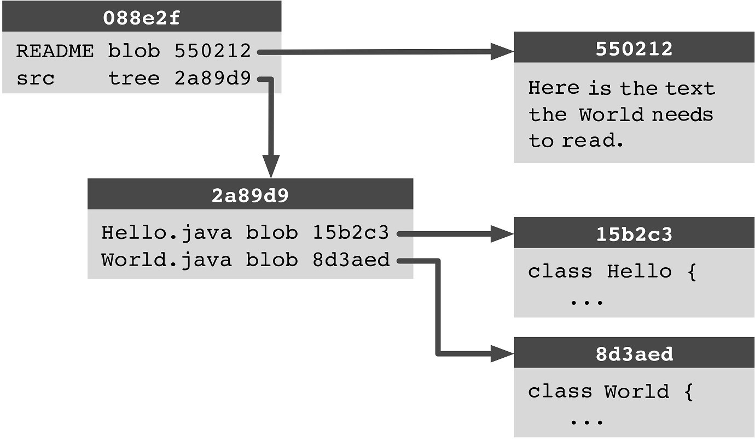
Figure 5.2: Representation of directories in the repository

Identical Data Is Stored Only Once
To save memory, identical data is stored only once. In the following example, the file contents from foo.txt and copyof-foo.txt return the same hash, because they are identical:
为了节省内存，相同的数据只存储一次。在下面的例子中，从foo.txt的和文件内容copyof-foo.txt的返回相同的哈希，因为它们是相同的：
> git hash-object -w foo.txt
a42a0aba404c211e8fdf33d4edde67bb474368a7
> git hash-object -w copy-of-foo.txt
a42a0aba404c211e8fdf33d4edde67bb474368a7
By using this approach, not only does Git save memory, it also gains performance. Many Git operations are fast because they only compare hashes in their algorithms without looking at the actual data.
通过这种方法，不仅混帐节省内存，它也获得性能。许多使用Git的操作是快，因为它们只比较它们的哈希算法，不看实际的数据。

Compressing Similar Content
Git can do more than just merge identical file content. When programmers are constantly creating new files that differ from their predecessors in only a few lines, Git can save these files using a delta method, which stores only the changes after the original version in pack files.
Git的可以做的不仅仅是合并相同的文件内容。当程序员正在不断地创造，从他们的前辈不同的只有几行新的文件时，Git可以节省使用增量方法，存储后只改变了原始版本的包文件，这些文件。
To do this, use the gc command when you want to save space. Git removes any unwanted commits that are no longer accessible from any branch head, and stores the remaining commits in pack files. For projects that contain mostly source code, an amazingly high compression is achieved. Often the size of the unzipped workspace contents with the current version of the project is greater than the size of the Git repository with years of project history.
要做到这一点，使用GC命令，当你想节省空间。 Git的删除任何不需要提交不再从任何分公司负责人访问，并存储剩余犯包文件。对于主要包含源代码的项目，一个令人惊讶的高压缩的实现。经常与项目的当前版本解压缩后的工作区内容的大小大于Git仓库具有多年项目历史的大小。

Is It Bad When Various Files Happen to Get the Same Hash?
That would be bad, because Git identifies content by its hash. Git could therefore provide incorrect data when the contents of various files happen to have the same hash. This is known as a hash collision.
这将是不好的，因为混帐其哈希标识的内容。因此混帐可以提供不正确的数据时，各种文件的内容碰巧有相同的哈希值。这被称为散列冲突。
The good news is that a hash collision is an extremely unlikely event. The reason is that there are at least 2¹⁶⁰ possible hashes. For instance, after five years the Linux kernel project “only” has about 2²¹ objects in its repository.
好消息是，散列冲突是一种非常罕见的事件。其理由是，有至少2160可能散列。例如，经过五年的Linux内核项目“仅仅”在其存储库约221对象。
In theory, the SHA1 hash algorithm has weaknesses, in which you could find an SHA1 collision with 2⁵¹ operations. However, a research project at Graz University of Technology tried from 2007 to 2009 to find one (!) such hash collision, and was terminated without success. In summary it is safe to say that security in the context of version control is okay today.
从理论上讲，SHA1散列算法的弱点，在其中你可以找到251操作的SHA1碰撞。然而，一个研究项目，在格拉茨科技大学尝试过2007到2009年，以找到一个（！），这样的哈希冲突，并终止没有成功。总之它是安全的说今天的安全版本控制的情况下是可以的。

Commits
Commits are stored in the object database. The format is simple:
提交存储在对象数据库中。格式很简单：
> git cat-file -p 64b98df0
tree 319c67d41a0b3f7464550b41db4bb1584939ad2a
parent 6c7f1ba0828a5b595026e08d2476808105a6b815
author Bjørn Stachmann <bs@test123.de> 1295906997 +0100
committer Bjørn Stachmann <bs@test123.de> 1295906997 +0100

Section on trees & blobs.
In addition to metadata, such as the author, committer, date and comment, a commit object contains hashes for other objects in the object database. The tree object describes the contents of the commit. It refers to the project’s root directory and, as described above, is represented by trees and blobs. The parent object represents the previous commit.
除了元数据，例如作者，提交者，日期和评论，提交对象包含哈希对象数据库中的其他对象。树对象描述的承诺内容。它指的是项目的根目录，如上文所述，被树木和斑点表示。父对象表示上一次提交。

Object Reuse in the Commit History
Except for the very first commit, every commit has at least one predecessor commit (parent object). Often a commit only changes a few files in a project, and most of the files and directories remain unchanged. Whenever possible Git reuses objects from the previous commit.
除了第一个提交，每次提交至少有一个前辈犯（父对象）。通常，一个犯只改变一个项目的几个文件，大部分文件和目录保持不变。只要有可能的Git重新使用先前对象提交。
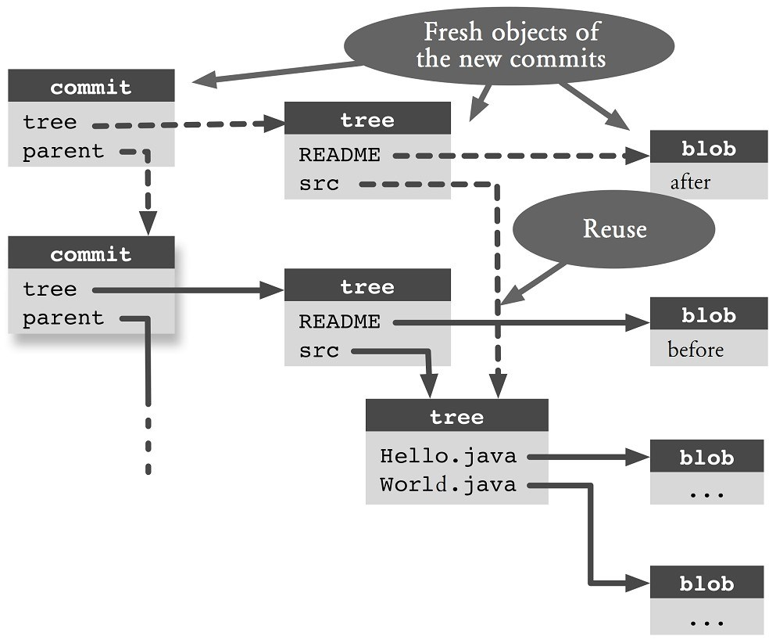
Figure 5.3: Reusing of an object tree
Figure 5.3 shows an example. A commit (represented by the second rectangular with the header “commit” on the second row from the top, with solid arrows) includes a README file and a src directory containing other files. When a new commit is created (the rectangular with the header “commit” on the first row, with dashed arrows), in which only the README file has changed. A new blob object is created for README. However, for the src directory, the existing tree object and associated blob can still be used.
图5.3示出了一个例子。一个提交（由第二个矩形，从顶部的第二排，用实线箭头头“提交”表示）包含一个README文件，并包含其他文件的src目录。当一个新的提交被创建（与标题“提交”的第一行上，用虚线箭头的矩形），其中仅自述文件已经改变。一个新的BLOB对象的自述创建。然而，对于src目录，现有的树的对象和相关联的斑点仍然可以使用。

Renaming, Moving and Copying
In many version control systems you can trace the history of file renames and time changes. Most often this is achieved by using a special command to move or rename files. In Subversion, for example, you move a file with svn move. However, Subversion is clueless when the user moves a file by dragging and dropping the file to a new location. In this case, Subversion knows nothing about the move and instead records a file deletion and creates a new file.
在许多版本控制系统，您可以跟踪文件重命名和时间变化的历史。最多，这是通过使用一个特殊的命令给移动或重命名的文件来实现的。在Subversion，例如，移动与SVN移动文件。然而，Subversion是无能当用户通过拖放该文件到一个新的位置移动一个文件。在这种情况下，Subversion不知道有关移动，而是记录的文件删除，并创建一个新的文件。
Git takes a different approach: it stores no information about which files have been moved. Instead, it employs a rename detection algorithm: If a file is missing from a commit but was still present in the predecessor, Git checks if a file with the same name or very similar content emerges in another location. If this is so, Git assumes that the file has been moved. Figure 5.4 shows this: The foo.txt file that has been moved is missing in the second commit. Git then examines all recently added files for one that has similar content and locates it in src/foo-moved.txt. This is interpreted as renaming.
Git的采用不同的方法：它没有存储信息的文件已被移动的资讯。相反，它采用了重命名检测算法：如果一个文件是从丢失提交，但仍存在于前作，如果使用相同的名称或非常相似的内容的文件出现在其他位置的Git检查。如果是这样的话，GIT中假定该文件已被移动。图5.4显示了这一点：已移动到第二次提交缺少的foo.txt的文件。之后Git检查所有最近添加的文件一个有相似的内容，并找到它的src/富-moved.txt。这被解释为重命名。
sample-workspace/ sample-workspace
foo.txt (foo.txt missing)
/src /src
bar.txt bar.txt
foo-moved.txt
(Commit 1) (Commit 2)
Figure 5.4: A file is moved
Step by Step Following renames and moving
Git will show which files have been renamed or moved.
Git会显示哪些文件已被重命名或移动。
- Get a summary
You activate rename detection using the log command with the -M option (for “Move”). To format the output, use the --summary option to display information about file changes. The problem is, the output is very long. If you like a shorter one, you can filter the output using the grep command. The percentage in each line indicates how similar the source and target files are.
您激活使用日志命令和-M选项（“移动”）重命名检测。要格式化输出，使用--summary选项显示文件更改的信息。问题是，在输出是很长的。如果你喜欢使用较短的，可以过滤使用grep命令的输出。每一行的百分比表示的源文件和目标文件是多么相似。
> git log --summary -M90% | grep -e "^ rename"
rename foo.txt => foo-renamed.txt (90%) rename src/{before => after}/bar.txt (100%)
- Track the history of a file that has been moved
Use the log command with the --follow option to continue listing the history of a file beyond renames (works only for a single file). Without this option, the log would end at file renames.
使用日志命令和--follow选择继续上市以后重命名文件的历史记录（仅适用于单个文件）。如果没有这个选项，日志将结束在文件重命名。
> git log --follow foo-renamed.txt

Step by Step Tracking down copies
You can also track data that has been copied using the – C option.
您还可以跟踪已使用复制的数据 - C选。
> git log --summary -C90% | grep -e "^ copy"
If necessary, you can use the --find-copies-harder option to make Git do the calculation longer. If this option is present, Git will examine all files in a commit, not only those that have been changed.
如果有必要，可以使用--find-副本，难度选项，使混帐做计算更长的时间。如果这个选项，Git会检查提交的所有文件，不仅是那些已被更改。
You can also configure Git so that rename detection is enabled by default. Then, you do not need to specify the -M and --follow options for each log command you issue.
> git config diff.renames true
Step by Step Determining the origin of a code section
You want to find out who last changed some lines of code and when.
你要找出谁是最后一次修改的代码，并在一些线路。
- Print the origin information line by line
Git can even determine the origin of lines of code when larger sections of the code were copied or moved from other files. The blame command also displays when and by whom a line of code was last modified.
Git的，甚至可以决定行代码的原产地时大段代码被复制或从其他文件移动。怪命令也显示时间和人员的代码行的最后修改。
> git blame -M -C -C -C copied-together.txt

f5fdbad0 foo.txt (Rene 2010-11-14 18:30:42 +0100 1) One,
a5b80903 bar.txt (Bjørn 2011-01-31 21:32:49 +0100 2) Two or
f5fdbad0 foo.txt (Rene 2010-11-14 18:30:42 +0100 3) Three
The -M option (M for Move) reveals the copies and moves of a file. The -C option also detect copies of files in the same commit. You can also use multiple -C options to search for files in other commits. For large repositories this can sometimes take a little longer.
-M选项（M代表移动）揭示了拷贝和文件的举动。 C选项还检测的文件在同一个副本提交。您也可以使用多个-C选项来搜索其他提交的文件。对于大型的仓库里面这样有时会需要更长的时间。

Summary
- Object database: The files, directories, and metadata for all commits are stored in this database.
- SHA1 hash: You can retrieve objects from the object database using an SHA1 hash. A SHA1 hash is a cryptographic checksum of file contents.
- Identical data is stored only once: Objects with the same content have the same SHA1 hash and are stored only once.
- Similar data is compressed: For similar data there is a delta method that stores only the changes.
- Blob: The content of a file is stored in a blob.
- Tree: A directory is stored in an object tree. An object tree contains a list of file names with the SHA1 hash of the content belonging to a blob or a tree.
- Commit graph: Commit objects form a commit graph, along with the tree and blob objects.
- Rename detection: File rename and move do not have to be reported before a commit. Git recognizes this later by examining the similarities of the file contents. Example: git log --follow
- Who was it: You can use the blame command to determine the origin of lines of code, even if they have been moved or copied.
- 对象数据库：该文件，目录和元数据对所有提交都存储在数据库中。
- SHA1哈希值：您可以检索使用SHA1哈希从对象数据库中的对象。一个SHA1哈希值是文件内容加密校验。
- 相同的数据只存储一次：具有相同内容的对象具有相同的SHA1哈希和存储一次。
- 类似的数据被压缩：对于类似的数据，因此仅存储改变的增量方法。
- 斑点：一个文件的内容被存储在一个斑点。
- 树：一个目录存储在一个对象树。对象树包含与属于一个blob或树的内容的SHA1哈希文件名的列表。
- 提交图：提交对象形成一个提交曲线，随着树和BLOB对象。
- 重命名检测：文件重命名和移动不必报告之前提交。 GIT中认识到这一点后通过检查的文件内容的相似性。示例：git的日志—follow
- 是谁：你可以用怪命令来确定行代码的来源，即使他们已被移动或复制。

