Nike Homework: Q1–Q2 Answers

Question 1: Industry (4 sub-questions)

Q1.1 Revenue Shares (2014–2025)

Chart
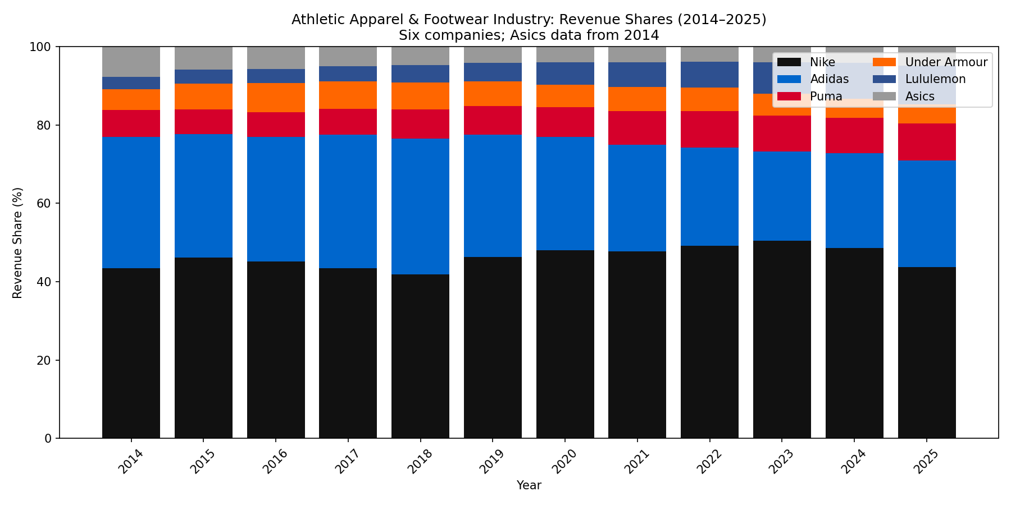
Industry Revenue Shares

Is any company gaining ground at the expense of others?
Yes. From the revenue-share data (2014–2025):
Company | 2014 | 2025 | Change
Nike | 43.4% | 43.8% | +0.4 pp
Adidas | 33.5% | 27.1% | −6.4 pp
Puma | 6.9% | 9.5% | +2.6 pp
Under Armour | 5.4% | 4.8% | −0.6 pp
Lululemon | 3.1% | 10.0% | +6.9 pp
Asics | 7.7% | 4.7% | −3.0 pp
- Lululemon gained the most share, from 3.1% to 10.0%.
- Puma also gained, from 6.9% to 9.5%.
- Adidas lost the most share, from 33.5% to 27.1%.
- Asics lost share, from 7.7% to 4.7%.
- Nike share was roughly flat over the full period, but peaked at 50.4% (2023) before dropping to 43.8% in 2025.
- Under Armour lost share, from 5.4% to 4.8%.

Why?
- Lululemon
  - Strong position in athleisure and yoga/studio wear, particularly among women.
  - Premium pricing and loyal customer base.
  - DTC focus and community marketing.
- Puma
  - Brand refresh and product innovation.
  - Solid performance in football, motorsport, and lifestyle categories.
  - Gains partly at Adidas’s expense.
- Adidas
  - Weakness in China (Yeezy exit and geopolitical pressure).
  - Inventory problems and restructuring costs.
  - Execution issues versus Nike and emerging competitors.
- Nike (2023–2025 decline)
  - Softer demand in North America and China.
  - Competition from On, Hoka, and Lululemon.
  - Ongoing wholesale strategy adjustments.
- Asics
  - Smaller global scale versus Nike/Adidas.
  - More limited DTC and brand reach.

Q1.2 Operating Margins

Chart
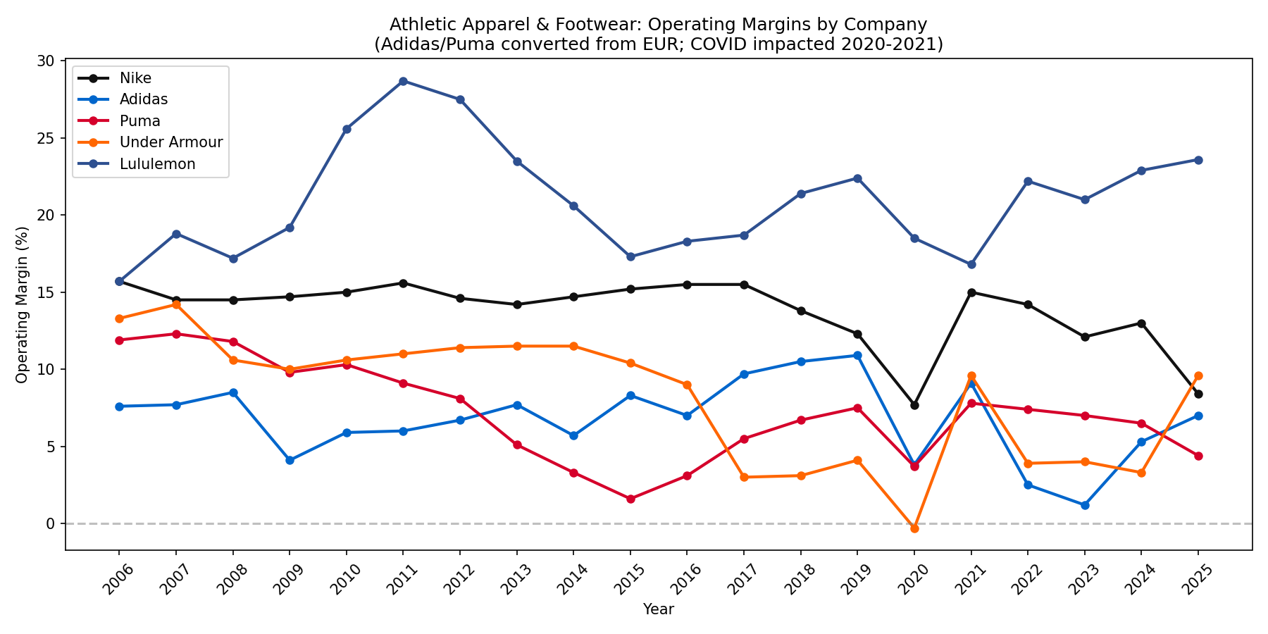
Operating Margins

Which company has the highest operating margins?
Lululemon has the highest operating margins over the period.
Approximate ranges (from data):
- Lululemon: 15.7%–28.7%, ~23.6% in FY2025
- Nike: 7.7%–15.7%, ~8.4% in FY2025
- Adidas: 1.2%–10.9%, ~7.0% in FY2025
- Puma: 1.6%–12.3%, ~4.4% in FY2025
- Under Armour: −0.3% to 14.2%, ~9.6% in FY2025
Lululemon’s premium, DTC-led model supports higher pricing and margins than the more wholesale-oriented athletic brands.
Note: Asics operating income is not provided in the data, so Asics is not included in the operating-margin chart or comparison.

Are margins stable?
No. Margins are volatile across companies and over time:
- Lululemon – Most stable and consistently high (roughly 16–29%). Some variation around COVID and expansion.
- Nike – Moderate volatility: 12–16% in normal years, dipped to 7.7% in FY2020 (COVID), 8.4% in FY2025 (demand and margin pressure).
- Adidas – Highly volatile: 2.5% in 2022, 1.2% in 2023 due to China, Yeezy, and restructuring; recovered to 7.0% in 2025.
- Puma – Considerable swings: low single digits in 2014–2016, then improvement; 2020 COVID dip and ongoing variability.
- Under Armour – Very unstable: negative (−0.3%) in FY2020, swings from 3% to 14% over the decade; recent rebound to ~9.6% in FY2025.
COVID (2020–2021) clearly pressured margins for most firms; Adidas also faced brand-specific and China issues in 2022–2023.

Q1.3 What is the geographic distribution of Nike’s business?
Nike reports revenue by geography. Based on the Product & Geog. sheet and the 10-K:
FY2025 Revenue Distribution ($mn):
Geography | Revenue | Share
North America | 19,572 | 42.3%
EMEA | 12,257 | 26.5%
Greater China | 6,586 | 14.2%
Asia Pacific & Latin America | 6,251 | 13.5%
Converse | 1,692 | 3.7%
Total | 46,309 | 100%
The 10-K states that U.S. sales accounted for approximately 43% of total revenues in FY2025 (Nike Brand + Converse), and non-U.S. sales for approximately 57%. Nike is geographically diversified, with North America as the largest region but significant exposure to EMEA, Greater China, and APLA.

Q1.4 Nike and Adidas: Do they compete across sports or are they geographically focused?
They compete across sports globally — they are not geographically focused.
- Both Nike and Adidas sponsor a broad range of sports: football (soccer), basketball, running, tennis, golf, etc., across multiple regions.
- Nike sponsors the NBA, NFL, major European football clubs (e.g., Barcelona), national teams (France, England, and recently Germany, taken from Adidas after 77 years), and global athletes.
- Adidas sponsors Real Madrid, Manchester United, MLS, and national teams (Italy, Spain).
- Both brands invest heavily in football globally; soccer accounts for over 40% of apparel sponsorship deal volume.
- They compete for the same athletes, teams, and leagues worldwide — e.g., Nike’s successful bid for the German national team from Adidas in 2024.

Question 2: Nike – Asset Value (8 sub-questions)

Q2.1 Where are Nike’s marketing expenses reported? What does that number include? What is “demand creation”?
Nike’s marketing expenses are reported in the Consolidated Statements of Income under “Demand creation expense”, which is a line item within Total selling and administrative expense.
- What it includes: Demand creation expense covers (1) advertising and marketing (brand campaigns, digital, media) and (2) sports marketing (athlete endorsements, team/league sponsorships, events).
- “Demand creation”: Nike’s term for brand-building spending that drives consumer demand. It is the portion of SG&A that functions as marketing investment.

Q2.2 Capitalization of marketing expenses: Brand value by discounting demand creation (WACC 9%)
Treating demand creation as a perpetuity: Brand value ≈ Demand creation ÷ WACC.
- FY2025 demand creation: $4,689 mn
- Perpetuity value: 4,689 ÷ 0.09 ≈ $52.1 bn
Using a 10-year average (~$3,200 mn): 3,200 ÷ 0.09 ≈ $35.6 bn.

Q2.3 Comparison to marketing company estimates
- Interbrand (2025): Nike ≈ $33.7 bn (down from $45.4 bn in 2024, $53.8 bn in 2023).
- Our perpetuity estimate using current spend ($52 bn) is above Interbrand, reflecting that we treat all demand creation as brand investment. Using a normalized or lower growth assumption would bring our estimate closer to Interbrand’s $34–45 bn range.

Q2.4 Royalty Relief Method
- Sustainable revenue: $46.3 bn
- Royalty rate: 13% → Imputed royalty = 0.13 × 46.3 = $6.02 bn/year
- Perpetuity (no amortization): 6.02 ÷ 0.09 ≈ $66.9 bn

Q2.5 Brand value with 10% amortization
- Brand value = Royalty relief ÷ (WACC + amortization rate) = 6.02 ÷ (0.09 + 0.10) = $31.7 bn

Q2.6 Reasonable assessment of brand value
Method | Brand value (approx.)
Capitalization (current DC) | $52 bn
Capitalization (avg DC) | ~$36 bn
Royalty relief (perpetuity) | $67 bn
Royalty relief (10% amortization) | $32 bn
Interbrand 2025 | $34 bn
A reasonable range is $32–40 bn, consistent with royalty relief (with amortization) and Interbrand, and accounting for the need to maintain spending to sustain the brand.

Q2.7 Demand creation: FY2020–FY2021 drop and FY2022 recovery
From the Demand Creation sheet: FY2020 = $3,592 mn, FY2021 = $3,114 mn (drop), FY2022 = $3,850 mn (recovery).
- FY2020–FY2021 drop: COVID-19 led to event cancellations (Olympics, leagues, tournaments) and reduced sports marketing. Nike cut discretionary spend and postponed campaigns.
- FY2022 recovery: Sports resumed, events returned, and Nike ramped up marketing again. The FY2022 10-K (p. 32) discusses the impact of COVID on demand creation and its rebound as activities normalized.

Q2.8 Asset value (brand as main component)
Ignoring minor adjustments: Asset Value ≈ Brand value (as instructed).
- Brand value (reasonable estimate): ~$35 bn
- Asset Value ≈ $35 bn (other adjustments treated as second-order).

Data Source
- Data: NKE-Homework-2026-1.xlsx, sheet “Industry”
- FX: Adidas and Puma converted from EUR to USD using annual rates from the sheet; Asics from JPY to USD
- Period: Revenue shares from 2014 (first full year of Asics data); operating margins from 2006

