## Project Description

1. Folder stucture

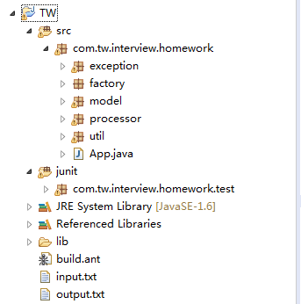

* 1. src

src folder include all the necessary java code.App.java is the main class to test. You can run App.java directly as well.

* 1. junit

junit folder contains one Test class, which can be used for unit test.

* 1. lib

lib folder has one external jar file junit-4.8.2.jar, which is required for unit test.

* 1. build.ant

This file is an ant script which is used to junit test and run the project. can be run directly, after running the script, a new folder “report” will be generated, it contains unit test result details.

* 1. input.text

This file is a input file.

* 1. output.txt

This file contains expected result for this project. Which is the same as output in mail mentioned.

1. Result screenshot.
   1. project output

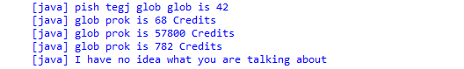

* 1. junit test output

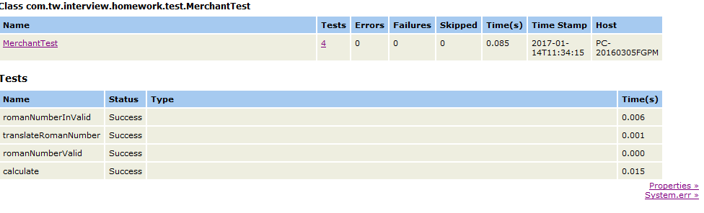

1. Assumption
   1. Input content should be in input.txt
   2. Questions were assumed to be end with “?”
   3. Input content (except Roman Number) is case sensitive.
   4. We treat “Credits” in content as an unit, so you can use other unit as well, plz check below:

eg: glob glob Silver is 34 GalaxyDollars . glob prok Gold is 57800 Credits

* 1. Word “is” is a very key word. We can treat the “is” as “=” in an equation. plz check below:

Eg1: “glob is I”. we treat it as “glob=I”

Eg2: “glob glob Silver is 34 Credits”. we treat it as “glob glob Silver = 34”.

We will initial corresponding object based on the equation.

1. Design
   1. Roman Number

Each Roman Number is a java object. They both have **ROMAN_NUMBER**, **ARABIC_NUMBER**, **MAX_REPEAT**, **SUBTRACT_ENABLE**

* 1. Metal

Gold, Silver, Iron is Metal Object. they both have **name**, **unitName**, **unitCost**

* 1. **Eg:** new Metal(“Silver”,”Credits”,”17”);
  2. GalaxyLanguage

GalaxyLanguage is used to store galaxy number. It has **galaxyNumber**, **romanNumber**, **arabicNumber eg:** new GalaxyLanguage(“glob”,”I”,1)

* 1. ProcessorStub

This class holds IProcesser instance which is used to handle different content.

* 1. ProcessorFactory

This class is used to get Processer Instance by different content.

* 1. RomanNumberFactory

This class is used to get Roman Number instance

1. Test case
   1. normal case

**input**:

input 1:

glob is I

prok is V

pish is X

tegj is L

glob glob Silver is 34 Credits

glob prok Gold is 57800 Credits

pish pish Iron is 3910 Credits

how much is pish tegj glob glob ?

how many Credits is glob prok Silver ?

how many Credits is glob prok Gold ?

how many Credits is glob prok Iron ?

how much wood could a woodchuck chuck if a woodchuck could chuck wood ?

**output:**

pish tegj glob glob is 42

glob prok is 68 Credits

glob prok is 57800 Credits

glob prok is 782 Credits

I have no idea what you are talking about

* 1. roman number lowercase and mutiple unit(Points,Credits, GalaxyDollars)

**input**:

glob is I

prok is v

pish is X

tegj is c

glob glob Silver is 34 Points

glob prok Gold is 57800 Credits

pish pish Iron is 3910 GalaxyDollars

how much is pish tegj glob glob ?

how many Points is glob prok Silver ?

how many Credits is glob prok Gold ?

how many GalaxyDollers is glob prok Iron ?

**output:**

pish tegj glob glob is 92

glob prok is 68 Points

glob prok is 57800 Credits

glob prok is 782 GalaxyDollars

* 1. wrong roman number case (“DLMM”is not a valid Roman Number)

**input:**

glob is M

prok is V

pish is d

tegj is L

glob glob Silver is 34 Points

how much is pish tegj glob glob ?

**output:**

L followed with M is invalid!!!

com.tw.interview.homework.exception.InvalidRomanNumberException