Let’s create a simple page that acts like a planning board. We’ll have three categories: To Do, In Progress, and Done. We can move the items around on the board to mark their progress.

Note: Planning Boards

The concept of a Planning Board or a Task Board is a part of the Scrum Agile software development methodology. To learn more, see: http://en.wikipedia.org/wiki/Scrum_(development)

To give you an idea of our final product, here’s a picture of the finished product:
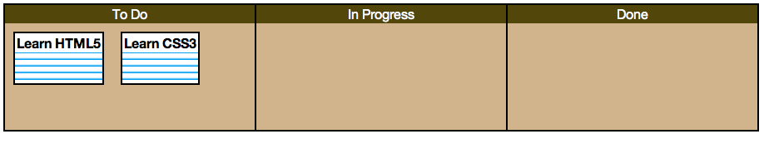
Let’s dive in, starting with the HTML!

<div id=”board”>
<div id=”todo”>
<div id=”item1” draggable=”true”>
<div id=”item2” draggable=”true”>
</div>
<div id=”inprogress”></div>
<div id=”done”></div>
</div>

Our first div, div id=”board” will act as the main container. The board will be divided up into three other divs. Finally, several smaller divs will act as note cards holding our items. The note cards will start in the “To Do” section:

You may have noticed we have an attribute, draggable, set to true. This attribute is required for making our two notecards draggable.

Next, we need to specify the JavaScript code that will actually make the Drag and Drop magic happen.

First, we’ll bind the dragstart event to our two notecards:

$('#item1, #item2').bind('dragstart', function(event) {
event.originalEvent.dataTransfer.setData("text/plain", event.target.getAttribute('id'));
});

Next, we’ll bind the dragover event on the board sections:

$('#todo, #inprogress, #done').bind('dragover', function(event) {
event.preventDefault();
});

Finally, we’ll bind the drop event to the board sections, and define what to do once something is dropped onto them:
$('#todo, #inprogress, #done').bind('drop', function(event) {
// do something!
});

We want to drop the whole div element that represents a card into the new location. To do this, we first grab the notecard element’s id, which we previously stored to the dataTransfer object:
$('#todo, #inprogress, #done').bind('drop', function(event) {
var notecard = event.originalEvent.dataTransfer.getData("text/plain");

});

Next, we’ll actually add a new element to the target, by using the appendChild method:
$('#todo, #inprogress, #done').bind('drop', function(event) {
var notecard = event.originalEvent.dataTransfer.getData("text/plain");
event.target.appendChild(document.getElementById(notecard));

});

Finally, as we did before, we’ll disable the default behavior that disallows any items to be dropped:
$('#todo, #inprogress, #done').bind('drop', function(event) {
var notecard = event.originalEvent.dataTransfer.getData("text/plain");
event.target.appendChild(document.getElementById(notecard));
event.preventDefault();
});

