XGS landing speed plugin

See changelog at bottom.

Installation

Just drop the folder xgs into your X-Plane-11\Resources\plugins folder and you are ready to go.

(Optional) Customization

Limits for the vertical speed at touchdown and the associated textual rating are configurable per aircraft model (an airliner has completely different limits compared to a glider).

The configuration file is simple text:

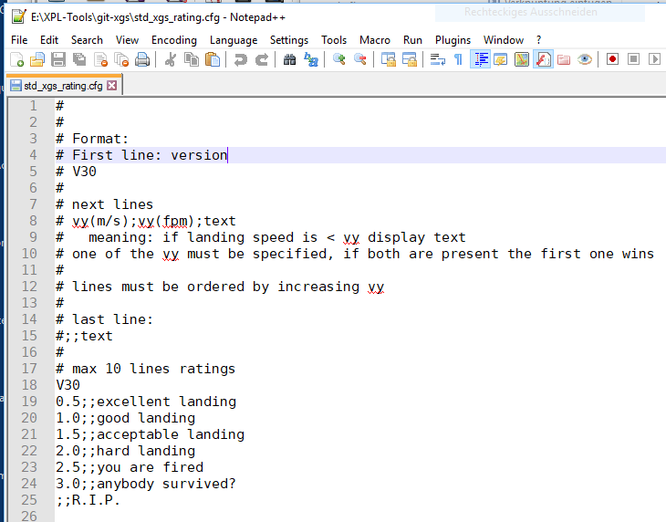
You can adjust limits and texts as needed. Vertical speeds can be specified as m/s or fpm but only one value should be specified per line.

If you have several aircrafts that should share the same configuration you can configure this with file acf_mapping.cfg

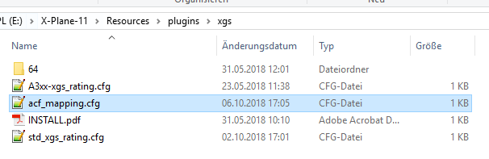
It is a simple text file mapping the aircraft’s ICAO code to the name of a config file.

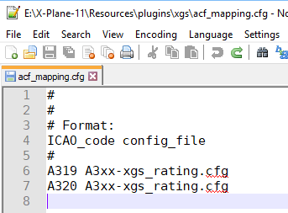

After starting a flight a configuration file is searched in the following order:

- file xgs_rating.cfg in the aircraft’s directory,
e.g. X-Plane-11\Aircraft\Laminar Research\ASK 21\xgs_rating.cfg
- Try to map via acf_mapping.cfg
- Use std_xgs_rating.cfg

Search is terminated after first match.

Output

If enabled in X Plane’s plugin menu the xgs plugin logs a summary of your landing parameters into X-Plane-11\Output\xgs_plugin.log.

Changelog

3.10
- INSTALL.pdf added
- log is now in X Plane's \Output folder
- threshold information is written to log as well
- much more flexible handling of configuration files
- better avoidance of false landing reports due to teleportations
- lots of optimizations

3.12
- make initialization of plugin more robust
- give runway information for many VFR-only fields

3.20
- VR support
- report IAS at touchdown and (right now for the ToLiss A319 only) computed VLS

3.30
- use geometric vertical speed (sim/flightmodel/position/local_vy) instead of indicated speed for reporting and computing g load.
Indicated is obviously simulated as barometric and lags behind.
Expect lower vertical speed and higher g-load.
- report pitch at touchdown

3.31
- Fix incorrect landing distance for displaced thresholds

3.32
- Fix widget not showing with scaled UI

3.33
- Make display time of result pop-up user selectable

