Transform3DTool

Overview
There are many AS3 librarys for transform DisplayObject, such as senocular’s TransformTool, GreenSock’s TransformManager, etc. DisplayObject become 3D in Flash Player 10. Transform3DTool is a library like TransformTool, but it’s for 3D in Flash Player 10!
Transform3Dtool is designed like the 3D tool in Flash CS4/5.
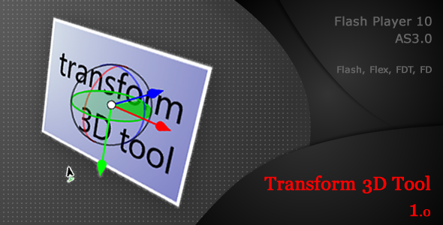

Usage
Create a Transform3DTool, add it to the display list, and set Transform3DTool.target. For example:
var tool3d:Transform3DTool = new Transform3DTool();
addChild(tool3d);
tool3d.target = mc1;
tool3d.addEventListener(TransformEvent.UPDATE, updateEventHandler);

Components
Transform3DTool consists of RotationTool, TranslationTool and GlobalTranslationTool.

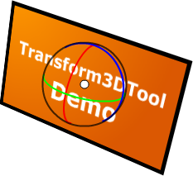 | 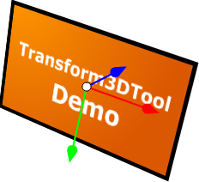 | 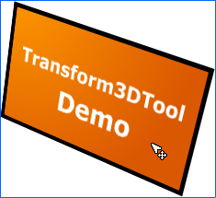
RotationTool | TranslationTool | GlobalTranslationTool

You can set Transform3DTool.tool to specify which tool to use. The tool names are listed in TransformToolMode. There are 4 tool mode:
- “all”
- “rotation”
- “translation”
- “global translation”

Transform Mode
There are two transform modes in Transform3DTool: Internal and Global, just like 3D tool in Flash CS4/5. Set Transform3DTool.mode to specify which transform mode. The mode names are listed in Transform3DMode.
Global transform mode means that the 3D transformations move in relationship to the Transform3DTool’s coordinates.

Global | 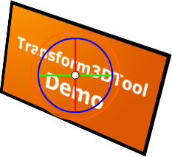 | 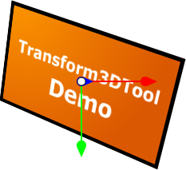
Internal
 | RotationTool | TranslationTool

GlobalTranslationTool is always “Global”.

Styles
By default, Transform3DTool x control is Red. If you want change the color or thickness of line, You need set the Transform3DTool.xCtrlStyle. For y, z controls, set the yCtrlStyle, zCtrlStyle.
For more detail styles:
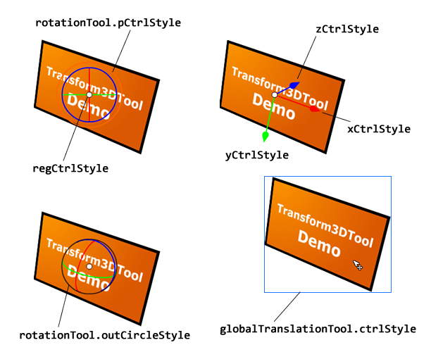

Cursors
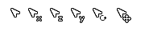
Transform3DTool consists of RotationTool, TranslationTool and GlobalTranslationTool. You can custom mouse cursor for every tool for each DimentionControl. For example, you can set the control cursor of tool by giving a DisplayObject:
Transform3DTool.rotationTool.xCursor = new Circle;
Transform3DTool.rotationTool.yCursor = new Circle;
Transform3DTool.rotationTool.zCursor = new Circle;
Transform3DTool.rotationTool.pCursor = new Circle;
Transform3DTool.rotationTool.RegCursor = new Circle;

Transform3DTool.translationTool.xCursor = new Circle ;
Transform3DTool.translationTool.yCursor = new Circle;
Transform3DTool.translationTool.zCursor = new Circle;
Transform3DTool.translationTool.regCursor = new Circle ;

Transform3DTool.globalTranslationTool.cursor = new Circle;

ToolBar

transform3d.toolbar.ToolBar is completely independent from Transform3DTool, It was used in Tfm3DToolDemo. ToolBar consists of ToolButton instances. For custom development, you need build custome Class extends ToolButton. For example, add three custom ToolButton to ToolBar.
_bar = new ToolBar();
_tToolBtn = new TranslationToolButton();
_rToolBtn = new RotationToolButton();
_modeBtn = new TransformModeButton();
_bar.addToolButton(_tToolBtn);
_bar.addToolButton(_rToolBtn);
_bar.addToolButton(_modeBtn, "right");
addChild(_bar);

Support
You can email me at http://activeden.net/user/itamt for any problems. I hope Transform3DTool is useful to you.

Best wishes to you.

