

Premaster Project

Keystrokes Dynamics for Identification

Department of Information Technology
Faculty of Computer and Information
Cairo University

Under the Supervision of:
Dr. Iman El-Azab

Team Members:

Mohamed Sami Ismail

Mohamed Talaat Saad

Mahmoud Fathy Mohamed

Table of Contents

List of Figures 3
Abstract 4
Acknowledgments 5
1. Introduction 7
1.1 Motivation 7
1.2 Literature Review 8
1.3 Definitions and Objectives of the Project 10
2. Theoretical / Technical Background 13
2.1 Source Data Used 13
2.2 Static versus Dynamic Identity Verification 14
2.3 Search Space for Keystroke Template Comparison 14
2.4 Keystroke Analysis Methods 15
3. Software Development 17
3.1 Requirements & Specification 17
3.2 Initial Exploration and Preliminary Results 18
3.2.1 Issues from Preliminary Results 19
3.2.2 Development of Keystroke Verification Algorithm 20
3.3 Software Implementation 24
3.3.1 Outline 24
3.3.2 Learning Login 25
3.3.3 Verification Login 26
4. User Trials 30
4.1 Reasons for a User Trial 30
4.2 Description of the User Trial 30
4.3 Ethical Issues and Approval Process 30
5. Results 33
5.1 Effectiveness of Keystroke Biometrics Program 33
6. Conclusion 38
6.1 Recommendations for Future Work 38
References 39

List of Figures

Figure 1 - Digraph latencies for the Typed Pattern "no"
Figure 2 - Keystroke Latencies for Initial Development
Figure 3 - Comparison of Windows API Timing Methods
Figure 4 - Formula for Standard Deviation
Figure 5 - Formula for Sample Standard Deviation
Figure 6 - Formula for Verification using weighted Latencies
Figure 7 - Results of Verification Algorithm on Initial Data
Figure 8 - Main Entry Point into Keystroke Biometrics Identification System
Figure 9 - Stored Profile for the string "goldenau"
Figure 10 - Program Verification Login Screen
Figure 11 - Screen Confirmation of a Login Match
Figure 12 - Summary of Login Attempts by Trial Users
Figure 13 - Summary of Impostor Login Attempts by Trial Users
Figure 14 - Comparison of User’s Signature Profile for "the brown fox" Standard Phrase

Abstract

In the last decade with the evaluation of the internet, computer security importance appeared rapidly with the need to provide higher level of security for information systems due to the network attackers and intrusions. Finding new techniques and upgrading currently ones those used to allow only the legitimate users to access sensitive data take a big area of computer security researches. The usual way of authentication system that depends on password validation still not enough to provide required high level of security. So we need more intelligent ideas to achieve our purposed security goals.

Keystroke biometric technique is one of these ideas that can provide us with better security for our protected information. Keystroke identification differ from other biometric techniques where it doesn’t require any special security hardware, it requires only the already existing computer keyboard to measure keystroke dynamic which differ from user to user . Each user has a typing signature for keystroke which relate to the keystroke latencies and pressure measures. These two measures are considered to be unique for each user.

In our project, we implemented a keystroke dynamics technique as a way of user’s identifications enchantments. Statistical data is collected from the user typing inputs to create unique signatures for user and saved in special profiles. In our implementation we compare generated typing authentication trials with constructed user’s profiles stored in database.

Acknowledgments

We would like to thanks our supervisor Dr. Iman El-Azab for having the confidence in our abilities to allow us to pursue the topics which excite us. Dr. Iman as been more than generous in both her time and confidence in our abilities and we thank her for her advices and for the opportunities she has provided us.

We would like to thank our colleagues at Faculty of computers and Information Cairo University for their helpful stimulating conversations and insights into our work. Lastly we would like to thank our parents and friends, for the opportunities and the constant encouragement they have provided to us and for pushing us, understanding us, and helping us to achieve our dreams.

Part 1

Introduction

1.1 Motivation

With the increasing of sensitive information systems and network intruders the trends of protecting the sensitive data. Preventing unauthorized users from accessing your secured data is one of the main requirements of modern security research. Our problem is to provide high level of security authentication and better user identification .Verifying the user who is accessing information resources. So we need more robust techniques to authenticate and identify the system users before accessing the resources.

The commonly known technique usernames and passwords which is used for user authentication has a need to a lot of improvements .Usernames and passwords can be stolen and can be guessed using brute force attack algorithms. Especially in the case of low complexity passwords. There are many alternatives to passwords technique, one of them is the user biometrics just like figure print, voice signature, iris scanning and hand geometry. There is a common issue between these alternatives that it needs a special hardware.

Using the keystrokes biometrics we can achieve a new away of user identifications with small cost. No need for additional equipment because it is already use existing keyboard. Keystrokes dynamics used to describe the unique typing pattern of users. This pattern hardly unique for each user and it can be same in some cases for similar typing text. With implementing this technology we can increase the security accessibility of our information system using inexpensive and easy technique.

Literature Review

Keystroke dynamics have been discussed in many papers of identity verification with differences in users input samples and information and also in the way of analysis and implementation.

In the following part we will list the previous work in keystroke dynamics.

In 1985:

Umphress and Williams made a digraph for latencies between the captured keystrokes. They worked on two different data sets. Each of them consists of different number of characters, where the reference profile has 1400 characters and the test profile has 300 characters. The results of this method proved the validity of keystrokes biometrics as a identity verification technique. But this study has some limitations because it requires large amount of input characters, and the False Acceptance Rate (FAR) achieved was 6% which is high for a verification method based on the fact that says FAR should be less than 1% for systems accessibility .

In 1988:

Williams and Leggett extended their previous study in 1988 .They increased the number of users in the study and reduced the experimental variables and also discarded some not useful digraphs. By this modifications they reduced the FAR to 5% which still not applicable for verifying login.

In 1990:

Leggett et alia took the concept of the keystroke stroke dynamics into dynamic environment testing verification. Dynamic environment means that the users' verification occurs while they type the test profile and this allow real-time verification of identity. This fixed the problem of time of check to time of use (TOCTTOU). This problem is defined as that the verification is done only once at login only, while someone else can use this access during the same session later on. The results of Legget et alia were based on sequential statistical theory and it were a FAR rate of 12.8% and a False Reject Rate (FFR) of 11.1% .These experiments proved that dynamic user identification is possible and can be better with more enhancements.

In the same year two papers released used the username and passwords which are compared to the user profile. The results proved more accuracy and more efficiency in search space.

In a study by Joyce and Gupta, this study depends on the login .They give the login four components username, password, first name and last name. They used basic statiscal function of mean, variance and standard deviation and also digraphs to detect the match. The result was FAR equal to 0.25% and FRR 16.67%.

Later on a study by Bleha et alia used the Bayes statiscal rule for classification. He chose Gaussian distribution function. There were two sources of samples. One for username and second for select user phrase of text for verification. The result was FRR 3.1% and FAR 0.5%.

Another study by Monrose et alia to work around the problem of attacker who try to gain access of the system using login information. In the study Monrose used random number for each password. Based on the users typing pattern, the system determine to send this number to administration server, so we can reduce the risk of attacking. Monrose expand his study later by including the keystroke duration. His conclusion is "keystrokes dynamics to protect from unauthorized access to systems".

In 2000:

Haider et alia discussed the approaches of analyzing user keystroke pattern. These approaches are neural networks, statistical methods and fuzzy logic. With username and passwords the best FAR was 2% using a combination of our approaches and for sure not acceptable. The best result was for the statistical approach. To increase the system performance Haider suggests recording the keystrokes period.
One of the most commonly used application that depends on keystrockes is Net Nanny's Biopassword .This application is used to authentication .

1.3 Definitions and Objectives of the Project

The goal of this project is to build an application with the special functions which can identify users based on biometrics keystrokes and verify that keystroke biometrics is an accurate and effective method of identification. And to prove that this way of identification can be used as effective method to increase computer security. In our implementation we will determine if this method of identification can reduce the False Acceptance Rate to be less than 0.5% which determines the ability of using this method to improve computer security.

In our implementation of this project we will use two different measures as a data for analysis, this based on the discussions of many papers in the past that was related to keystroke biometrics, the two measures are the latency between two successive keystrokes(inter-keys delay) and the keystroke duration(the time a key is depressed). The identification and validation process is achieved by comparing the statistic from the data being validated and a user reference profile that is related to that login identity and that is constructed at learning mode.

In this project the users are asked to enter three different strings. Two of these strings are selected by the user, the user name and password, but the third string is a common standard phrase required by all users (not user-selected). Based on the user name we compare the statistics of data being validated against the user profile of that user name not against all the database users’ profiles. Our implementation has a continues learning algorithm where the reference user profile is adjusted to apply the changes in the user’s typing patterns over time. The project implementation has two modes, the learning mode and verification as any biometric identification system. The leaning mode is to generate a user reference profile, the verification mode to validate the user’s inputs to their generated stored profiles. This will show the effectiveness of the program in user identification. To determine the False Acceptance Rate we require the users to login as other users to attempt verification.

Our project implementation uses the java programming language for development of the user interfaces, learning and verification algorithms. MySQL as a database management system for storing user profiles. Microsoft Excel as data analysis and plotting for users logins.

Part 2

Theoretical / Technical Background

Source Data Used

During a user typing session, we can collect different types of data and information that can be considered as a unique pattern for each user. Most of these data to be gathered are related to time while the user is typing on the keyboard. Such as the latencies between successive keystrokes that represent the time from pressing some key on the keyboard until the time of depressing another key. There are no limitations about the number of keys that we measure the latencies between them where we can calculate the latencies between more than two successive keys not only to form digraphs but to tri-graphs, and so on. The second type of data that we can collect during user typing session is the keystroke duration that can be considered as unigraphs where it represent the time from pressing some individual key until it is released.

The third measure is the keystroke pressure, but this biometric measure has some problem because it requires special types of keyboards that allow calculating the pressure on the keyboard keys and also because most of the currently used computer’s keyboards have only two statuses for their keys that indicate the position of the key is on or off, this means that the keystroke pressure is not applicable for these types of keyboards. And if we built systems that require special types of keyboards these lead for losing one of the keystroke biometric advantages mentioning that keystroke biometric does not require special type of hardware.
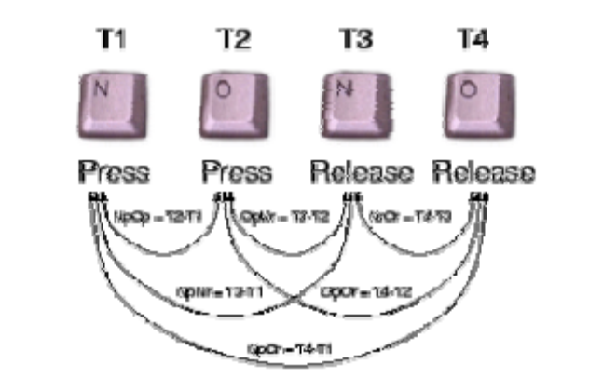
Figure1: Digraph latencies for the Typed Pattern "no"

2.2 Static versus Dynamic Identity Verification

In this paragraph we will talk about the two different approaches for user identification process using keystroke biometrics. First approach is the static verification that compares the keystroke characteristics of a known word or phrase to that of a pre-constructed reference template profile. An example of static verification process is the popular username and password login process, where the user identity is only verified only one time at login, but once the user is verified and entered the system, no identity verification occurs again until he log off the computer and re –login to the system again. This means that if some intruder knew the user’s name and password of certain system’s user, and logged in the system, he will not be detected as intruder while using the system. Second approach is the dynamic verification; this approach provides an advantage over the previous static verification approach where it allows for continuous identity verification during a session of system usage, this by comparing the collected and analyzed the keystroke characteristics during user session with a predefined user’s reference profile. This approach allows detecting unauthorized ones to use the system even if they successfully logged in. So, the dynamic keystroke biometrics identity verification provides another level of security for the systems that use any static verification method such as the normal username and password login.

2.3 Search Space for Keystroke Template Comparison

In the last section we discussed the static and dynamic verification techniques, in this section we will talk about the search space of template comparison. There are two different methods of comparison for keystroke verification process that can be executed. The two ways differ from each other in the search space of comparison. The first method is to compare the collected and analyzed data against all the referenced profiles in the database, we compute the distance between the input profile and all the stored referenced profiles in database, where the most nearest profile within certain degree of certainty is verified as the user attempting to gain access.

The second way is to compare the collected data to the referenced profile that has the same entered username at login, in this method we have reduced the search space of comparison and by the way to reducing the processing time of comparison, but this approach requires the username to be entered by the user to link to the stored reference profile that we will compare against. In the first way we can verify the user using any text, we should not ask the user to enter his/her username but has large search space and high processing time. In the second way we must ask the user about his/her username to claim identity, but low processing time.

2.4 Keystroke Analysis Methods

Some of Keystroke analysis techniques that can be used as a data analysis for the keystroke and identity verification process are fuzzy logic, neural networks and statistical techniques as well as combinations of these approaches. the statistical methods have been proved as the most accurate. The statistical methods can be used in two different paradigms, comparing by using any distance measure and classification using the Bayes classification algorithm. Using the neural network as an analysis technique is effective but it has a major disadvantage, the neural network must be retrained when a new user is proposed and added to the system database.

Part 3

Software Development

3.1 Requirements & Specification

The keystroke analysis method used for verification is statistical analysis. The exact nature of the analysis is not determined until after some initial testing has been performed. In order to achieve the objectives of the project as outlined in section 1.3 there are several requirements that the software needs to achieve.
- The program needs to use statistical analysis methods to perform keystroke identity verification.

- A signature profile for each token i.e. username, user phrase/password and standard phrase needs to be generated during the learning process and then used for comparison in the verification mode.

- The program will capture a username, user phrase/password and standard phrase for all users.

- The standard phrase is used as a point of comparison for latencies of the same phrase and may demonstrate the possible uniqueness of an individual’s keystroke patterns.

- The program will have a learning mode where a user will type the strings in several times as well as a normal login mode.

- It is also needs to incorporate a continues learning feature so that the user profile will adapt to changes in the user’s keystroke patterns over time.

- A log of all user attempts at identity verification needs to be kept; this is mainly all of the keystrokes latencies for the username, user phrase/password and standard phrase.

- The response time for verification needed to be short.

3.2 Initial Exploration and Preliminary Results

Initially, a Java SE Program was constructed on NetBeans IDE. This only had a basic interface that allowed a user to enter in a text string. The program would then calculate the associated digraph which is the time between when a key was press and then released. This information was then displayed in a Text Box. Entering in random text strings showed that the timing used was inadequate as it seemed that the resolution was at best 10ms which was inadequate for the analysis. This issue is discussed in section 3.2.1.1.

The word “gold” was used as an initial string and the latencies for ten attempts were output and were then copied into a spreadsheet for analysis. The mean and the standard deviation for each latency was then determined from the test data. This is shown by a graph, figure 2, of all the latencies for the word “gold” for all the ten attempts at a resolution of a microsecond. This resolution was used purely to check the behavior of the program for consistency. As can be seen the majority of the keystroke latencies are within one standard deviation for the mean, which is shown by the +/- allowable error on the graph. Through analysis of the graph and through use of the program there were several issues and technical problems that were identified in the preliminary phase of development.
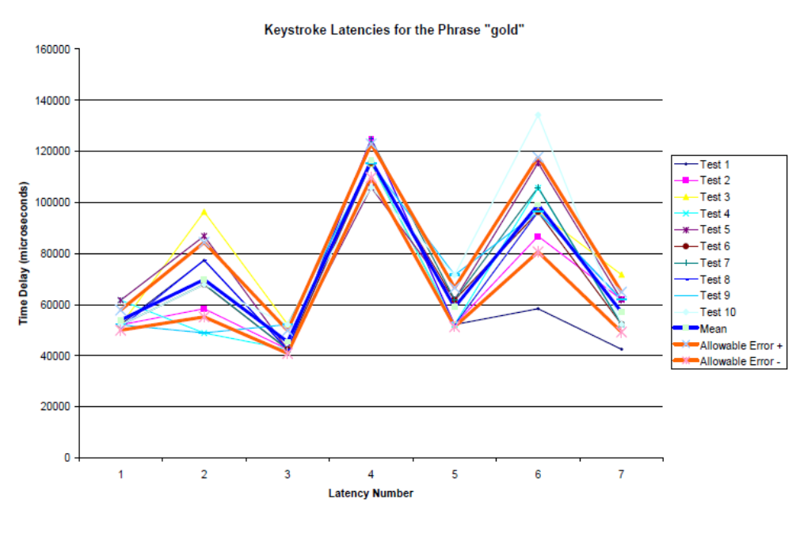
Figure2: Theoretical Keystroke Trace

3.2.1 Issues from Preliminary Results

3.2.1.1 Timing Issues

As mentioned above the initial timing resolution was not high enough to perform an accurate analysis of results. Because timing is so critical to the performance of the verification, it is essential that accurate timing is obtained with sufficient degree of resolution. On a dedicated machine this may not be much of a problem, however on time-sharing operating systems where execution of the program may be through a variety of networks, hardware/software systems this may be more of a significant problem.

3.2.1.2 Keystroke Logging

One of the problems that were discovered was that when a user depresses a key they may only release it after they have depressed one or more keys. This would only measure the time from one Key Down event to the next Key Up event. This created problems with making digraphs for the phrase which at this stage relied on the user pressing and releasing keys in exactly the same order at all times. While this should be the case, sometimes users as they become more efficient at typing will often depress more than one key at a time. By blindly measuring the digraphs these changes could not be accommodated and so one of the objectives of making the program adaptable to gradual changes in the user’s keystroke patterns would not be met. It was decided that the only solution for this was to temporarily store all the latencies for a login attempt and then to re-order them so that they were arranged in the order they were first depressed. This can be shown in figure 4., of a hypothetical situation where for the word “gold” the letter “o” is depressed before “g” is released and “d” is depressed before “l” is released.

Key Down Event | Time | Key Up Event | Time
G down | 150 | G up | 210
O down | 190 | O up | 230
L down | 250 | L up | 290
D down | 270 | D up | 310
Figure 4: Theoretical Keystroke Trace

3.2.2 Development of Keystroke Verification Algorithm

The basis for the algorithm is to develop a profile signature of keystroke latencies for each of the three strings that the user would type during the login process. The basic process is to compare the latencies of each login and see if they fall within a certain number of standard deviations from the mean reference latency for each digraph. If more than 80% of all the possible latencies passed this test then input for that string would be considered valid. The usual way of calculating standard deviations, figure 4, requires that all of the login digraph times need to be stored; the population standard deviation can then be calculated from all of these digraphs.
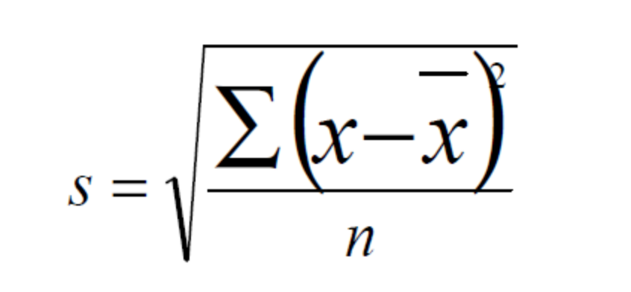
Figure 4: Standard deviation formula

This process means that every previous login needs to be stored just so that the standard deviation can be calculated. Manipulating the above standard deviation formula, a method can be used that does not require all the previous latency values for the standard deviation to be calculated. The formula, shown in figure 5, only uses the value for the sum of the values for each latency and the squared sum for each latency. This enables the standard deviation to be counted more quickly and reduces the amount of storage space required for the user’s profile.
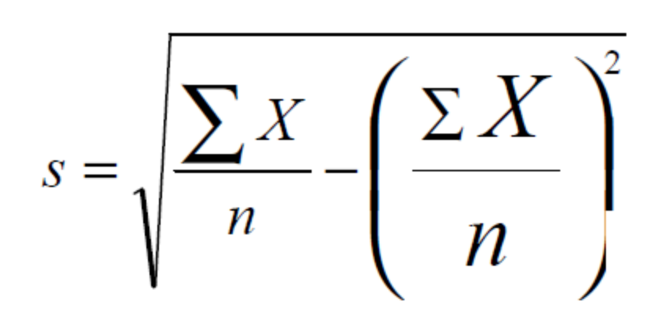
Figure 5: Sample Standard deviation formula

The main problem with using the standard deviation directly is that a digraph maybe be approved even though it has a high variability and consequently allows many more digraphs to be approved because the allowance for error is high. So that even if more than 80% of latencies fit within one standard deviation of the reference profile, it may not be significant if the variability is high. A way to alleviate this problem is to assign a weight to each of the deviations with regards to how the standard deviation compares with the mean as a percentage. Meaning that if the standard deviation, in comparison to the mean is high, then the approval for that latency would have a low weighting. The weight for each latency using this approach is given below in figure 6.

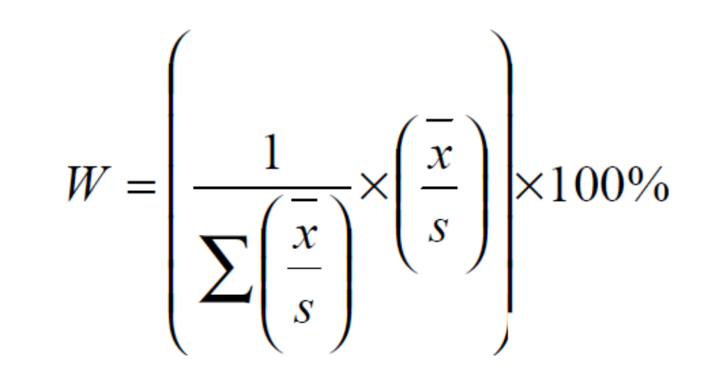
Figure 6 Formula for verification using weighted latencies

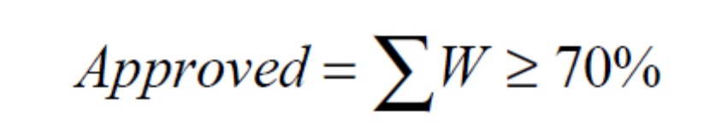
Where x dash is the mean, s the standard deviation and W the weighted value for each latency.

This approach can be illustrated using the following table that displays how the keystroke latencies in figure two are approved using the previously mentioned formulas. To be approved more than 80% of latencies must fit within one standard deviation of the reference profile and for each valid latency that fits within the standard deviation the sum of the weights must add up to at least 70%. These figures may be modified during the development of the software and initial user trials.

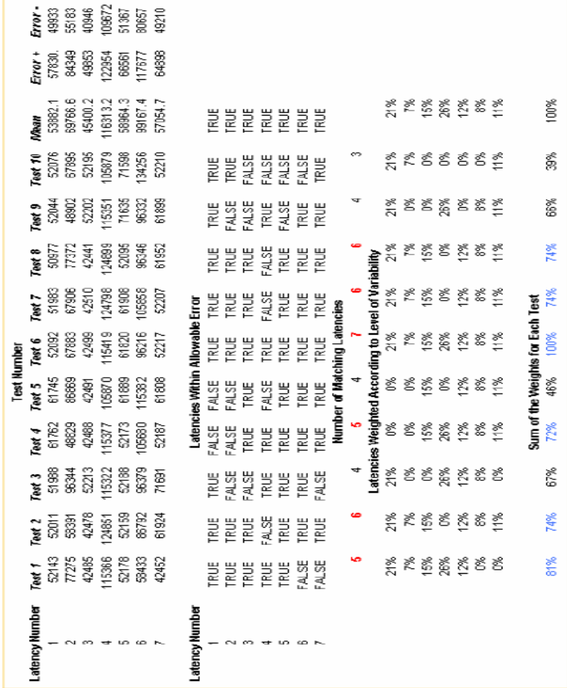
Figure 7: Results of Verification Algorithm on Initial Data

3.3 Software Implementation

3.3.1 Outline

The program has two operating modes, a learning mode where an initial profile is generated for the username, user phrase and standard phrase and a verification mode where the user input is compared to the reference template and is classified as being a successful or unsuccessful login. A screenshot of the main entry point to the program is given in Figure 8. To give a realistic indication of a real login process the username selected by the user must be between 5 and 12 characters and the user phrase must be between 8 and 25 characters long. Finally, the standard phrase that all users have to type in is “the brown fox”. The actual phrase is essentially irrelevant, it was merely chosen because the characters of the phrase are spread out across the keyboard, thereby giving larger inter-key delays that are useful for analysis. A longer phrase such as “the quick brown fox jumped over the moon” was considered, the problem was that the average user kept making typographical errors and would have to restart the login process, as well as the fact that for the larger string the variability tended to be much higher for less advanced typists.

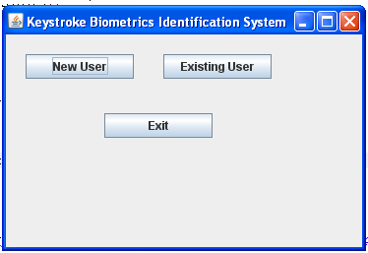
Figure 8: Main Interface for keystrokes system

3.3.2 Learning Login

To build an initial keystroke profile for each user the program enters the learning login mode. First a user is asked to select a username and a user phrase as described in section 3.3.1. Once this has occurred the user is requested to enter their login credentials a total of 10 times. During the developmental phase of the program all ten logins were used to develop a profile. The profile for the string “goldenau” is shown in figure 9.

Latency Digraph | Mean Latency | Sum of X | Sum of X Squared
G | 530 | 19089 | 10276930
G-O | 907 | 32644 | 30398770
O | 434 | 15629 | 6879291
O-L | 1794 | 64588 | 116126600
L | 564 | 20301 | 1160640
L-D | 960 | 34573 | 34414060
D | 447 | 16101 | 7350737
D-E | 1915 | 68924 | 132168900
E | 538 | 19354 | 10513950
E-N | 884 | 31825 | 29311090
N | 582 | 20959 | 12379290
N-A | 1678 | 60418 | 102627900
A | 564 | 20292 | 11749020
A-U | 1069 | 38480 | 43294730
U | 534 | 19213 | 10584790

Figure 9: Profile for “goldenau”

Initially, all of the 10 logins in the learning mode were used to generate the template. The value of the latencies was added to the sum of X column and the square of the latency was added to the sum of the square column. What was discovered was that there was a high degree of variability in the initial login of users. This would create a very high tolerance and would therefore more easily allow False Accepts from invalid users. To try to reduce this problem the first five logins are not used to generate the profile. Only the logins from 5 to 10 are allowed to generate and update the profile.
During login attempts 5 to 10 there is no validation of the input being implemented. One limitation of the program is that it does not allow users to use the delete or backspace key to correct any mistakes they have made while typing in the three strings. While it is possible to add the ability for the program to handle this, the user’s typing pattern would be disturbed by using the Delete and Backspace and the latencies would probably deviate too far from the profile anyway. During the input if a user tries to modify previously typed text the login is reset and they are required to start again. All login attempts are appended to a log file so that further analysis is possible, this is in additional to the signature file that store the user’s signature for each string, and finally there is a configuration file that stores the number of logins, the number of accepted logins and the how many of each of the strings have matched their respective profile.

3.3.3 Verification Login

The verification login forms the core of the program. A screen shot of this is shown in figure 10.

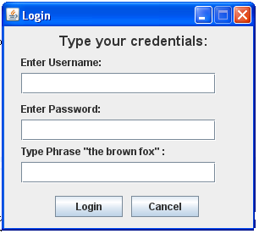
Figure 10: Program Verification Login Screen

From the user’s perspective the learning login and the verification login are exactly the same. In both cases the strings that have been selected by the user are displayed on the form. This is done so that they don’t have to worry about memorizing the word, as this is not the purpose of the study.
The first stage in the verification process is to timestamp and stores all key press and release events for each login. Assuming the user has not made any typographical errors or used the delete or backspace key, which will reset the form anyway, the raw keytraces are reordered into key depress events and inter-key delay digraphs in a similar fashion as is shown in figure 9. Then from the stored profile files the standard deviation for each latency is determined. The algorithm established in section 3.3.2 is used to perform the validation process for each string. Initially, the tolerance level was set to 0.5 standard deviations. This was found to be too high and so the criteria for latency match was reduced and now for an approval for a login string to occur only 50% of latencies must fit within one standard deviation away from the mean of the reference profile. Another change was made so that for each valid latency that fits within the standard deviation, the sum of the weights as described in figure 6 must add now add up to at least 75%. This gives slightly more emphasis to the weighted system. For a login to be valid, at least two of the three login strings must meet the criteria of having greater than 50% of the latencies within one standard deviation of the mean or the weighting system must give a score of 75% or greater. A screenshot of a matched profile is given in figure 11.

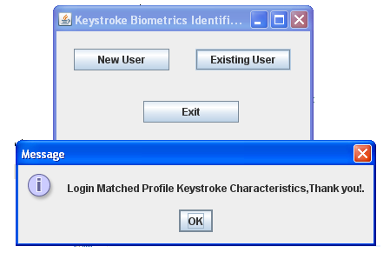
Figure 11: Screen confirmation of Login

As mentioned in the requirements the profile had to be able to adapt to gradual changes to the users typing patterns. This is implemented by adding the key latencies value and the square of the key latency value as described in the Learning Login section to update the mean and standard deviation for the profile. Even if the overall login is not approved, if an individual username, user phrase or standard phrase meets the verification criteria the data will be merged into the signature profile for that string, therefore continuously modifying itself to changes in the user’s typing patterns.

Part 4

User Trials

4.1 Reasons for a User Trial

A user trial is necessary to determine the False Accept Rates and False Reject Rates of the biometric system. These two measures are some of the most important measures of the effectiveness of an identity verification system. Since these figures cannot be determined accurately and conclusively using simulations a trial must be used to determine the effectiveness of the program with real users by performing some type of user trial.

4.2 Description of the User Trial

The user trial involves the participation of at least ten users of varying typing ability. Each user will be given a copy of the program and will be required to use the program and enter at least 50 valid logins. The User Survey gathers information about the users typing ability and various other associated data. This can help determine why a user has certain characteristics, for instance a beginner typist may have high variability in their signature profiles for the login process. Once at least 10 users have completed the trials and attempted at least fifty logins the information gathered can be analyzed and the False Reject Rate i.e. the rate of rejection for valid users, can be determined.
The next stage of the user trial is to have at least two users at random pick two other users to impersonate and try to login as an impostor. Analysis of these results will determine the False Acceptance Rate, which is the rate at which an invalid user is able to login successfully.

4.3 Ethical Issues and Approval Process

Due to the fact that keystroke biometrics is a unique personal identifier, in the same manner as an iris scan or fingerprints, ethical consideration must be given to its application and capture in much the same way as police would do for fingerprints or DNA.

Ethical approval for the user study was obtained from the ITEE ethics committee under the direction of Dr Greg Hooper. This involved a submission detailing the nature of the trial, as well as how issues such as confidentiality, privacy and security of captured data were achieved. Due to the personal nature of the capture data, in all references to interaction and results from the system, a trial user is only identified using a user trial number so that data is collected in a de-identified form.

Part 5

Results

5.1 Effectiveness of Keystroke Biometrics Program

The program as described in section three has had varying levels of success. Below in figure 12 is a summary of the login attempts by the trial users.

User Number | Number of Logins | Successful Logins | Username Accepted | User Password Accepted | Common Phrase Accepted
1 | 51 | 53% | 69% | 63% | 35%
2 | 51 | 76% | 80% | 43% | 69%
3 | 52 | 83% | 54% | 75% | 90%
4 | 60 | 82% | 55% | 80% | 78%
5 | 51 | 80% | 78% | 67% | 73%
6 | 51 | 76% | 37% | 88% | 78%
7 | 53 | 92% | 91% | 68% | 92%
8 | 51 | 67% | 57% | 80% | 49%
9 | 53 | 91% | 51% | 92% | 85%
10 | 51 | 67% | 47% | 43% | 96%
11 | 54 | 72% | 76% | 72% | 56%
 | User Average: | 76% | 63% | 70% | 73%

Figure 12: Summary of the login attempts by the trial users

This table indicates that the False Reject Rate is in the order of 24% as the average percentage of successful logins for the trial users was only 76%. This is a fairly disappointing result considering most of the previous studies discussed in the Literature
Review has been able to achieve False Reject Rates below 10%. Part of the reason for these poor results is that users who have poor typing skills were included in the user trial.

The second phase of the user trial program was to get two users to pose as impostors and try to logon as other users. One point to note is that the impostors did not observe other users typing into the program. By observing a user type the chances of making a successful login as an impostor increase significantly as the impostor now has an idea of what the approximate latencies are and this is especially true for slower typists because is easier to distinguish their individual keystrokes. After each user to be impersonated had finished their 50 logins, the two impostors then tried to log in another 50 times using the original signature profiles for the impersonated users. For these four situations almost all attempts failed except for the username when user two attempted to login as user 9. Overall, this gives a False Acceptance Rate of 0%. While these results seem quite impressive they are not conclusive. More impostors were needed and all users should have been tried to be impersonated by all the other users. This is the only way to have real confidence in the results. Also, many more users would be needed in the user trials of the program. Unfortunately, the number of users required to prove confidence in the False Accepts Rate beyond reasonable doubt would be quite large and beyond the means and scope of this project.

User Number | Number of Logins | Successful Logins | Username Accepted | User Password Accepted | Common Phrase Accepted
User 1 Trying to log on as User 3 | 52 | 0% | 0% | 0% | 0%
User 1 Trying to log on as User 4 | 60 | 0% | 0% | 0% | 0%
User 2 Trying to log on as User 5 | 51 | 0% | 0% | 0% | 0%
User 2 Trying to log on as User 9 | 54 | 0% | 4% | 0% | 0%

Figure 14: Summary of Impostor Login Attempts by Trial Users

To show how distinct the user’s profile signatures are, figure 14 shows the comparison of the reference profile of the standard phrase “the brown fox” between all users in the trial. While most of them look very similar all profiles have a unique pattern. The main problem is trying to distinguish between them.

The main area where the program does not function well is when there is high variability. Outlying logins that deviate markedly from the mean tend to skew the reference profile rendering logins that would otherwise be accepted to be invalidated or vice-versa. One reason for this is that the initial login numbers 5 to 10 have a high variability as the user gets accustomed to typing in the various words and phrases. This was partially help by ignoring the first five logins but it would also be useful to have an additional five more logins for the initial generation of the template. This is because during this phase there is no verification of the input so that the signature can adjust itself more easily, rather than when verification is used and change is incremented much more slowly.

Another method to reduce the variability would be to remove the outlying latencies periodically, especially if they are from earlier logins so that the signature profile may more closely match that of the user.

It is clear that this program as well as many other programs and algorithms respond best to typists that have a reasonable level of skill and consistency. Some of the users in the trial especially user ten had poor typing skills .
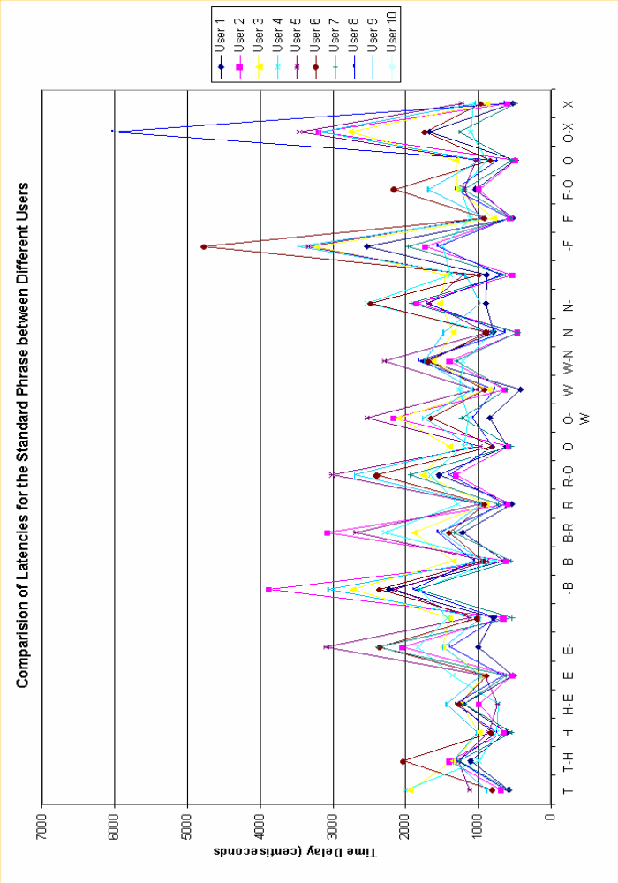
Figure 14: Comparison of Users Signature Profile for “the brown fox” standard Phrase

Part 6

Conclusion

The program developed for the capture and analysis of the typing dynamics was not overly complicated or fancy. It was able to do its objectives of logging data and to verify login attempts by using statistical analysis. It was also able to continuously adapt to changes in the users’ typing patterns. Another important objective was that the response time was virtually immediate.

The results from the user trial showed promise. While they were not as good in terms of False Reject Rates as contemporary research papers have achieved, it is still no less significant. The 24% False Reject Rate was quite high and this may have been due to very restrictive algorithms. In part, due to this restrictive algorithm, the False Accept Rate proved to be 0% however, as mentioned earlier this is not conclusive as the tests for this were fairly limited due to the small user trial size.. What is required is a larger and more in depth study that has more users so that the validity of the False Reject Rate can be proved beyond reasonable doubt.

Overall, the project has been a small success; the program has shown that using typing dynamics analysis is a useful method in providing identity authentication. If it is simply viewed as strengthening the login process it is has shown to be quite adequate in this regard. While the actual program was not as effective as some programs and algorithms that have been published it manages to show some ability and demonstrates the vast potential using the technology.

6.1 Recommendations for Future Work

In addition to the statistical analysis approach used for this project other methods that could be used are neural networks and fuzzy logic. Ideally, this project should have had a larger user trial in order to properly validate the findings. This could be considering for future works. Other areas that could be considered for future work is the effect that different types of keyboards, times of day and other variables have on the ability for a user to type a consistently recognizable keystroke pattern. One of the more interesting and advanced areas of typing dynamics biometrics is that of dynamic analysis. Using this approach a user may constantly be verified throughout their session at the computer, so that a person cannot just sit down in front of a computer that has been left unattended and gain access. This area seems to be the logical conclusion for the technology and may prove one day to be very widespread.
References:

[1] Haider, S., Abbas, A., Zaidi, A., A Multi-Technique Approach for User
Identification through Keystroke Dynamics, IEEE International Conference of
Systems, Man and Cybernetics, Vol 2, p1336-1341, 2000

[2] Monrose, F., Rubin, A., Authentication via Keystroke Dynamics, Proceedings of
the 4th ACM Conference on Computer and Communications Security, p 48-56,
April 1997

[3] Gollman, Dieter, Computer Security, Chichester ; New York : Wiley, c1999,
QA76.9.A25 G65 1999

